STUDENT REPRESENTATIVE COUNCIL
MONTHLY MEMBER REPORTS

MONTH 2022

Contents
Executives 4
PRESIDENT: RAMEEZ PARKAR 4
VICE-PRESIDENT EDUCATION (UNDERGRADUATE): VACANT 5
Not submitted 5
VICE-PRESIDENT EDUCATION (POST-GRADUATE): SANJAY THAPA 5
Not submitted 5
VICE-PRESIDENT ACTIVITIES: CAMERON CHESTERS (AWAY UNTIL OCTOBER) 5
Not submitted 5
GENERAL SECRETARY: SABRINA YOUNG 5
Not submitted 5
Campus Representatives 5
BANKSTOWN REPRESENTATIVE: JASMINE RICCIARELLI 5
CAMPBELLTOWN REPRESENTATIVE: DHARSHINI SATHYANARAYANAN 7
HAWKESBURY CAMPUS REPRESENTATIVE: VACANT 7
Not submitted 7
LIVERPOOL CAMPUS REPRESENTATIVE: ROMONDA EID 7
PARRAMATTA CITY CAMPUS REPRESENTATIVE: VACANT 9
Not submitted 9
PARAMMATTA SOUTH REPRESENTATIVE: RAZIN POLARA 9
NIRIMBA CAMPUS REPRESENTATIVE: SARA MIKHA 10
ONLINE STUDENT REPRESENTATIVE: CAITLIN MARLOR 11
Not submitted 11
KINGSWOOD CAMPUS REPRESENTATIVE: JULIAN GONZALEZ 11
Not submitted 11
SMALL AND REGIONAL CAMPUS REPRESENTATIVE: VACANT 11
Not submitted 11
Equity Collective Representatives 11
DISABILITY REPRESENTATIVE: ROBERT REED 11
ETHNO-CULTURAL REPRESENTATIVE: CRYSTAL RAM 15
ENVIRONMENT REPRESENTATIVE: VACANT 17
Not submitted 17
FIRST NATIONS REPRESENTATIVE: TIFFANY SHARPE 17
INTERNATIONAL STUDENTS REPRESENTATIVE: ANKANKSHA ANKANKSHA 18
RESIDENTIAL STUDENTS REPRESENTATIVE: JORDAN BRETT 19
WOMEN’S REPRESENTATIVE: VACANT 20
Not submitted 20
QUEER REPRESENTATIVE: JACOB MEIN (EMILEE) 20
WELFARE AND WELLBEING REPRESENTATIVE: VICKY-RAE REED 21
WELFARE AND WELLBEING REPRESENTATIVE 21

Executives

PRESIDENT: RAMEEZ PARKAR

Name: | Rameez Parkar | Role: President
Month: |  | September 2022
Reporting Period |  | Friday 5th August 2022 – Thursday 1st September 2022

Date | Training

Date | Meeting
Friday 5th August 2022 | SRC Grievances Panel Meeting
Friday 12th August 2022 | SRC August General Meeting
Monday 15th August 2022 | SRC General Consultation
Wednesday 17th August 2022 | Respectful Relationships Taskforce
Friday 19th August 2022 | SRC Grievances Panel Meeting
Monday 22nd August 2022 | SRC Consultations
Thursday 26th August 2022 | SRC Executive Meeting
Friday 27th August 2022 | SRC Grievances Panel Meeting
Sunday 29th August 2022 | Consultation with Residential Campus Representative
Thursday 1st September 2022 | Special SRC Meeting
Notes:
- Planning is underway for a Cross-campus Facilities and Services Forum a date is yet to be confirmed.

Actions assigned to me at SRC meeting
- I have made initial contact with NUS Representatives and am getting a quote for reaffiliation.

VICE-PRESIDENT EDUCATION (UNDERGRADUATE): VACANT

Not submitted

VICE-PRESIDENT EDUCATION (POST-GRADUATE): SANJAY THAPA

Not submitted

VICE-PRESIDENT ACTIVITIES: CAMERON CHESTERS (AWAY UNTIL OCTOBER)

Not submitted

GENERAL SECRETARY: SABRINA YOUNG
Events attended
6 August – Western Badminton Social Session and picnic
8 August – Meet and Greet with SRC, Editors, and Student Community
13 August – Vinnies volunteering
26 August – Wear it Purple Day event
Meetings
9 August – hosted MATES mentoring session
9 August – facilitated ECG session
10 August – Mental Health and Wellbeing Team meeting
11 August – SRC Budget Committee Meeting
15 August – Meeting with Richard Martino on policies and procedures and discussion of Vote of Formal Notice actions
16 August – hosted MATES mentoring session
16 August – facilitated ECG session
18 August – ECG catchup meeting
18 August – Diversity Fest Q&A
23 August – hosted MATES mentoring session
23 August – facilitated ECG session
24 August – Mental Health and Wellbeing Team meeting
25 August – Executive meeting
25 August – UNAA x WSUNS conference
30 August – hosted MATES mentoring session
40 August – facilitated ECG session

Trainings
5 August - Diversity and Inclusion workshop
25 August – Succession Planning Workshop
Concerns

Actions
5 August - participated in VR research at the Westmead MARC’s Institute on the WSU HPRNet Project for Perceptual Learning
8 August - participated in VR research at the Westmead MARC’s Institute on the WSU HPRNet Project for Perceptual Learning
14 August – Open Day volunteering with Events Team
31 August – Assisted with Student Events pop-up
To do
- Finalize budget report by next meeting
Outcomes

Campus Representatives

BANKSTOWN REPRESENTATIVE: JASMINE RICCIARELLI
Monthly Report Bankstown Student Rep (Aug/September)

3rd August 2022- Bankstown Campus Stall
Ran the campus stall at Bankstown with. Monda. We had a lot of fun talking about what the src does and giving away some colouring mindfulness packs and I can’t wait to do the next one.

3rd August 2022-Meeting with Hassan
Showed Hassan event location for Bankstown chill afternoon and we have decided to start with the event planning.

6th August 2022- Campus Stall colouring sets

15th August 2022-Consultation on SRC Agenda Changes
Where we spoke about the new reporting system for SRC members.

18th August 2022- Planned the next c-stall with Monda for week 7

23rd August 2022- Bankstown Provost meeting
Farewell to Bankstown event maybe 19th oct: food tucks, live music, learning about the history of the campus plus tory of the educational college that. the campus was prior to the uni, possible give away, open time capsule.

23rd August 2022- Wear it purple prom
Sheard the Macarthur Wingecarribee Diversity Network purple prom on WesternLife and in the local Wingecarribee area.

23th August 2022- Campus stall
Spoke to Bakar about final products for the C-stalls and where they were going to be dropped off for collection.

24th August 2022- Campus stall Bankstown

Ran the second Bankstown campus stall with Monda. Although the stall was quieter students still came and spoke about some improvements about the uni and its facilitates.

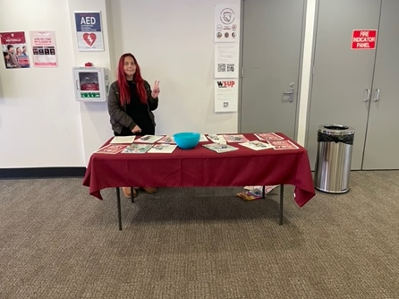

25th August 2022- Succession Planning

Proposal and Actions-

Will continue c-stalls with Monda, giving out art packs to students during the stalls and using the c-stalls as a way to get students feedback on campus improvements

CAMPBELLTOWN REPRESENTATIVE: DHARSHINI SATHYANARAYANAN
SRC member report – August
Dharshini Sathyanarayanan – Campbelltown Campus Representative
Two months ago, in collaboration with disability and equity collective, I created a poll for students to share their views on the accessibility features in the shuttle bus tracker. More than 100 students shared their honest opinions, in which majority of the students were undergraduate students. Majority of the responses came from Parramatta South campus students, then Campbelltown campus students and then Penrith campus students. Data showed that 89.9% of the students knew what the shuttle bus tracker is. 40% of the students found that there were accessibility issues in the current app. 51.9% of the students who responded believes that live timetable will immensely help the app to be more user-friendly. These data numbers are just part of the whole data report published a week ago. We are yet to have a meeting on how to go forward. More details will be disclosed.
Last month we started the SRC campus stalls. We will be having these stalls every third Thursday in a month from 11am to 2pm in Campbelltown Campus. We have these stalls just in front of the Building 4. Rob, Disability Representative, and Tiffany, First Nations Representative, helped out in arranging the whole stall since I had class. We were able to talk to student about what the SRC is really about.
I look forward to working with the SRC in the coming months, in regards to shuttle bus tracker and SRC Campus stalls.
Regards,
Dharshini Sathyanarayanan

HAWKESBURY CAMPUS REPRESENTATIVE: VACANT

Not submitted

LIVERPOOL CAMPUS REPRESENTATIVE: ROMONDA EID
SRC REPORT AUGUST

15/8/22 – Submission of Agenda Item “Free Little Pantry” for Liverpool Provost Meeting. Attached previous information details on the initiative which was constructed by Vicky-Rae, for all Provost members to see ad familiarise themselves with for the next meeting. Sent all information to Diana Curuenavuli, before Agenda item deadlines.
16/8/22 – Meet the CEO of the Arnott’s Group George Zoghbi. I considered this to be as a form of training as it was an interesting demonstration of skills required for a graduate program which encourages growth from mistake making and stellar leadership trials along the way.
18/8/22 – Liverpool Campus Provost Meeting. Little Free Pantry was spoken about for much of the meeting where questions were asked on the distribution and the contribution of pantry items. Brian’s main concerns were raised around school kids who are not part of the University – having access to level 1 where the pantry is unlocked. There was also talk about encouraging and removing the stigma around students having to ask for free food during their Uni journey. I support and encourage students to reach out to me and ask for help, there is no shame, and my door is always open. I initially asked for a budget of $5k to go towards the pantry seeing the average spend on groceries (including the price increases) is around the $180 mark. The pantry was stocked on the 7th of July only to be empty some 10 days later. The calculations were made, and to have a full functioning pantry throughout the Spring and Summer Semester, it will cost $5k. I was obviously not awarded that much; however, I am grateful for the $1k which was agreed on and hope to make a difference with nutritional foods for my campus cohort. There was also talk of constructing a progress report to keep an eye on the running and the donating side of things, along with pamphlet making which will be left for students to take during a counselling, welfare, or well-being service appointment.
24/8/22 – C-Stall at Bankstown Campus. Jasmin and I have been chatting with the Bankstown Campus students, introducing ourselves as their Representatives and reminding them what we do as SRC members. We encourage students to leave feedback and allow them the opportunity to just come and say hello at their own accord. Jasmin has encouraged well-being on her campus by supplying adult colouring books and pencils which we find to be useful for de-stressing during exam period and addressing the needs of the Bankstown campus as they have asked for something “chill” on their campus. Jasmin and I have been working well together on these campus groups which we believe are part of our duties around hosting a campus forum.
25/8/22 – C-Stall Parramatta City Campus with Ellyn-Joyce. Much of the same routine, we had some goodies to hand out as the order of lanyards, jellybeans, highlighters, and tote bags have come through. We are still waiting on the pens and our jerseys to arrive. Ellyn and I had a few conversations with the Parramatta City students, and a lot of students were pleased to be at that campus.
25/8/22 – CCEN meeting CANCELLED
25/8/22 – Remembrance Day planning started. Working group formed for Remembrance Day led by the lovely Vicky-Rae.
26/8/22 – Wear it Purple Day. I was unable to attend the Q&A due to class at the same time however, I like to support my colleagues at their events and was able to say hello to Vicky-Rae during her important event, in support of Wear it Purple Day.
26/8/22 – Distributed Life Blood and SRC pamphlets throughout the campus, at every level there are pamphlets on the notice boards.
31/8/22 – Laugh Therapy – no participants.
1/9/22 – Vote of formal notice meeting.
1/9/22 - Consultation with Jasmin on buying more “well-being” packs to distribute at my home campus. Unable to have held a C-Stall meeting at Liverpool yet, as there have been a few logistical issues. Planning on a full day at Liverpool to make up for the lost time, sometime this month.
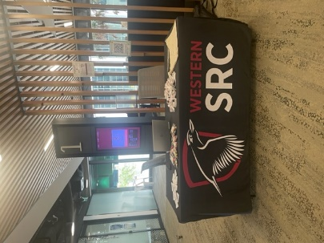 At Parramatta 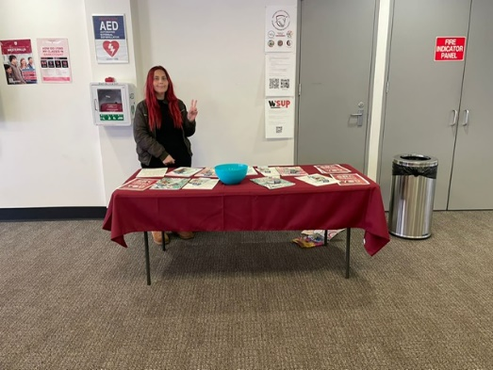 At Bankstown

By Romonda Eid
18900864
SRC – Liverpool Campus

PARRAMATTA CITY CAMPUS REPRESENTATIVE: VACANT

Not submitted

PARAMMATTA SOUTH REPRESENTATIVE: RAZIN POLARA
Meetings, events or conferences I have attended this month in my capacity as a member of the SRC:
· Meeting with COS executive for SRC merch.
· Special purpose meeting SRC
· Meeting with provost committee members for upcoming event.
Communication and engagement, I have been involved this month as a member of the SRC:
· Following on my previous report from July in terms of SRC merch for C-stall I have finalised the design of polo and hoodies. I have requested a sample from the supplier. Once the sample arrives, I will get this discussed with the SRC members and grant before giving it to the print.
· I have been involved in planning of the events for one of the club called “Wild West Runners” as the executives requested that the event will be based in the parramatta south campus.
· I am also working with the Inclusive communities to host the international student dinner for the diversity fest event.
· His will be conducted at parramatta south campus in the HUB involving international student rep. helping us out.
· Furthermore, I will also be working in involving in the kingswood spring festival organised by the events and the provost committee. We will be encouraging clubs to showcase their talent on the day to create more engagement.

NIRIMBA CAMPUS REPRESENTATIVE: SARA MIKHA
NIRIMBA CAMPUS REPRESENTATIVE: SARA MIKHA
Monthly meeting:
Joined SRC March meeting, we discussed some of the agenda items and budgets and got on track with everyone's plans and events. This also helps me know what everyone's goal is and what we are up to. It is beneficial to keep us updated every month.
Provost:
· Joined the Provost monthly Meeting; we talked about what has to be fixed in Nirimba and Olympic parc campus. Everyone has a job to complete till the next meeting.
· I had a Meeting with Marry; we walked around the campus and discussed if anything needed to be fixed or changed, such as equipment or furniture.
Meetings:
· I had a meeting with Michelle Holdstock and Suzanne. They both are librarians; the topic was about how could the library create a child-friendly space that is more accommodating to the carer? We brainstormed some ideas, such as: transferring one of the study rooms into a room with games for kids. We will hopefully have another meeting in the future.
Project C-stall Meeting:
We had a brief meeting about the stalls that we wanted to put on campuses; we established to finish most of the work, such as the location on each campus, time and partners that we are working with. We only have little things to finish, such as banners, shirts and badges

ONLINE STUDENT REPRESENTATIVE: CAITLIN MARLOR

Not submitted

KINGSWOOD CAMPUS REPRESENTATIVE: JULIAN GONZALEZ

Not submitted

SMALL AND REGIONAL CAMPUS REPRESENTATIVE: VACANT

Not submitted

Equity Collective Representatives

DISABILITY REPRESENTATIVE: ROBERT REED
August Disabilities Representative Report / Activities
Below are the following events and collaborations between the SRC Disabilities Representative and associative relations internal and external to WSU. August was a significantly busy month, especially concerning student advocacy and triage of issues that have been brought to the attention of both myself and the Disability Collective
3rd August Assistive Technology Monthly Catchup with Sally Leggo.
The importance of these sessions is the continual change associated with advances in assistive technology provided for students at WSU. Included in this meeting was an update on the clearing and upgrade to access rooms at all Campuses. Listings for the accessible rooms have been updated and will be included in the Disability Collective Newsletter on Monday. Sally has also indicated that referral waiting times may be slightly increased due to reduced staff loads. All students will have their assistive technology needs tended to at the earliest possible time.
5th August Mate’s Corner Men’s Discussion Group
7th August Initial talks with Terri Mears regarding student representation at upcoming Space Utilisation Workshops
9th August Student Advocacy and triage to correct support services
11th August Correspondence with Disability Services and Welfare concerning possible advocacy for student
12th August Monthly SRC Meeting Liverpool City Campus
15th August Discussion at Campbelltown Campus with Emilee (Queer Rep) on future event collaboration.
This included possible ideas on how to run the World Aid’s Day event in December with the combination of education and entertainment by virtue of daily sessions ending with a movie night. Further collaboration is to be undertaken with Emilee, and I wanted especially thank Emilee for her insight and proposals.
15th August Consultation meeting regarding SRC agenda changes
17th August Disability Collective Executive Catchup.
This meeting had been postponed until August due to various issues regarding the availabilities of the executive team. Of significant note was the representation of one of our reps at the Australasian Diabetes Conference in Brisbane, which can open collaboration with organisations external to the university. Congratulations to DC Engagement Officer Stephanie Hannah for presenting to a highly diverse audience from different medical fields.
17th August Discussion for the collective use of space at Kingswood Campus Building H with equity representatives and staff involved in the decision process.
18th August Assisted Tiffany (First Nations) and Dash (Campbelltown Rep) with C’stall at Campbelltown Campus
18th August Student Advocacy meeting
18th August Correspondence with Disability Collective Executive regarding future events involving guest speakers on a range of topics and issues that impact students' lives and members of the community with disabilities.
This follows from discussions held on 11th August regarding connections made by Stephanie Hannah due to her attendance at the medical conference.
19th August Mate’s Corner Men’s Discussion Group
22nd August Correspondence with Jenny Page and Pero Dundic regarding the inability to access the SRC office at Campbelltown.
This has since been resolved due to the issue being caused by the changeover from swipe access to tap access
23rd August Disability Collective and Equity, Diversity and Wellbeing monthly meeting.
Highly informative meeting due to the full agenda of items that were tabled. The attendance of Brendan Hoey, Sports Coordinator, was of significant importance, discussing the roles and future events that will be held on campuses post-covid. Brendan Hoey also discussed accessibility to increase the possibility of all students attending as many events as possible. However, in agreeance, there will be events where accessibility will not be available to all due to the nature of some events. Updates were provided on the shuttle bus issues that had been presented previously, and currently awaiting the next meeting to discuss the statistical analysis that has been provided in the last two weeks.
24th August Space Utilisation Workshop 1. I had the privilege of attending the Space Utilisation Workshop presented by WSU OEC staff. This event was important as it allowed the issues of accessibility to be highlighted from the eyes of a student with complex disabilities. The staff who attended the events were unaware of the impact of the layout of campuses on those with accessibility issues, especially concerning shuttle buses and access to the building. Campbelltown was noted, as this is my home campus. It was pointed out that to access certain facilities on campus, a student, especially those with mobility issues, would have to traverse nearly twice the distance of those with no mobility issues, mainly due to the numerous stairways and steep inclines across the campus. It was noted that some of these problems could be alleviated by proposing changes to the route the shuttle bus currently uses—especially the accessibility to building such as building 24. The proposal of a new stop outside the Uniclinic would allow students with mobility issues to reduce the amount of physical travel required to attend classes in this building. Accessibility in current spaces was also discussed, including the possibility of sensory-sensitive rooms for those students who have sensory issues and are significantly affected by areas of everyday use at the campus, but a high thoroughfare area.
24th August Student Elections Webinar with Grant Murray
25th August Cross Campus Equity Network Meeting
26th August Student advocacy and liaison with external agencies for best possible approach for a student.
26th August Mate’s Corner Men’s Discussion Group
29th August Student advocacy follow-up
29th August Delivered C’Stall merchandise to Campbelltown SRC office for use at the next session by the Campbelltown Rep.
1st September SRC Special Meeting Vote of Formal Notice.
2nd September Mate’s Corner Men’s Discussion Group
5th September Student Advocacy meeting with Welfare Services
7th September Assistive Technology monthly catchup. Be detailed in the following report
7th September Space Utilisation Workshop 2. To be detailed in the next report. It will be interesting to hear what has been taken from the previous session and developed beyond conversation and into possible proposals.
I invite current representatives to attend our monthly meetings/sessions as participants
or observers. This has been offered several times in the past, and very few have taken these
opportunities to gain a better understanding of issues faced by students with disabilities. I would like
to thank Tiffany, Vicky-Rae and Dharshini for their attendance and involvement at various meetings
we have with university stakeholders and committees.

ETHNO-CULTURAL REPRESENTATIVE: CRYSTAL RAM
SRC Member Report – September2022 Meeting Attendance ETHNO-CULTURAL REPRESENTATIVE: 08/08/2022 Meet & Greet between SRC; Editors & Student Community staff 15/08/2022 Consultation on SRC Agenda Changes 22/08/2022 Meeting with Student Leaders of WSU 24/08/2022 Student Elections – Webinar 25/08/2022 Workshop: Planning for Future Success 25/08/2022 Meeting with Dean of the School of Nursing and Midwifery and Provost of the Parramatta South campus - Professor Deborah Hatcher 30/08/2022 Meeting with Grant Murray 09/09/2022 SRC Meeting As the ethnocultural representative, I will continue in my efforts to partake and report the needs of students across all fields on and off campus. As the representative I believe it is anticipated that I strengthen student voice and increase participation in activities which are currently online. I plan to organise regular meetings both face to face and virtual, for students that allow a chance for the students of various communities to grow and develop. Since being elected I have sustained effort to support and advance networks as well as partnerships with individuals, groups, clubs, and offices which are working towards the same otherwise similar objectives such as the Provost Committees where we will be working alongside with the Inclusive Communities Coordinator and team, for the upcoming Diversity Fest. This will assist to leverage our capacities and resources, as well as to avoid duplication of activities and meetings, especially with university staff. Further to this, I have collaborated with multiple student collectives and societies to schedule events for the remainder of the term, acknowledging various days of observance in ethnically diverse communities. On Thursday 18 August, the student community came together to celebrate Raksha Bandhan. Thank you to everyone who attended, I would like to commend the ongoing work and support of Daniel Jantos and Marissa Waddington. The Mid-Autumn Festival is a harvest festival celebrated particularly by the Chinese and Vietnamese community. Similar festivals are celebrated as Chuseok in Korea and Tsukimi in Japan. This festival is held on the 10th of September this year. Like many other harvest festivals around the world, this is close to the autumn equinox. The Mid-Autumn Festival primarily celebrates the moon, and the importance of the sun in our lives. I wish those who celebrate a Zhōng qiū kuài lè!
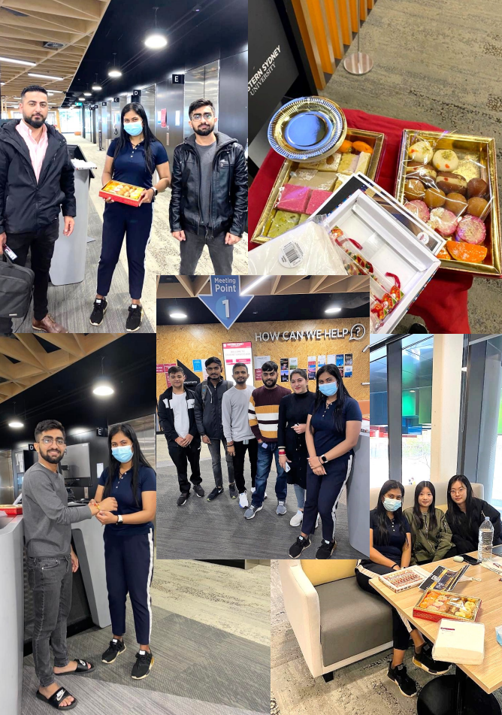

ENVIRONMENT REPRESENTATIVE: VACANT

Not submitted

FIRST NATIONS REPRESENTATIVE: TIFFANY SHARPE
FIRST NATIONS REPRESENTATIVE: TIFFANY SHARPE
First Nations Representative – September SRC Report
I continue to be engaged with the student leaders and Indigenous cohort, along with adequately meeting the standards of criteria within the First Nations role and responsibilities stated in the portfolio. Also, I want to mention the increasingly expansion of engagement and promoting more about what is the SRC and what we do for the student? I am increasing my opportunities by collaborative initiative projects with Equity Representatives and Western SRC Student Leaders overall.
Meetings:
· 12th August 2022: Academic Senate Meeting
· 12th August 2022: August SRC Meeting
· 17th August 2022: Zoom Meeting to discussion for Collective use of Building H at Kingswood Campus à In attendance were Richard Martino (Student Community) and Daniel Jantos (Inclusive Communities)
· 30th August 2022: Academic Senate à Meeting with the Chair and Student Representatives
· 1st September 2022: Vote of Formal Notice Meeting
· 2nd September 2022: STEM Cluster Board Meeting
· 6th September 2022: APCAC Meeting
Events:
· Badanami Morning Tea – Indigenous Literacy Day
· Indigenous Professoriate Lecture – Professor Susan Page
Additional Initiatives:
· C-Stall Campbelltown Campus
On Thursday 18th of August, Campbelltown Campus held there first C-Stall that I helped Dash (Campbelltown Campus Representative). I gone Student Events to picked up the tablecloth from Emily Liddell in the morning, then went to class. Once my classes were finished in the morning, I had gone to the SRC Office to have the C-Stall setup and assembled to attract the attention of the students on Campbelltown Campus.
Student representatives that assisted on the day of the Campbelltown C-Stall with engaging with the students and promoting what SRC does for the students at Western Sydney University. The following representatives that had dedicated their time to take initiative of the project that is happening across the campuses, and destinated at Campbelltown Campus:
Dash – Campbelltown Campus Representative
Rob – Disability Representative
Tiffany – First Nations Representative

INTERNATIONAL STUDENTS REPRESENTATIVE: ANKANKSHA ANKANKSHA
SRC REPORT AUGUST
As the International Representative, I feel like I have completed the responsibilities assigned to me under this role. Following are the activities I engaged in to fulfill my responsibilities:
1. Hosted community dinners along with Inclusive Communities at the parramatta city and south campuses.
2. Reached out to international students to make sure they aren’t facing issues and tried to resolve if they were.
3. Talked with the events officer regarding an event I’m planning to host at the end of the semester.
4. Engaging with various other clubs and collectives for the Diversity Fest for a collaborative event.
5. In talks with allocating the space at Building H to the collectives.
6. Talked with the previous international collective officers to better understand what path they were on so that the next members can build up on it.

RESIDENTIAL STUDENTS REPRESENTATIVE: JORDAN BRETT
Members Report September
05/08/2022 – Meeting with Residential Student
09/08/2022 – Meeting with External Stakeholders
11/08/2022 – Meeting with Residential Students
12/08/2022 – General Meeting
15/08/2022 – Engagement with Representatives
16/08/2022 – Meeting with Representatives
18/08/2022 – Meeting with the Online Student’s Representative
22/08/2022 – Forum with Representatives
24/08/2022 – Correspondence with Manager of Student Community
25/08/2022 – Correspondence with the Online Student’s Representative
29/08/2022 – Consultation with SRC President
01/08/2022 – Special Meeting
Personal Report to the Residential Student Body
Residential Students are becoming tired of complacency within the Student Representative Council and know that only a united council with effective representation can provide the support needed to protect the interests of residential students. Students know the Student Representative Council has not worked in the interests of the wider student body, and I have been working with the President to establish the first steps towards moving the council to a better future.
I am proud to inform students that under my advocacy and engagement, the council has passed the “Establishment of a Residential Student Collective,” to much debate from members who appear to be at odds with providing grassroots advocacy for residential students. This has been a long-term project of mine, and I am so glad that I have been able to contribute to lasting change for residential student lives.
I am honoured that I was able to second a motion to move the “Establishment of a Western SRC Students Assistance Program” in collaboration with the President and the Kingswood Representative. This motion marks the first step towards independent advocacy services, student owned facilities, and equitable educational outcomes for all.
Under my advocacy, residential students know they are getting the best deal possible. Western students know how tough things are, and I’m getting on with the job to support my peers. Whether it’s housing, welfare, education, or social commitments, I am committed to fighting for an SRC that will unite students together.
Should you have any question on anything discussed, or if you would like to reach out, please contact me.
Warm regards,
Jordan, Residential Student’s Representative

WOMEN’S REPRESENTATIVE: VACANT

Not submitted

QUEER REPRESENTATIVE: JACOB MEIN (EMILEE)
Queer Collective September Report
Queer Collective has been getting busier this past month, with members still joining. We have done a little less than we would have wanted in terms of events, but we have been making plans for a lot of coming events from now until the end of the year
We have had a couple meetings regarding diversity fest in week 10. Our current plan is to have our stall which will feature making custom badges for anyone who is interested, this is especially queer based because it is a good way to get pronoun pins to all our members without needing to bulk order and have no variation in design.
We have also started talks with the disability collective regarding doing an event for World Aids Day in December, not too much has been planned yet, but details have been discussed regarding what the event should be, such as a movie night, which movie is best suited, how it relates to AIDs day, etc. More will come of this when December approaches.
Within queer collective, we have been planning more events, the next one we plan to have is an open mic night, where people in the queer space will be able to express themselves freely in poetry, stories, even jokes, essentially any medium they want to do on a stage. We have decided where we want to do it, we just need to work out the last specifics such as catering and other costs before we get it approved.
Queer Collective’s second zine has come out, which included drawings and poems from various members in queer collective, it has been a success, and we plan on doing an in-person drawing event for the next zine at some point in the near future.
Lastly, Queer Collective had a meeting with Inclusive Communities, we talked about how to start to minimise hostilities between queer collective and chaplaincy, the idea has been pitched to have some form of document guaranteeing respectful behaviour toward each other, so as to hold accountability on both sides if any form of hostility breaks out, this will hopefully get done before September ends, depending on how long it takes to draft, finalise, etc the document.

WELFARE AND WELLBEING REPRESENTATIVE: VICKY-RAE REED
WELFARE AND WELLBEING REPRESENTATIVE: VICKY-RAE REED

I FEEL THAT I HAVE ADEQUATELY UNDERTAKEN THE ROLES AND RESPONSIBILITIES OF MY ROLE FOR THE AUGUST-SEPTEMBER PERIOD OF 2022 BY ENGAGING WITH THE FOLLOWING:
- Escalation of student complaint re: cleanliness of accessible bathrooms on Kingswood Campus to John Poulos, Facilities – August 12th
- Promotion of Wear It Purple Panel – August 12th
- Consultation on SRC Agenda Changes – August 15th
- Consultation with The Academy in regards to support to attend the LGBTQIA Leadership Summit – August 15th
- Collation of Little Free Pantries Report for consideration at Liverpool Provost by Liverpool Representative Romonda Eid – August 15th
- Submission of an article to Vice President Undergraduate Bakar Mohamad for publishing in W’Sup – August 15th
- Email correspondence with Campus Living Villages Operations Manager Todd Tang to retrieve demographics data for equity collectives - August 15th
- Email response to Amy Phelan re: additional support for students struggling to access quality food – August 16th
- Response to Amy Phelan regarding the creation of a pamphlet re: Little Free Pantries, Welfare and Wellbeing as well as the collectives – August 16th
- Conversations with NUS Disabilities, Georgie McDaid re: Spoons Rooms at WSU – August 16th
- Zoom Meeting to discuss Collective Use of Building H – August 17th
- Disability Collective and Welfare & Wellbeing Catch-Up – August 17th
- Meeting with Kerry Fielding, Counselling Services- August 17th
- Advocacy meeting with Terri Mears, Disability Services – August 18th
- Meeting with Emma Taylor, Mental Health and Wellbeing – August 18th
- Invitation from Penrith City Council to attend their DIAP launch and 30-Year Celebration of the Access Committee – August 18th
- Forwarding of meeting details for Bankstown Provost Meeting to Bankstown Representative Jasmine Ricciarelli – August 18th
- Meeting with Disability Collective re: Guest Speaker event for October – August 18th
- Negotiation of Mandatory Training with Richard Martino, Manager of Student Community- August 19th
- Student Representation Disciplinary Panel – August 22nd
- Email correspondence to Equity & Diversity about the potential of separating the Equity Collectives from SRC to fall under Equity and Diversity as well as Inclusive Communities – August 22nd
- Conversations with NUS President Georgie Beatty re: advocacy at WSU for students -August 22nd
- Circulation of data from the Shuttle Bus Survey – August 23rd
- Promotion of Wear It Purple Prom – August 23rd
- Distribution of C-Stall Merch to Liverpool, Campbelltown and Bankstown Campuses-August 24th
- Bankstown Campus Provost Meeting – August 23rd
- Disability Collective, Equity and Diversity and Wellbeing Monthly Meeting – August 23rd
- The Leadership Institute LGBTQIA+ Leadership Summit – August 24th & 25th
- Email Correspondence with Student Events, Nick Dionisopoulos re: Remembrance Day Commemorations and wreath making workshop – August 25th
- Meeting with Taurai Moyo, Student Clubs re: Wreath Making Workshop & Remembrance Day Commemorations & C-19 requirements – August 25th
- We’re Here, and We’re Queer in the Workplace – Wear It Purple Panel with Queer Collective & Rainbow Western – August 26th
- Bankstown CBD Campus Communications and Change Meeting – August 31st
- Correspondence with Bankstown Representative Jasmine Ricciarelli re: cleaning and restocking of Bankstown Storeroom – August 31st
- Tidying of Bankstown Storeroom – September 1st
- Responding to Disclosures Training – September 1st
- Vote of Formal Notice Meeting – September 1st
UPCOMING:
- NSW Council for Pacific Communities Meeting – September 5th
- Assistive Technologies Catch Up – September 7th
- SRC General Meeting – September 9th

