STUDENT REPRESENTATIVE COUNCIL
2021 Meeting 2 - February
Thursday February 25th – 4:00-6:00pm
Meeting ID: 878 8817 9905

Agenda
- Procedural Matters

  - Welcome, Introduction, and Apologies
  - Acknowledgement of Traditional Custodians of the Land
  - Declarations of Interest
  - Starring of Items
  - Order of Business
  - Confirmation of Previous Minutes
  - Confirmation of Member Reports
  - Action Sheet from Previous Meeting

- General Business of the Council

  - Report from the Chair
  - Report from Student Representation & Participation
  - Report from Collectives
  - Report on SRC Budget
  - Reports and Recommendations from SRC Committees
    - SRC Clubs & Activities Committee
- New Business of the Council

  - Special Agenda Item: Mental Health and Peer App
  - Special Agenda Item: Student Community
  - Women’s Collective Get Together
  - Inclusion Calendar
  - Ticket Groups at SRC Elections
  - Welfare Officer
  - Moratorium on UberEats
  - Attack on Worker’s Rights
  - Respectful Relationships Taskforce Module
  - SRC Mixed Competition
  - SRC WesternLife Badges
  - Limited Funding for Student Clubs
  - Budget Approval for 2020 Diversity Fest
  - Q&A Session for International Students

- Procedural Matters

1.1. Welcome, Introduction, and Apologies
The Chair officially opens the meeting, acknowledging Country, and welcomed members and guests. The following members have provided their apologies for this meeting; Danielle Wolf, Razin Polara, Rosina Armstrong-Mensah, Nikodin Matic, Adeem Jiwani

1.2. Acknowledgement of Traditional Custodians of the Land
The cultural protocol of the acknowledgment of the traditional custodians of the land on which this meeting is held on.

1.3. Declarations of Interest
The Chair invites the committee to declare any new conflict of interests in relation to any matters on the agenda or their role on the committee more generally.

1.4. Starring of Items
The Starring of items is to take place for agenda items requiring additional discussion.

1.5. Order of Business
Discussion whether a change to the order of business is required.

1.6. Confirmation of Previous Minutes
January minutes to be reviewed and confirmed as a true and accurate record of the meeting.

1.7. Confirmation of Member Reports
February member reports submitted and disseminated with meeting paperwork to be confirmed as a true and accurate record of activities.

1.8. Action Sheet from Previous Meeting
See ‘Additional Documents’ for list of action items from the January meeting.

- General Business of the Council

  - Report from the Chair
SRC President to provide her report at each monthly meeting of the SRC.

  - Report from Student Representation & Participation
Staff report and update provided by SR&P at each monthly meeting of the SRC.

  - Report from Collectives
Report from the Collectives to be provided at each monthly meeting of the SRC.

  - Report on SRC Budget
Report on SRC Budget to be provided by the General Secretary at each monthly meeting of the SRC.

  - Reports from SRC Committees
    - SRC Clubs & Activities Committee
Report and recommendations from Vice President Activities following the SRC Clubs & Activities Committee meeting.

- New Business of the Council

3.1. Special Agenda Item: Mental health and Peer app

Issue | Mental health and Peer app
Date | 2/12/2020
Mover | Mary-Pearl Chung
Seconder

Description:
Ellen Brackenreg, the Executive Director of Equity Diversity Safety and Wellbeing at Western Sydney University to speak about the Peer app project and call out for Ambassadors.

Portfolios/Students Impacted:
Student Representative council, WSU students

3.2. Special Agenda Item from Student Community

Issue | Special Agenda Item from Student Community
Date | 16/2/21
Mover | Mary-Pearl Chung
Seconder

Issue Description:
Grant and Richard to discuss ongoing strategies to proactively encourage reps to fulfil requirements of their roles.

Portfolios/Students Impacted:
Student Representative Council

3.3. Women’s Collective Get Together

Issue | Event catering and Prize
Date | 11/02/2021
Mover | Rosina Armstrong-M
Seconder

Issue Description:
The women collective looks forward to having pizza time at the Campbelltown campus. The day will be women’s collective centered day at Campbelltown campus but open to everyone. Students are encouraged to engage in the event to win some prizes on the day. First three students willing to assist in preparation will earn a $20 voucher. Other students on the day are to locate the treasure prize (book or something else) and keep it.

Portfolios/Students Impacted:
All students but prizes are for women.

Recommendation:
For the SRC to approve an amount of $450 towards women’s collective gathering.

Justification/Reason for Recommendation:
This is to start a connection with students to engage.

Budget Impact:
Items | Quotes/Cost
Voucher | $ 60
Treasure prize | $ 150
Catering | $ 240

Proposed Action:
I propose that the SRC allocate $450 towards the women’s collective event on the 14th April 2021.

3.4. Inclusion Calendar
Issue | Inclusion Calendar for implementation by SRC on Social Media and WesternLife
Date | 15th February 2021
Mover | Vicky-Rae Renier-Clark
Seconder

Issue Description: The purpose of this calendar is to celebrate and raise awareness and understanding of significant events for people who may identify with different diversity groups.
Developing an effective Diversity and Inclusion culture is an important part of being a world leading university. Diversity adds value to our problem solving, decision making and creativity. Inclusion fosters collaboration, trust and respect and supports psychosocial safety and wellbeing.
I believe that the implementation of an inclusion calendar would assist both SRC and Equity Representatives to more effectively represent their associated cohorts within the University community and engage them through our social media as well as workshops, webinars and events in alignment with these days of observance.
Please note: I have attempted to ensure dates and information are accurate and that most major events are included, however mistakes or omissions may occur.

Portfolios/Students Impacted: All Portfolios and cohorts

Recommendation: I recommend that the SRC in collaboration with the Equity Collectives and Chaplaincy create an inclusion calendar to encompass the many days of observance of our University community to foster better engagement, planning and inclusion.

Justification/Reason for Recommendation: There seems to be a tangible disconnect between the SRC and the University community in way of inclusion and observance of important dates for our students beyond that of the academic key dates. I believe such a calendar would assist us to foster a community of care through our planning going forward.

Budget Impact:
nil

Proposed Action: The SRC in collaboration with the Equity Collectives and Chaplaincy create an inclusion calendar to encompass the many days of observance of our University community to foster better engagement, planning and inclusion. Additionally assisting both SRC and Equity Representatives to more effectively represent their associated cohorts within the University community and engage them through our social media as well as workshops, webinars and events in alignment with these days of observance.

3.5. Ticket Groups at SRC Elections

Issue | SRC Elections
Date | 16/2/21
Mover | Rameez Parkar
Seconder | Crystal Ram

Issue Description:
The Student Representation Guidelines allow for the candidates in an SRC Election to identify and run as a ticket group on a ballot. At the last election there were technical issues that resulted in tickets not being identified on ballots.

Recommendation:
That the SRC call for every step to be taken to allow for tickets to run and for a smooth running of upcoming SRC Elections.

Justification/Reason for Recommendation:
The best representation for students will come from completive elections with high participation. Allowing tickets and not only results in better compliance with the Guidelines it is also likely to engage more students.

3.6. Welfare Officer

Issue | Introduction of an Interim Welfare Officer
Date | 16/2/21
Mover | Rameez Parkar
Seconder | Crystal Ram

Issue Description:
In the current Procedures review process the introduction of a new Welfare Officer position has been agreed to. However the review is unlikely to get finalized before the election.

Portfolios/Students Impacted:
SRC-WIDE

Recommendation:
The creation of an interim Welfare Officer that the SRC will fund till the approval of the Procedures Review.

Justification/Reason for Recommendation:
A welfare officer position is urgently needed especially in such tumultuous times. The sooner this happens the better.

Budget Impact:
Items | Quotes/Cost
Honorarium | $5000

3.7. Moratorium on UberEats

Issue | Terrible conditions faced by UberEats Drivers
Date
Mover | Rameez Parkar
Seconder | Crystal Ram

Issue Description:
In addition to being poorly paid UberEATS drivers also face terrible conditions. Late last year a student at WSU who worked as an UberEATS drivers unfortunately died in an accident.

Recommendation:
That the SRC stop any funding being used for UberEATS whether at events, through vouchers or any other means.

Justification/Reason for Recommendation:
The SRC has previously given away UberEATS vouchers in giveaways. It is not appropriate for the Western SRC to be supporting a business that has directly exploited the students we represent.

Budget Impact: None

3.8. Attack on Workers Rights

Issue | SRC Elections
Date | 16/2/21
Mover | Rameez Parkar
Seconder | Crystal Ram

Issue Description:
The Federal Government has launched an attack on worker rights in its latest Industrial Relations Omnibus Bill. It represents the strongest attack on workers’ rights since Work Choices.

Portfolios/Students Impacted: All

Recommendation:
- Call on the Federal Government to entirely drop the bill in its entirety.
- Work with Unions NSW on a campaign to inform students about their rights and forms of redress in cases they are not receiving their entitlements.
- Issue a resource informing students about resources available on campus that may help them with issue they may have.

3.9. Respectful Relationships Taskforce Module

Issue | SRC Elections
Date | 16/2/21
Mover | Rameez Parkar
Seconder | Griffen Burgess

Issue Description:
The Respectful Relationships Taskforce has created a module that we can potentially use

Portfolios/Students Impacted:

Recommendation: Work with staff to see in what ways we can implement the module and resources from the Taskforce.

Justification/Reason for Recommendation:
To ensure the safest possible experience for all students.

Budget Impact: None

3.10. SRC Mixed Competition

Issue | An inclusive and accessible mixed tournament for Western Students
Date | 12/02/2021
Mover | Simon Preuss-Kearney
Seconder

Issue Description:
The SRC PFA (Pride Football Australia) tournament team received a decent amount of interest from the Facebook page and it suggested to me that there is potential to utilise this interest in the student body. Therefore, I believe we should explore the possibility of the SRC hosting our own mixed soccer tournament. We could call it the SRC cup and enter our own team to beat, or simply run it and think of creative prizes (A trophy of our mascot, or the SRC image, or something funnier?).

Portfolios/Students Impacted:
Any student who wishes to attend. A location campus is to be discussed.

Recommendation:
The SRC to discuss the plausibility of such an event, and their personal interest in it (be it in organising, participating, or not interested at all, etc). Additionally, the SRC to organise this event alongside the guidance of Western Sport.

Justification/Reason for Recommendation:
Interest has been expressed that student were interested in similar tournaments to the PFA day team we organised. This includes students who expressed that they could not attend on the day, female players who were not able to join due to it not being mixed, and those who couldn’t travel as far as Redfern. A tournament we put on alongside the guidance of Western Sport would cater to all of those interested.

Budget Impact: To be considered
Items | Quotes/Cost
Prize for winning team | Cost and Item unknown (a trophy is an option)

Proposed Action:
I propose the SRC votes on creating a tournament of our own, and individuals will commit to putting it together alongside Western Sport (with the assumption simon will take responsibility for the overall organisational duties).
3.11 SRC WesternLife Badges

Issue | Encouraging engagement on our SRC WesternLife page
Date | 15/02/2021
Mover | Simon Preuss-Kearney
Seconder

Issue Description:
To encourage more engagement in our WesternLife SRC page, I suggest the formation of a few badges that we could create for student members to obtain. It might not directly result in much, but it is nice to recognise active members of our SRC community, and this would be at least a small acknowledgement of that.

Portfolios/Students Impacted:
Any SRC WesternLife Student Users.

Recommendation:
A few of the SRC representative come up with some badges for the page. Then we can mention them to the group and if there are no objections, they will be added to the WesternLife page.

Justification/Reason for Recommendation:
I believe that offering this to students creates a sense of achievement to the active members of our page and community. Also creates some additional interest in getting involve with the knowledge that involvement will be recognised. It also offers us opportunities to later make awards or prizes based on these badges to recognise involvement, and furthers the SRC tools to foster engagement (if the SRC does so choose).

Budget Impact:
None

Proposed Action:
I propose that any interested SRC representative create badges for our Westerlife Page (with the approval of a majority of SRC Representatives).

3.12. SRC Student Club Grants

Issue | Limited funding for Student Clubs
Date | 16/02/2020
Mover | Nikodin Matic – Vice President Activities
Seconder

Portfolios Impacted:
- All
Issue:
- Clubs are limited in regards to what events and activities they can host with the allocated $3,000 funding per year. A couple hundred extra dollars could go a long way to help Student Clubs host the events that are currently not an option.
Recommendation:
- Set up a pool of funding that Student Clubs can apply for.
Reasons for Recommendation:
- To allow Student Clubs to host bigger and better events that is currently just out of their reach with the limited $3000 Student Club allocation.
- This initiative was very supported at the latest SRC Clubs and Activities Committee held on the 9/2/2021.

Budget Impact:

SRC Student Club Grants Budget | $5000

Proposed Action
I move that the Western Sydney University SRC allocates $5000 towards the establishment of the SRC Student Club Grants Scheme for the year 2021 which will be overseen by the SRC Student Club Grants Committee chaired by the SRC VPA and two other SRC members.

Criteria for assessing applications is below.

Criteria | Points Available | Points Awarded
How crucial are the funds for the student club to survive and continue to run?  - Does the club need this funding to begin or continue operations or will it cease to exist if funding is not approved? /20 points  Total points for this category | 20  20 | /20  /20
How active the student club is throughout the year?  - Has the club attended the SRC Clubs & Activities Committee?  - Has the club attended the C-3 congress?  - Has the club attended Western Fair?  Total points for this category | 7  3  5  15 | /7  /3  /5  /15
Has the student club approached any other sources of funding both internally and externally of WSU.  - Has the student club approached the Provost Committee?  - Has the student club approached external parties?  Total points for this category | 7  3  10 | /7  /3  /10
The cost per student for the activity/event.  - What is the cost per student per use breakdown for the extra funding?  Total points for this category | 30  30 | /30  /30
The current breakdown and allocation of their budget.  - How has the student club utilised or allocated their money in the last year?  Total points for this category | 10  10 | /10  /10
How successful has the student club previously been along with their events.  - Has the club won any awards?  - Quality and quantity of events hosted by the club during the year.  - Attendance of students per event  Total points for this category | 5  10  10  25 | /5  /10  /10  /25
The size of their membership base.  What is the size of their membership on Western Life?  Total points for this category | 15  15 | /15  /15
Other Criteria | 25 | /25
Total Points | 150 | /150

3.13. VPA Portfolio

Issue | Funding within the portfolio of Vice President - Activities
Date | 16/02/2020
Mover | Nikodin Matic – Vice President Activities
Seconder

Portfolios Impacted:
- VPA
Issue:
- In order to allow me to undertake my responsibilities effectively and to not clog up SRC meeting time to put a motion for multiple budget requests for various events and activities each meeting.
Recommendation:
- VPA be allocated a sum of money to allow Nikodin to fulfill my obligations and responsibilities as the Vice President - Activities.
Reasons for Recommendation:
- To not clog up SRC meeting time with each individual budget request for various events and activities.
- To allow me to undertake my role effectively and plan events in advanced.
- Survey by students highlights that SRC events are the second most important thing the SRC should focus on in 2020-21.
- I will implement a forward-thinking long-term investment like approach to ensure a low cost per use per student. This will allow the SRC to maximise value and many of the purchases and ideas will be able to be reused.
- My club won Best Event in 2019 amongst 3 other awards, so I believe that goes towards my credibility in running events that the students enjoy and maximizing a limited budget.
- Furthermore, the SRC has underspent their allocated budget in recent history. So by using the budget in a positive manner that will improve student engagement and events at the University can only be a positive.

Budget Impact:

VPA Portfolio | $15,000

Proposed Action
I move that the Western Sydney University SRC allocates a sum of $15,000 out of the SRC budget to the portfolio of the VPA for events, activities and infrastructure projects. I do this conditionally that the events, activities and infrastructure projects will be distributed amongst the WSU campuses to reach as many students as possible. Furthermore, oversight would be provided by the budget committee chaired by the General Secretary and overseen overall by Grant as the Student Representative Officer for full transparency and oversight.

3.14. Q&A Session for International Students

Issue | Q&A Session for International Students
Date | 19/02/2021
Mover | Manika Sahni – International Student Representative
Seconder | Adeem Jiwani

Portfolios Impacted:
International Students

Issue:
Visa and Employment challenges being faced by International Students.

Recommendation:
Invite a speaker who would be able to address the above-mentioned challenges being faced by International Students. The webinar is aimed to be conducted as a Q&A session with a panel of 5 international students who would be invited to ask questions to the speaker.

The aim is to help students with the information they need and encourage two-way communication.

Budget Impact:
Speaker Fee | = $2500
Gift card to panellists | = $500 ($100 * 5)

Proposed Action
I move that the Western Sydney University SRC funds $3,000 for an online webinar aimed at helping international students finding answers to visa and employment challenges being faced by them during their student journey.

3.15. Budget Approval

Issue | Budget Approval for 2020 Diversity Fest
Date | 19/02/2020
Mover | Manika Sahni – International Student Rep
Seconder

Portfolios Impacted:
All Students

Issue:
The budget request is for the money spent by the international rep on promotional video for diversity fest and Facebook promotion of Employability Webinar held in October 2020. The allocation was approved last year but was not submitted as a budget request in Western Life. As per procedural requirements, the committee needs to approve the budget request again as this request is from previous calendar year.

Recommendation:
To approve $153 for the money spent by international rep on Promotional Video and Facebook Promotion.

Budget Impact:
=$153
1. Diversity fest promotional video: $125.58
2. Facebook promotion for employability webinar: $27.50

Proposed Action
I move that the Western Sydney University SRC approves $153 for the money spent by international rep on Diversity Fest Promotional Video and Facebook Promotion of Employability Webinar.

Additional Documents (see next page)
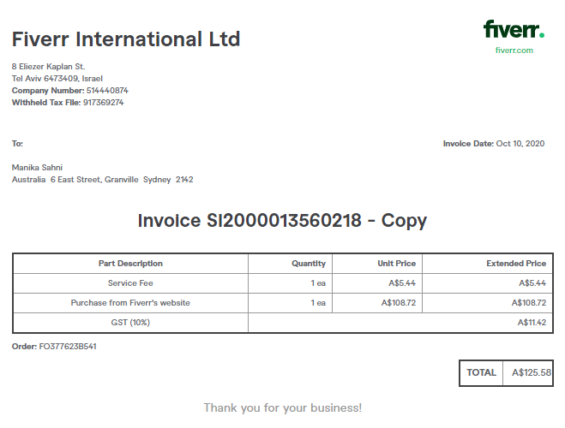
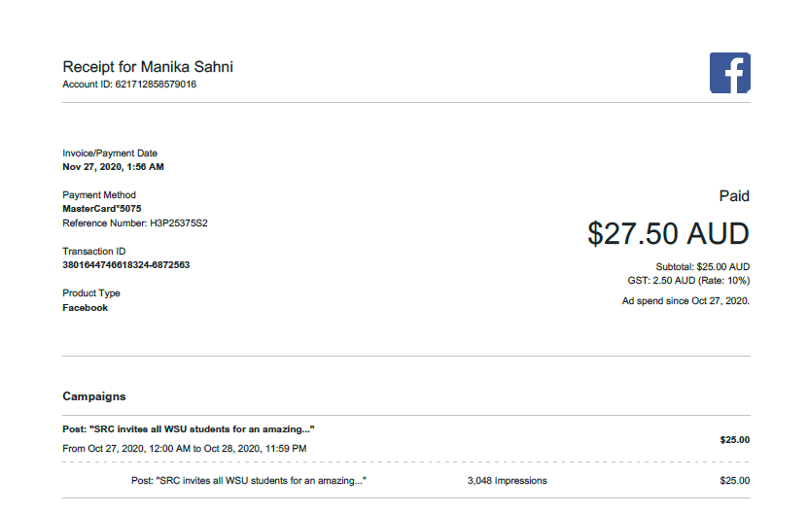

- Other Business

- Next Meeting and Close

- Additional Documents

6.1 January Action Sheet

Student Representative Council Action Sheet
Action | Responsibility | Completion
SRC publish drop it times (Simon) | Simon
Campus reps attend office and provide list of inventories | All reps
Publish final copy of SRC Social Media Policy on website (Pearl) | Pearl | Completed
Discuss proposed procedural changes for minimum SRC Representative requirements and to see if they can be added into the current procedures amendment process still underway | Nikodin/SR&P
Manika to organise separate informal meeting regarding motion for International Student Advice Clinics. Adeem and Manika to compose feasibility report. | Manika/Adeem
Simon to lead formation of Mardi Gras soccer team. | Simon
Organise purchase of chess board | Simon
Chase up DAP approval for student observer Gavin | Tyler | Completed
Tyler to reach out to reps interested in SRC Budget Committee and liaise with Grant about next steps | Tyler | Completed

