Student Representative Council
Student Representative member’s reports – January
The following reports are to be provided by all SRC members

Members who failed to provide reports

Bojanic, Matthew – President
Kathik, Anirudh - Parramatta City Campus Representative
Miller, Shayne – First Nations Representative
Yigiter, Erdem - Queer Representative
Chheda, Rohan - International Student Representative
Wolf, Danielle - Environment Collective Representative
Jha, Vageesh - Residential Students Representative
Cupitt, Sarah - Online Students Representative

Bonatti, Daniel - Vice President Education (Postgraduate)
I write a report greater than 200 words as I am in the Executive of the SRC. I am the Vice President Education (Postgraduate), & NUS delegate elect, plus CAPA delegate and Budget and Remuneration, Communication, SSAF Committee member. I am in the Faculty Engineering, Mathematics and Computing doing Graduate Diploma in Building Surveying. I am following my role as described in Student Representation Procedures Clause 14 & 15. I easily achieved the required 42 mandatory hours.

- Conference WEC, 19 to 23rd November, 9 to 5pm, Melbourne Exhibition Centre. Engineers Australia and the World Federation of Engineering Organizations, following my November Report, of relevance to WSU, I met Dr Ee Loon Tan mentoring a Western Sydney Student representing WSU EWB chapter Engineers Australia, 2019 EWB Challenge Showcase at WEC.with a project to do with a skin over an oil barrel to make it safe to store water. The Challenge provides students with the opportunity to learn about design, teamwork and communication through real, inspiring, sustainable cross-cultural development projects. First year University students from across Australia and New Zealand, demonstrated and displayed their innovative, community-centred design ideas developed in response to the 2019 Challenge; WaterAid Timor-Leste. The Challenge, focus on communities in Timor-Leste, offering a variety of project themes including water supply, sanitation, climate resilience, digital technologies and more. Top student design ideas, including those presented at WEC, are shared back with WaterAid and other relevant partners to support their work. The 2019 EWB Challenge is delivered in partnership with WaterAid. WaterAid enables the world’s poorest people to gain access to clean water, decent toilets and good hygiene.
- USyd, 27th November 2019, Email, Invitation Mr McKevitt– CIV2019/13 prediction of cracking propagation and failure in concrete structures.
- USyd, 28th November 2019, Email, Acceptance Daniel Bonatti to Mr McKevitt–
- USyd, 29th November 2019, Email,Administration – Mr McKevitt– Affiliation Letter Western Sydney University Student for THE University of Sydney
- Conference, EWB, 30 November, NSW Regional Conference at the University of Technology Sydney, I had to decline this invitation as my airplane was late from Melbourne due to the smoke.
- USyd, Monday, 2nd December 2019, 9am to 2pm, total 5 hours, Summer Research Program Project CIV2019/13, Inter-university Prediction of cracking propagation and failure in concrete structures, Face to Face at The University of Sydney, Start date – Mr McKevitt set up meeting 11am with Associate Professor Daniel Dias Da Costa I negotiated 10 week with an extension until end of March due to unforeseen interruptions. This was confirmed with Mr McKevitt. Manger Dr Fernando signed enrollment form.
- USyd, Tuesday 3rd December 2019, Civil Engineering Conference Room 438. Not attend went to Melbourne CAPA Conference.
- Conference, CAPA, 3 to 6 December, Council of Australian Postgraduate Associations (CAPA) Annual National Conference 2019 (for postgraduate students) Melbourne Victoria - Victoria University City Flinders Campus. Following my November report WSU sent three delegates Vageesh Jha, Anurska Kapoor, and me.

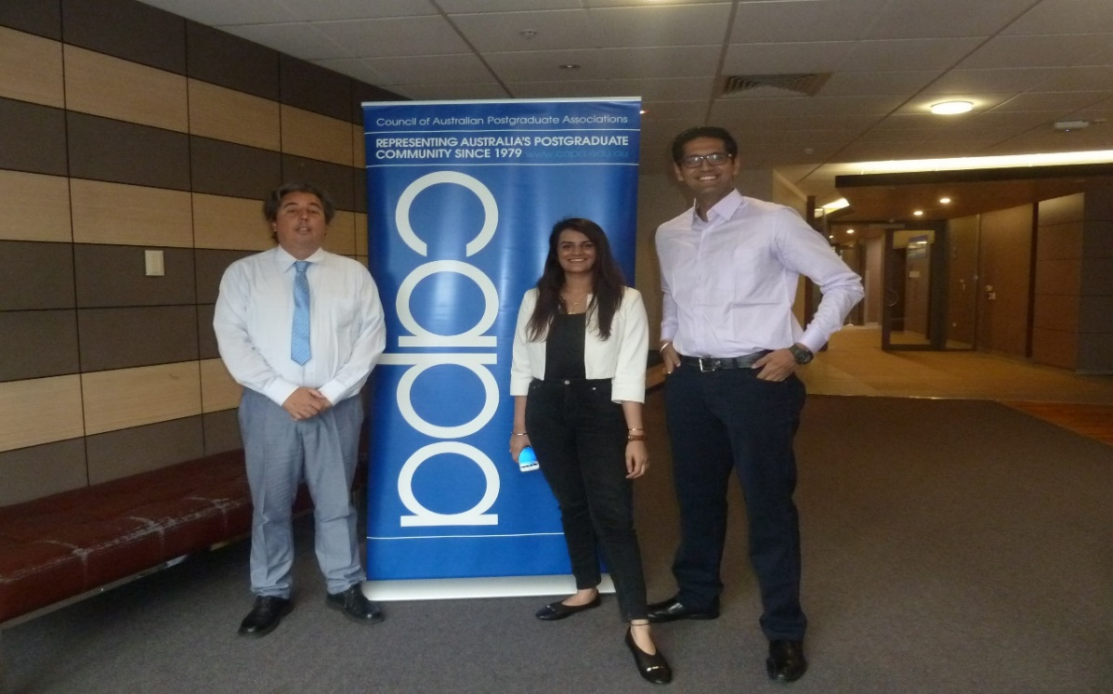
WSU had two achievements, most importantly WSU got a position on Council of Australian Postgraduate Associations at Melbourne AGM and conference, our delegate postgraduate WSU student Anurska Kapoor was elected the Communication & Media Officer for CAPA. Next achievement was becoming the lead University in NSW for the international student concession campaign.
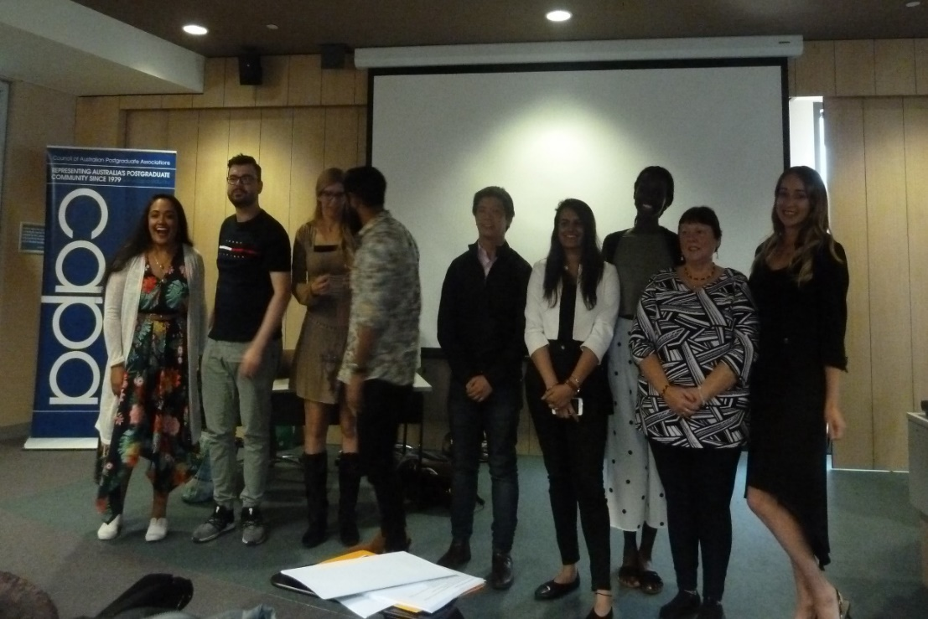
- SRC Special Meeting, 5 December, 2-3pm, total 1hour, the meeting was to get the version of events, to do with SRC misuse of communication.
- SRC Meeting, 5 December, 3 to 3.31pm, total 30 minutes. The official scheduled SRC Meeting for 3pm lapsed at 3,31 pm, as there are 20, SRC members it was necessary to have 11 members present for quorum. The reason to wait was for a member for which was present earlier was to return at about 3.30pm. Time lapsed for which we can wait at 3.31pm.
- SRC Special Meeting, 5 December, 3.31 to 4.45pm, total 75 minutes, had quorum. Went through normal business. Special meeting called under Clause 51, with next ordinary meeting 12 in January. Clause 51 Inquorate Meetings the special meeting was for the transaction of that business. The special meeting was called straight after ordinary meeting lapsed. We covered acknowledgement, minutes and Communication Strategy and Ethics SR & P Report, General Business. In General Business- included Meeting Practice, Western Gyms, Equity, Events, Delegates, MUPSA, SR & P.
- Conference, NUS, NATCON, 9th-13th December 2019, Federation University Ballarat (University Dr, Mount Helen VIC 3350) following the November report, WSU had four delegates, these were Sarah, Frederick, Vageesh, and myself. We achieved five significant achievements, Frederick elected the WSU NUS National representative and getting four motions voted by the floor by Frederick, on Gender Neutral Toilets, Disability Access and Blood transfusion.
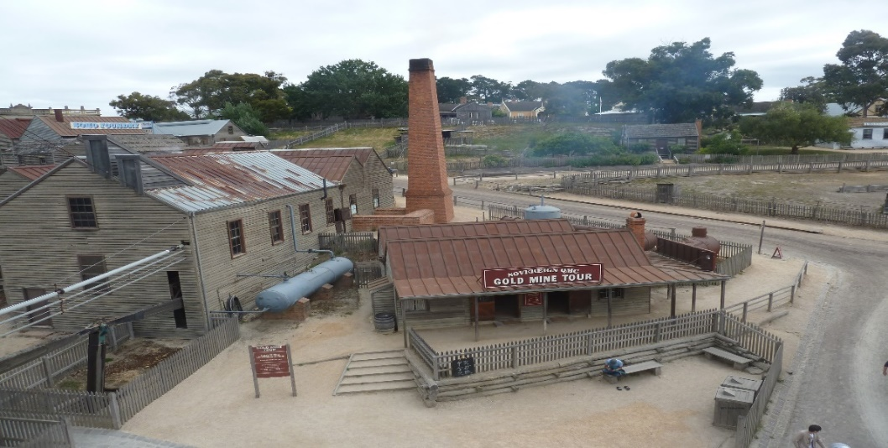
Sovereign Hill
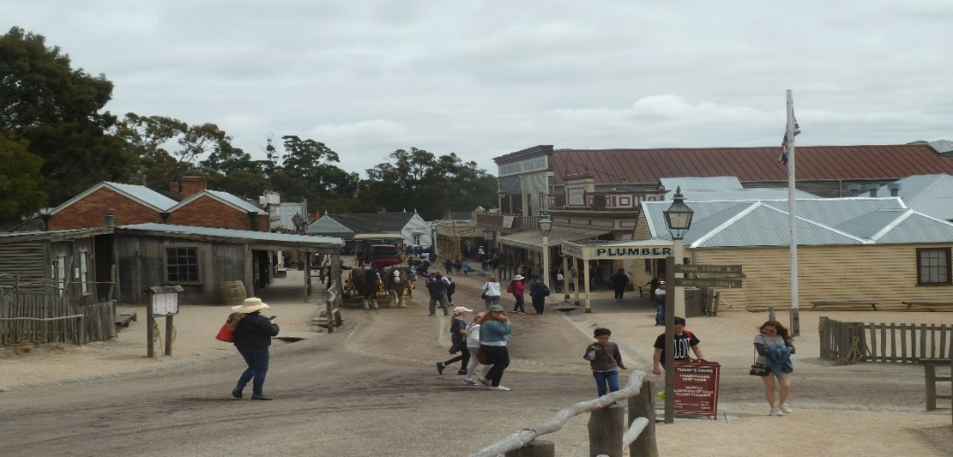
Sovereign Hill
- USyd Tuesday 17th December 11am to 12am,total 1 hour, Summer Research Program Project CIV2019/13, Inter-university Prediction of cracking propagation and failure in concrete structures, Face to Face meeting, planning & further Instructions Associate Professor Daniel Dias Da Costa, how to proceed focus AI want literature, want all headings. Add concrete software. Had matrix plan and some literature to review
- USyd Tuesday 17th December 2019, 12 to 2pm, total 2 hours, Face to Face at The University of Sydney, Administration – Student Affiliation Card, Unikey
- EWB WSU Chapter Meeting, 17th December, 3 to 6pm
- EWB Regional office, 3.30 to 4pm, visit to meet NSW Regional President Maria Tan
- CAPA Meeting, 6 -7pm, could not set up Skype link, Vageesh spoke to Rohan and Devendra, WSU and National International rep. I sent an email the meeting achieved Supra sent two stories to do with Travel.
- USyd, 4th December 2019 to Friday 21st December 2019, Summer Research Program Project CIV2019/13, Inter-university Prediction of cracking propagation and failure in concrete structures. Lecture Room 2 – Room 211, Commenced Research - Literature Review.
- SRC, Christmas
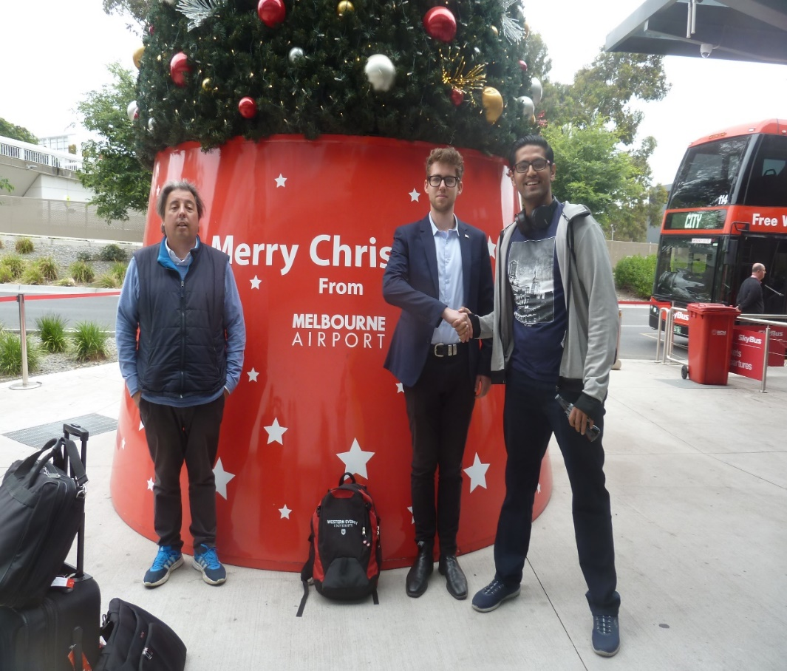
- EWB 27th December, Flight Centre Airplane Ticket to Cambodia booked and paid.
- EWB, 30th December, visit Doctor have medical questionnaire filled and signed uploaded to EWB.
- USyd, 1st January 2020, 10.45 to 4.23pm, total 6 hours, Summer Research Project, 10.45 to 2.15pm, Draft ideas and headings. Draft writing under headings of Question, SDGs, Motivation, Relevance/research, definitions of AI, review approach, Research Design and Methodology. Plus 5 reviews. 2.15 to 4.23pm Draft to type to word document.
- USyd, 2nd January 2020, 10am to 5pm, total 7 hours, 10am to 12.54pm, Draft ideas under headings, 12.54pm to 2pm Tentative timeline draft and write to word doc. 2pm to 4pm, Draft Design Methodology extra and conclusion to word doc. 4pm to 5pm Draft definition of defects.
- USyd, 3rd January 2020, 3pm to 10pm, total 7 hours, 3 to 5pm, Draft Abstract. 5 to 8pm, Drafts, 8.30pm to 8.45pm write Abstract to a word doc, 8.45pm to 10pm, Draft Introduction to word doc.
- USyd, 4th January 2020, References search to make references at end of report.
- SRC Minutes, 4th January 2020, 9am to 2pm, total 5 hours, Daniels version of the 5th December Special Meeting Minutes.
- SRC, 4th January 2020, Call to Frederick, about versions to use? Emails to executive and SR & P.
- USyd, 5th January 2020, 8am to 11.15am, total 3 hours, type references to report. 11.15am to 2.30pm continued References and added Keywords, SDGs Research Plan and Design details to headings to a word doc.
- USyd, 6th January 2020, 9am to 12, total 3 hours, Administration contact email and telephone, Sydney University for Summer Research Project.
- USyd, 7th January 2020, 9am to 9.30am, Administration contact email and telephone, Sydney University for Summer Research Project.
- USyd, 7th January, 2020, 12.27 to 2pm, total 1.5 hours, wrote draft to word doc, AO Matrix, Plan to report, extra Methodology and Recommendations.
- USyd, 7th January, 2020, 6pm, visit Office works to print AO, not possible.
- USyd, 7th January, 2020, 11.25pm, AO poster to power-point, make one page instead of 11, achieved.
- USyd, Tuesday 7th January 2020 – Friday 21st February 2020 Lecture Room 2 – Room 211, Research - Literature Review find more readings.
- USyd, 8th January 2020, 10am to 11.15am,total 1 hour, Administration contact email and telephone, Sydney University for Summer Research Project.
- SRC Training - Student Leadership – 4pm to 2am, Received Badges for Anti-Bullying, 07/01/2020 10:55 PM GRADED 100.00/100, Cultural Responsiveness 07/01/2020 8:52 PM GRADED 100.00/100, Equal Employment Opportunity 3, 08/01/2020 5:54 PM, GRADED 100.00 /100, Work Health and Safety Module 2: Risk Management 07/01/2020 7:33 PM GRADED 80.00/100, Work Health and Safety Module 3: Office Safety, 07/01/2020 7:43 PM GRADED 93.00/100, Work Health and Safety Module 4: Manual Tasks, 07/01/2020 7:56 PM, GRADED 100.00/100, Academic Integrity went through module did not have an assessment did not get a Badge must try again.
- SRC Training 8th January 2020, – Study Money and Life Skills, 4pm to 2am, Secrets to Success Quiz, Test 08/01/2020 6:32 PM, GRADED 70.00/80, Better Spending Habits Quiz, Test 08/01/2020 6:35 PM, GRADED 70.00/80, Perfectionism Quiz Test 08/01/2020 6:38 PM, GRADED 60.00/100, Public Speaking Quiz, Test 08/01/2020 6:40 PM GRADED 70.00/80, Procrastination Quiz Test 08/01/2020 6:43 PM, GRADED 70.00/80, Time Management Quiz Test 08/01/2020 6:52 PM, GRADED 70.00/80, Stress Management Quiz Test 08/01/2020 6:54 PM GRADED 70.00/80, Budgeting Skills Quiz Test 08/01/2020 6:29 PM GRADED 80.00 /80, Group Work Quiz Test 08/01/2020 7:09 PM GRADED 80.00/80, Managing Exam Stress Quiz Test 08/01/2020 6:57 PM, GRADED 60.00/80, Motivation Quiz Test 08/01/2020 7:00 PM GRADED 80.00/80 Maximizing Memory Quiz Test 08/01/2020 7:03 PM GRADED 70.00 /80, SMART Savings Goals Quiz Test 08/01/2020 6:48 PM GRADED, 80.00/80, Are you to tough on yourself? Test 08/01/2020 7:04 PM GRADED 12.00.
- Golden Key, 9th January, 6.30am to 8am, Golden Key International honor Society, webinar live, online, year of Acuity 2020 Guest speaker Rohan Jones, motivation.
- SRC Report, 9th January 2020, 8.30pm to 11.30pm, total 3 hours, write up to word and pdf doc December SRC Report, emailed to Frederick & SRC.
- USyd 10th January 2020, Email Contact Associate Professor for meeting, had matrix plan and some literature to review
- USyd, 10th January 2020, Submission ongoing Summer Research Project, to Professor check progress. Response email with instructions.
- FCC, Diploma in Project Management, 10th January 2020, Email with Congratulations for Diploma in Project Management 51415, and digital Certificate, from First Choice College private provider. 51415 is endorsed by Engineers Australia.
- JP Signatures, 11th January 2020, 12 to 5pm, total 5 hours, Charlestown Square to find NSW JP, to sign new Diploma Project Management 51415 Documents, to then scan at Officeworks and email WSU to get Advanced standing for Bachelor of Construction Management.
- Resume, 12th January 2020, 12.30 to 1pm, total 1 hour, Wrote up new Resume adding two Life memberships Worldwide Branding and Golden Key WSU chapter to existing two Golden key Deakin Chapter and USyd Union, and sent Resume to USyd administration and professor, for Summer Research Project.
- EWB, 13th January 2020, 8 to 9pm, total 1 hour, Facebook meeting with EWB students going to Cambodia Design Summit and Study Tour in February.
- USyd, 14th January 2020, 11 to 11.30 am, total 30 minutes, Email to Professor Summer research project.
- EWB, 14th January 2020, 3 to 4pm, total 1 hour, bought shoes for Cambodia Design Summit and Study Tour in February.
- WSU 14th January 2020, 4.30pm to 5pm, total 30 minutes, Advance Standing claim All Qualifications and Resume.
- SFS, 15th January 2020, 12 to 2pm, ARUP Sydney Offices, NSW Society of Fire Safety full committee meeting.
- CLM, 16th January 2020, 7.30am to 9am, total 1.5 hours, College Leadership & Management, Newcastle Division full committee meeting.
- USyd, 17th January 2020, 11.30 to 6pm, total 6.5 hours, 11.30 to 3.30pm, Draft Literature reviews three on AI and drafts to word doc. Rename Originality to authenticity and add structure heading. 3.30pm to 6pm, Draft fourth AI review and add to Structure heading details wrote to word doc.
- EWB, 17th January 2020, call to Frederick media for O week. Called Rohan no reply will email.
- SRC Report, 17th January, 7 to 9pm, total 2 hours SRC January Report.
- USyd, Tuesday 7th January 2020 – Friday 21st February 2020 Lecture Room 2 – Room 211 Research - Literature Review find more readings.
- USyd, 23rd January 2020, Submission ongoing Summer Research Project, check progress.
- EWB, 23rd January 2020, TBA tentative date for WSU Chapter meeting to do with O Week.
- CAPA, TBA January 2020, TBA tentative date for WSU to organize CAPA meeting to do with International Student Concession.
- SRC Budget Committee Meeting, Friday, 31 January 2020 (14:00-15:00)
- SRC Meeting #1 - Friday, 31 January 2020 (15:00-17:00)
- EWB, Sunday 2nd February 2020 to Tuesday 18th February 2020, Cambodia – Design summit Study tour to Cambodia with EWB
- Friday 21st February 2020 to Tuesday 31st March 2020 The University of Sydney, Extension – continue research further readings for literature review
- Tuesday 31st March 2020, Face to Face at The University of Sydney and Email, Deadline – submission of project.

Carr, Mandii – Vice president Activities
- I was asked to assist in the delivery of C3 again this year.
- I have organized a meeting with the Red Cross for Who Bleeds Wins review and pre-planning for 2020.
- I have been corresponding with reps and students via our social media pages.
- I am awaiting Matthew’s return to complete the rural visits as there was also fire warnings in during December, therefore the regional visits were postponed.
- I have been in correspondence with Matt Stansfield in regards to the clubs boards meeting and what that this will look like in 2020 with the introduction of the funding matrix.
- I have asked to be involved with Campus Groups beta testing.
- I have also requested that I assist Larissa Baker in the delivery of Western Fair.

Bekker, Frederick W. – General Secretary
As my primary role as the General Secretary I created the;
- Agenda item list,
- Member reports document,
- Minutes from the previous council meeting
I then made these documents available public online via tinyurl.com/wsusrc2019, Orgsync, and onto the SRC website http://westernsrc.org/ for public dissemination, transparency and accountability.

I inputted the financing from the previous meeting into Orgsync to allow members to access money allocated to them as per my core responsibilities.

Finally, during the second week of December I was fortunate enough to be chosen to represent Western Sydney University at the National Union of Students (NUS).

Although my experience of this was not the best, with rowdy behaviour, chanting to disrupt meeting proceedings, backroom deals to forfeit democratic processes, verbal abuse and threats of physical violence towards myself and others, significant alcoholism by attendees, and an inherent lack of voice or voting ability to represent WSU due to not binding with a political faction, I found the conference an educational experience.

I then assisted in setting up the bushfire appeal donation bin with the Liverpool Campus representative to help assist in the hopeful collection of much needed supplies that shall aid those in need during these trying times.

Ferrer, Natasha - Liverpool Campus representative
General Synopsis and Reflection:
Within the month of December, there has been a small amount of activity within Liverpool Campus as many students are taking this month off to celebrate Christmas, New Years and the end of their 2019 study year. Looking back to when I first started, it is amazing what I have experienced. I look forward to seeing what next year has to bring!

Experiences:
- Attended a cross-collaboration meeting with Liverpool Campus Life, CBM and Liverpool Youth Council.

Future Liverpool Campus Initiatives:
- Youth Week collaboration with Liverpool Campus life and Liverpool Youth Council.
- Combined activities with campus life, weekly relaxation events, etc.
- Monthly campus forums.
- Gardens in Liverpool Campus.
- Suggestion Boxes.

Sengupta, Aditi - Campbelltown Campus Representative
As regular classes and semesters have ended January has been a quieter month compared to other months. This month I have visited campus and restocked the kitchenette and emailed Campus Life officers about the cups and lids which has been resolved. I have been made aware of a recent smell in the fridge and have arranged to clean it this Monday evening. I have submitted all reports til date and Zoomed through to several meetings. After hearing about the RFS donation initiative to set up a clothing basket and advertise it, I visited university to hang up posters which had been created by fellow SRC member Vicky, however I had arrived early and they weren’t ready yet. Upon following up with Vicky, I have found out that the space has been already established at Campbelltown. However, I am working on creating posters for donation of food cans and blankets and setting up this initiative alongside extending the advertising of the clothing drive. I have provided my input towards ‘flying minute’ petitions including the flying minute on campus and equity budgets. I look forward to running more forums and events as the campus gets busier and engaging with students and working towards promoting their interests after receiving feedback that they would like more events especially food-based events at university.

Da Silva, Clare - Parramatta South Representative
Since the last meeting, I have worked on various different initiatives to engage and assist students.

Events:
I have some planned events for the next semester that I have finished promotional material for and am in the process of putting in budget requests and room bookings. This includes the ‘speed friending event’, a ‘Pizza with your SRC event’ and ‘Public town hall meeting’ in order to engage with students feedback (from last year and to hear what new students want this year). I am also putting together some suggestion boxes to be located on campus and a feedback link for students who want to submit project ideas for 2020. These will be located in the Hub, ready for the start of the spring semester.

Collaborations:
I have worked with other SRC Reps to put out the donation boxes for the RFS, both on Parramatta south campus and Parramatta city campus. I put up posters around both campuses to create awareness as well as sharing it with different clubs.
I have organised a meeting with Nap (CLO) next week, in order to look at his plans going into 2020, and get an understanding of what events, projects and initiatives the SRC can run (as not to double up).

Conference:
I attended the ANZSSA conference on the 7th of December with Grant. Over the course of the conference, I listened to many presenters talk about different initiatives that worked and networked with different students and staff from various universities. I will be submitting a report separately regarding the conference, as well as be presenting at C3 congress with Grant regarding this information and more.

Baker, Leahanne - Nirimba Campus representative
During January, I work each and everyday towards helping/ communicating with students at Nirimba, I have made multiple snapchat and Instagram private group chats for students to feel comfortable to talk about any concerns, issues or overall inquires. Throughout this social media private group chat I have kept students updated about many events on campus.
I have had a meeting today with the Building and Operations Manager at my campus to fix up U8 Student Chill Out Area and to fix up our campus vending machines. Such as bring in healthier and cheaper options.
I have not done the best I could throughout the month of January as due to the bushfires has affected my health and family. Hopes all goes well in the coming months.

Focus, Vlad – Bankstown Campus Representative
Continued efforts to get a response from the Bankstown library.
Discussed 2020 initiatives with Vicky-Rae for the Bankstown soup kitchen
Potential student-room (extension to campus life office)
Above-ground garden in the x-lounge
Further strategies for preventing future malicious damage to property acts and omissions in the library.
Discussion with the NSW Rural Fire Service regarding the best course of action to support our volunteer firefighters through initiatives and/or campaigns e.g. the 2019 'Parma for a farmer'.

Newton, Joshua - Hawkesbury Representative
At the moment there are only a couple of courses being run on Hawkesbury campus, due to this it has been quiet. I have made a complaint about the condition of one of the lecture halls as students have been becoming sick when using it, at this stage it appears that a maintenance team will be sent out to fix the air con and clear the filter. I established a flying minute in regards to funding for campus and equity representatives, this flying minute lapsed and as such will be a part of the meeting agenda on the 31st. I have been attempting to organise some events during orientation week however until the above motion is approved it will be difficult to put finalise these. I placed a suggestion box in the student lounge however it has since gone missing. I have attended all of the recent meetings and will attend the January meeting via zoom.

Renier-Clark, Vicky-Rae - Disabilities Rep
1st Jan:
Emailed Campus Life in regards to assistance with raised garden beds for the X Lounge (Bankstown Campus) for the propagation of produce to assist in lowering costs for soup kitchen. As it is proposed that these be built on top of plastic pallets these will be easy to move to the new campus once built to continue the program.

7th Jan:
Emailed Natasha ( Disability Services) re: Welcome to Wellbeing registrations and query DC involvement in event
Initial emails to SRC in re: to proposed bushfire relief initiatives
8th Jan:
Co-ordination of RFS Food Drive for Disaster Relief amongst SRC Members
9th Jan:
Recieved email from Brittany Hardiman ( Sustainable Futures) re: UN-RCE South Korea request for interview

13th Jan:
Emailed National Disability Officer (CAPA) following networking by Vageesh ( Residential Rep) at the CAPA Conference
Emailed Johnathon Allen ( Academy) in relation to previously held conversations re: Issues with implementing AIP provisions from a staff perspective
Emailed Sarah ( Online Rep) re: AIP provisions and accomodations for students in the online space
Resignation of DC Officer for Bankstown
Meeting of DC officers to discuss forward planning for 2020
Poll on DC and SRC FB page regarding Disability Awareness WOrkshops to be facilitated on Campbelltown, Parramatta and Bankstown Campuses in 2020

16th Jan:
Meeting with Natasha ( Disability Services) to discuss Welcome to Wellbeing and where DC can co-facilitate the event
17th Jan:
Zoom Interview with Un-RCE South Korea re: Disability in education and the community

22nd Jan
Follow up meeting with Vlad ( Bankstown Rep) re: forward planning for 2020

Feng, Allan - Ethno-Cultural Representative
In the past month I have been working with the Campbelltown representatives to purchase shelves and reorganise the student representative’s office. This will be brought up as an agenda item in the January SRC meeting.
As I will no longer be eligible to continue my position after I graduate, I intend on informing the SRC of my resignation around the time of the January meeting. I have also begun succession planning which has involved:
- Development of a handover document template and example that will accompany this report.
- Collection of all online resources for the ECC into a single package.
- Taking inventory of all physical resources belonging to the collective.
- Contacting persons of interest to gauge their interest in potentially filling my role.
- Informing my officers and ensuring that this transition is as smooth as possible. This is especially important regarding the planned events for the beginning of Autumn 2020 session such as Western Fair.

PLANNED INITIATIVES:
- I will be working with the collective to develop executive positions for the collective. This will be two executive positions for collective members and will commence in 2020.
- I will be re-convening the equity collective working party before the end of January 2020.
- I will be working with my officers to begin planning for Western Fair in autumn session 2020.
- I will be attending the C3 Congress training days
- Planned events of the upcoming semester include: Harmony week, Diversity Fest and Refugee week.

