Student Representative Council
Student Representative member’s reports - June
The following reports are to be provided by all SRC members

Sengupta, Aditi - Campbelltown Campus Representativ
My name is Aditi Sengupta, I am a first year Bachelor of Physiotherapy student. My Student Representative Council role is Campbelltown campus representative. My role is to identify, advance promote and advocate the interests of all students on my campus, keep the student kitchen well stocked at all times and collaborate with the Student Campus Council. My role also includes liaising with the student representatives of University committees and bodies, organising and running events for students, encouraging students to actively participate at the university and voice their opinion in matters concerning their interests, regularly attending all meetings with fellow Student Representative Council and Student Campus Council members. My role allows me to talk to students about Food outlets and prices at the university, Parking and transport, Student services, Clubs and societies, Social action and campaigns, Campus ideas and activities and Campus safety. Having been inducted into this role a few weeks ago, I have attended every meeting up until today via Zoom, have met the people who are my first point of contact for whatever issues I face, restocked the student kitchen, emailed Hussam Jabran and Larissa Baker (SCC office) to organise for cleaning of the fridge and acquiring stock for the kitchen. I am in contact with fellow SRC members and am organising a time to meet and organise for more kitchen stock.
Espinas, Jonathan “JC” – Hawksbury Campus Representative
After attending the informal SRC Training session (13/05/2019), I decided that I will take a walk around the whole campus and see if there is any problems to be fixed. Besides the construction happening near memorial hall, I found a minor problem closer to the library. Connected to the library is the community hub where there is a study area and a kitchen. I was glad that the stock supplies (i.e. coffee, tea bags) were always kept up to date but the only tiny problem was the fridge. Not the fact that it needed to be stocked but it was more of it needed to be cleaned. However I took the liberty of cleaning it myself.
On the 29th of May 2019, I attended my first Provost Committee Meeting at Hawkesbury where I met the other staff of that meeting. Although the duration of the meeting was around 30 to 40 minutes, a lot of content was covered. This included a reflection on events that happened earlier this year (i.e. Hawkesbury Show, Round Robin Volleyball). I as a student, before I became an SRC member, attended the Round Robin Volleyball. This social sporting event not only was it so competitive but sparked more of an idea to the Campus Life Officers about the next social sporting event. As of which I am looking forward into working with the Campus Life Officers in their upcoming social sporting event and other events they may propose. Furthermore additional 2 main events will be happening during the Spring Semester of 2019 at the campus which I will be representing the SRC in. These include ‘International Food Fair’ and ‘Hawkesbury Campus R Precinct Opening and 30 Year Anniversary’. For the ‘International Food Fair’, at the moment I am looking for cultural dance groups and that are students from WSU as part of the entertainment. As of which only a few students at Hawkesbury were interested but looking to see if more students will be interested. Both these events I believe will commence somewhere around the first week of August.
Finally SRC Meeting #5 (30/05/2019), which I was able to attend to. Again a lot of content was discussed which included budget allocation, SRC events, SSAF and much more. What interested me during that meeting overall is two things. One is the fact that a budget committee could be created in order to track the SRC finances, which I am looking forward to be part of, if that ever happens. Two is about the SRC meeting dates, which I look forward into hearing/discussing more in the next meeting which is SRC Meeting #6 (11/06/2019).

Bojanic, Mathew - Vice president education (Undergraduate)
Over the past month, I have undertaken numerous activities in order to help build a set of initiatives on which I would like to focus upon during the break, and the upcoming Spring Session. These initiatives tackle a number of broad issues, including academics, international student affairs, graduate employability, improved socialisation on campus (as well as student support) and student services. This report will discuss the steps that have been taken so far as to pursue these projects.
Academic Issues
Academics remains one of the core areas of focus within the Undergraduate Education portfolio, with a number of consultations undertaken in order to form an informed program of initiatives for the remainder of this year. This has involved meeting with the School Academic Committee (SAC) representatives of the School of Computing, Engineering and Mathematics (15/5), and the School of Business (24/5), in order to begin to build working relationships, and discern issues impacting various groups of students. Within SCEM, a number of issues were identified including the questionable role of Advanced Degrees in enhancing employability, as well as the distinct lack of vocational or workplace related training embedded within the course, greatly impacting employability. Another issue that was raised was the lack of support provided by staff in some units that required a large amount of hands on teaching, such as programming fundamentals. These issues were raised at an ‘Academic Strategy’ meeting with Hollie Hammond (27/5), the undergraduate student representative on the Academic Senate, and it is my intention for these to be brought up at the Academic Senate meeting on 21 June (at which I intend to be present). It is also my intention to meet with the SAC representative from the School of Nursing and Midwifery as soon as possible.
I am also currently working to expand the advisory network that current comprises the Undergraduate Academic Advisory Committee to ensure representation for all schools. It is my intention to work with Associate Professor Alphia Possamai-Inesedy, Chair of the Academic Senate, to establish the full committee, as she is committed to improving the Senate’s relationship with students.
The largest issue I am currently pursuing however, is that of Academic Misconduct. This is a major issue that impacts a number of different groups of vulnerable students, including International Students. I had a meeting with Rohan Chheda (International Representative), Vageesh Jha (Residential Representative) and Anirudh Kathik (PCC Representative) on 24 May to discuss how best to approach this issue with regard to International Students, and it was agreed that improved education during orientation was required. I have subsequently reached out to a number of stakeholders who have alerted me to the current ‘success’ of the Academic Integrity Module pilot, as well as other initiatives created by the University. Upon reviewing the module, I feel there are numerous improvements required to help better inform all students, international and domestic, as to how the hearing process operates, their rights under the policy, and most importantly, the sheer gravity of being found to have engaged in misconduct (especially important for International Students). I have scheduled a meeting with Dr Georgie Avard, who is coordinating the development of the Academic Integrity Module on behalf of Learning Transformations, to discuss these issues in more detail, with the meeting to take place on Friday 7 June.
International Student Affairs
There are also a number of initiatives I am working upon to help support International Students. At current, I am working to help understand why international students are disproportionately represented amongst all the students found to have conducted academic misconduct, beyond just a lack of understanding of plagiarism. I am meeting with Hannah McClean from the Secretariat in order to go through the data and see what reasons students are providing for engaging in academic misconduct. It is my hope that in identifying psychosocial stressors, primary prevention may be undertaken through a number of initiatives to help further reduce the number of students actively engaging in academic misconduct. It is also my intention to reach out to Michelle Gillard in order to discuss rolling out an expedited form of the Academic Integrity Module for our international students commencing in Spring Session through the international buddy program.
I am also working to help improve employment options for International Students. I met with Anthony Mitri, Executive Director of Academic Studies at The College to discuss the current vocational training courses offered by The College, and about streamlining them to the needs of students, with Security and ‘White Card’ courses, as well as staples like Food Safety, discussed. Through the establishment of a Vocational Training Subsidy (VTS) Program, it is my hope that the university may be able to upskill our international students such that they are able to find stable TFN employment, as opposed to cash based employment which is not only illegal, but often requires students to work longer hours for less money, greatly increasing stress, especially around exam time. This is something that I will continue to work on alongside our representatives that are international students, with me meeting with Vageesh, Rohan and Anirudh this coming Thursday to discuss this initiative further, and to encourage the canvassing of our international students for other courses they may wish to pursue. It is also my intention to take this issue forward to Chris Youness to discuss the potential to establish a streamlined jobs portal for international students to help them find work, in addition to providing support for the VTS Program.
Finally, I have recently touched base with Rowena Saheb, Mental Health and Wellbeing Promotions Coordinator, regarding pursuing a survey of International Student mental health and wellbeing. This is something with which I will follow up during the break after meeting with the Secretariat, to see what the University has already done in terms of surveying the student community.
Employability
Enhancing both short- and long-term student employability is an extraordinarily important issue. It is for this reason that I am passionate about pursuing the aforementioned VTS Program, which could prove incredibly beneficial for vulnerable domestic students struggling to make ends meet. It is my intention that this program not only supports these students to upskill, enhancing their employability, but also have the added benefit of subsidising the costs of students that require vocational units of competency to pursue practical placement for their degrees (e.g. Apply First Aid). Our students are already expected to pay so much, so if this training could be subsidised if offered through the RTO at The College, it could really make a difference.
The discussion with Anthony Mitri also explored the importance of value-adds to long-term employability, with vocational and soft skills incredibly important in setting students apart. Not only can this be delivered through vocational training (with the RTO considering pursuing a number of courses that will provide additional understanding of important issues
concerning business, finance and management to offer to students), but also through internships, with workplace experience, or the lack thereof, something of great concern to many. I feel that the University should be doing more to provide internship and networking opportunities for our students, as in the end, it should be seen as part of their core business. I met with Rebecca Pham, Manager the Accelerator Manager for Launch Pad, the University’s start-up incubator, on 5 June to discuss networking and internship opportunities in the STEM and Business space. Through Launch Pad’s network, Rebecca has identified many start-ups and SMEs wishing to be involved in hosting events, providing mentorship opportunities, providing project-based internships, and potentially hiring new graduates. It is my intention to work with Chris Youness, and other stakeholders, to help build an online platform to allow students to easily view, and apply for internships, as linking interested students and businesses is currently near impossible. I am also hoping to meet with other university staff members (I will not name them at this stage) with involvement in the business sector to help bring more organisations to the table.

Social and Support
Whilst clubs and societies remain the responsibility of the Vice President – Activities, due to the impact course-based clubs can have on academic support and enhancing employability, I have been actively working with SCEM students to build two new clubs, a computing association and an engineering association. The role of these clubs will be to facilitate additional peer-based learning, facilitate networking opportunities, create events that enhance employability with partners such as Launch Pad, and hold fun social events for students. I am currently aiming to hold a working meeting to help design the structure and plan the role of the club, in late June, with students recruited through online promotion. I would greatly appreciate the help of SRC Reps in promoting this through their networks, and I will endeavour to travel to talk with SCEM students in person to promote the initiative.

Other Projects
I am also currently involved in student representation on projects involving Western Unlimited, and am also working with various partners to help deliver the promised upgrade to Campbelltown’s sporting facilities, a project which I helped lead last year as Chair of Campbelltown SCC.

Bonatti, Daniel - Vice president education (Postgraduate)
Background I am in the Faculty Engineering, Mathematics and Computing doing Graduate Diploma in Building Surveying. I am following my role as described in Student representation Procedures Clause 14 & 15. I easily achieved the required 42 mandatory hours.
• Meeting 13-5-2019, total 2 hours, SRC Meeting Teleconference Zoom link attended
• Conference 14-5-2019, Design Build, for Architecture, Building, Construction, Design, attended on the day for 6 hours. I went to the Build Theatre sponsored by Australian Institute of Building, for which has a motto, Advance through learning. I am the Vice
President of the NSW Chapter of the AIB, in February I was on a focus group to help organise the conference with information on what topic areas we were interested in. In particular towards my training for WSU of interest was the following;
1. 12.30 to 2.00pm – Session; The Modern Slavery Act – Implications for Design and Construction, Speakers Nicole Thompson – Edge environment, Francesca Muskovic – National Policy Manager, Property Council of Australia, Joe Karten – National Sustainability Manager, Built, Jacqui Wager – Sustainability Leader, Stylecraft. One example was cleaners this is significant to university life.
2. 2.30 to 3.15pm – Session, How to improve team health and safety – David Broadhurst – Codesafe, David Solomon – MBA NSW, Carolyn Alessi – Case Manager, Mates in Construction, Brandon Hitch – CEO Crane Industry Council of Australia, Tom Barham – Senior Manager, PWC, Gloria Kyriacou Morosinotto – Safety Institute of Australia.
• Advocacy & Learning 15-05-2019 – 9 to 4pm, total 7 hours, Visit to Parramatta CBD campus, I was there for my course Building Regulations, though I spoke to several postgraduate students, who knew I had been elected the position of Vice President Education, for which spoke to me about issues such as Advance standing and Teaching and learning. I also spoke to the Lecturers who are giving back, as their pay is not much they are getting lunch.
• Meeting with Industry, 15-05-2019 – 6 to 8pm, total 2 hours, I went to my monthly meeting with the Australian Institute of Building NSW Chapter, my position is the Vice President (Records) and Honorary Secretary, I write the minutes, in particular making it a special meeting we had two guests, The National President David Burnell from Melbourne Victoria and the CEO Greg Hughes from Canberra ACT. In particular interest is there are several Adjunct Professors from Western Sydney University on this committee, keeping in contact with academia and industry.
• Conference 16-05-2019 – 10 to 4pm, total 6 hours, Design Build, for Architecture, Building, Construction, Design. I went to the Build Theatre sponsored by Australian Institute of Building, for which has a motto, Advance through learning. In particular to my training for WSU of interest was the following;
1. 10.30 to 11.15am – Session Contract Pitfalls – Speaker Robert Collings – General Counsel, MBA NSW, this speaker is the Solicitor for the Master Builders Association.
2. 11.30 to 12.15pm – Session Security of Payments in the NSW Building and construction industry, Speaker Dan Barrow, again this speaker was a senior solicitor from Newcastle.
• Conference - At the same conference I decided to change to the Design theatre not knowing of particular interest to the Bankstown campus project was;
3. 2.00 to 2.45pm – Session Designing for voice control in homes and light commercial buildings – Speaker Rob sanders – CEDIA, examples of all the latest mod coms from google and amazon.
4. 3.00 to 3.45pm – Session Urban gardens and the importance of naturalising our cities. Speaker Koichi Takada – Principle, Koichi Takada Architects, David green – NSW Executive Director, Australian Institute of Architects. This is significant to the Bankstown campus third level terrace which is hopefully going to be landscaped.
• Visit & Training SRC, 17-05-2019– 10.00 to 12.00am, Total 2 hours, Bankstown Campus, I went to get my SRC T-Shirt, From Revesby Station I got the shuttle bus to the campus I walked around found library, equity rooms, Connect books, Connect Student life, and Student Central who directed me to the SRC office. The office had moved from downstairs to upstairs. I found Charbel and Tuba, Charbel gave me the T-shirt, plus a SRC bag full of goodies and gave me a SRC training session which covered;
1. Chart describing the SRC representation & advocacy.
2. Student Representation and participation procedures, including role description, and learnt of the Honorariums.
3. List of representatives in the new SRC.
4. Information 2-3 July - C
3 Congress student leaders induction.
5. Access to the SRC website.
6. Contact information Chair Academic senate.
7. Contact information Chief student Experience Officer.
8. Information 15th July - Postgraduate Picnic Welcome Week.
9. Information student collectives and clubs.
Training - Further when leaving I had lunch at Coffee express and Cafeteria level 1, I bought a Training Book Business services training Leaner guide BSBMGT401A show leadership in the workplace, I visited the library found flyers - What’s On.
* Meeting 20-5-2019, 3 to 4pm, Total 1 hour, Bankstown Fit-out Milperra Room Teleconference, I attended, I contributed wanting extra power points and wanting accessible adult change facilities, I had not the plans from Vicky Rae before thus limited in what I could discuss, I have not had a set of slides or plans sent to me as promised to all during the meeting. Not sure if lifts are accessible lifts. Need more detail the plans were architecture mock-ups. In particular I know the architects are in discussions with Barani the third level terrace is a concern, the importance of landscape is paramount, the Barani should be at ground level?
* Conference & Training, 21-5-2019, 9.15am to 4.00pm, total 7 hours, UTS Student Voice Summit – Student Leaders Conference. See Conference report for further detail.
* NUS Election, 21-05-2019, total 1 hour, I helped Vic Miglionico verify if postgraduates are NUS members. At the student voice Conference I met the President of NUS. I asked if NUS accepted postgraduates as Vic Miglionico has put three postgraduates as provisional until verified by NUS. The president said yes postgrads are part of NUS and I forwarded her details to Vic. There was much other email correspondence.
* CAPA Conference, 22-05-2019, I missed this conference not receiving information in time thus missing registration deadline, details known by Charbel.
• Community & Academia 26-05-2019, 10 to 12am, Total 2 hours, Book Launch & Signing ALife of Purpose A biography of John Sulman by Dr Zeny Edwards, in attendance was Emeritus Professor of History Charles Darwin University this was held by the Historical Houses trust for which I am a member. The venue John Sulman house Turramurra Sydney was opened to the HHT members by its current owner CEO Les Schirato AM. The Australian Institutes of Architects most important prize bears the name of John Sulman knowing 13 winners was the purpose to visit the open heritage home. My other interest is as a National Committee Member of Engineering Heritage Australia, Engineers Australia, I had a request from Dr Edwards for partnership with EHA, to have heritage properties to visit. When I contact her I will discuss interest with Western Sydney University especially South Campus.
• Community & Industry, 28-05-2019, total 1 hour, I received in the post new book tilted ‘Wonders never cease’, for the centenary of Engineers Australia. On the National Committee of EHA are the group responsible for its publication.
• Meeting SRC, 30-5-2019, total 2 hours, Official First SRC Meeting since election, attended. I have put my hand up to be on the SRC Budget Committee. The president gave me $5000 to spend as the Vice President Education (Postgraduate). I agreed & voted the Vice president Activities have $45000.
• Advocacy, 31-05-2019, total 1 hour, I received several emails and text messages and missed calls from Grant Murray about a student, who has a complaint about his course private & confidential. After go ahead of Grant MI have contacted the student to advocate for him, so far no response back.
• Conference, 01-06-2019, total 1 hour, I received notice of Academic Freedom and Freedom of Speech Review, invitation from Angel McDonald Senior Governance Officer, with attachments and I downloaded;
1. The 300 page booklet Report on the independent review of freedom of speech in Australia Higher education providers March 2019 – The Hon. Robert S French AC
2. The 5 page Academic Freedom and Freedom of Expression - Report to Academic Senate, February 2019 - Professor Sharon Bell.
• Meeting SRC, Executive team, 05-06-2019, will attend.
• Conference, 06-06-2019, Parramatta CBD campus, Academic Freedom and Freedom of Speech Summit, report to follow next month.
• Correspondence, May, Many Emails read and responded too over 10 hours.

Hastings, Naomi – President
This report provides detail of events and initiatives I have been involved in since my last written report, so covering the May 17th -June 5th period.
- Bankstown City Campus Consultation, May 20th
Alongside several fellow SRC members, it was interesting to see the ways the design of this building integrated learnings of some of the failings of other university vertical campuses. I was happy to see better integration of green spaces and student social spaces throughout the building.

- Diversity Fest, May 21st
Allan, Clare, Erdem and I ran the SRC stall at Diversity Fest, Parramatta South, providing many students with information on the SRC and SRC-branded merchandise. I am certain this will stand out as the first of many engaging SRC stalls to be had at key university events.

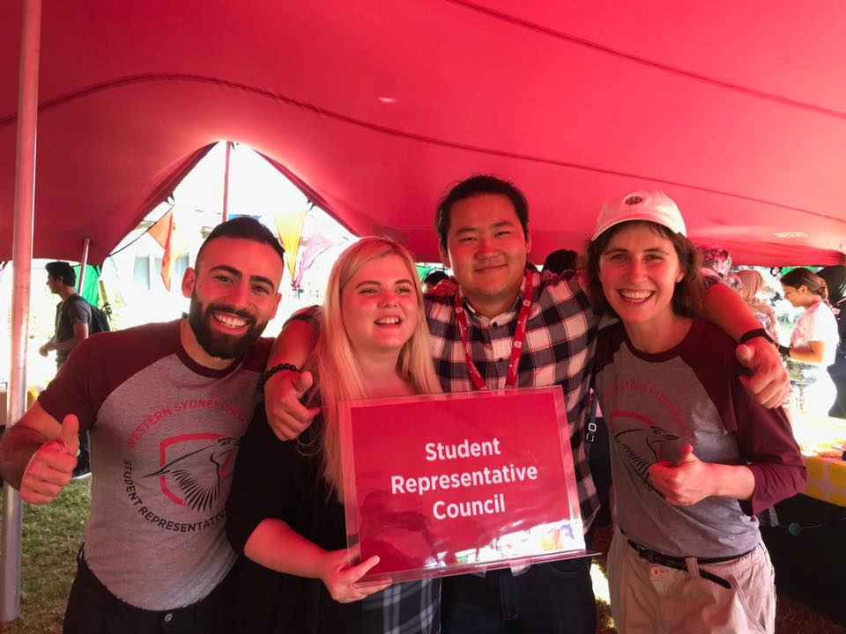
Figure 1. Erdem, Clare, Allan & me at Diversity Fest.

- ‘Blue’ Film Screening & Soup dinner, May 21st
Organised by Daniel Jantos from Chaplaincy, this event at Parramatta South. It had a high level of attendance and was a great ‘tester’ event for ongoing free dinner and movie nights at the campus, which I am in touch with the Parra South Provost about funding. The film ‘Blue’ is a must-see, exploring the issues of sustainability affecting our oceans and seas. In Danielle Wolf’s absence, I facilitated a discussion after the film, about strategies for moving forward in sustainability.

- Council of Australian Postgraduate Associations (CAPA) Special Council Meeting (SCM), May 23rd - 24th
Hosted at Australian National University, the highlights of attending this CAPA SCM included learning about the activities of postgraduate associations at other universities and National Aboriginal and Torres Strait Islander Postgraduate Association, hearing and voting on substantial CAPA constitutional changes and being elected as an interim member of CAPA’s newly created board. Please see my detailed report on this SCM, which I will be preparing shortly.

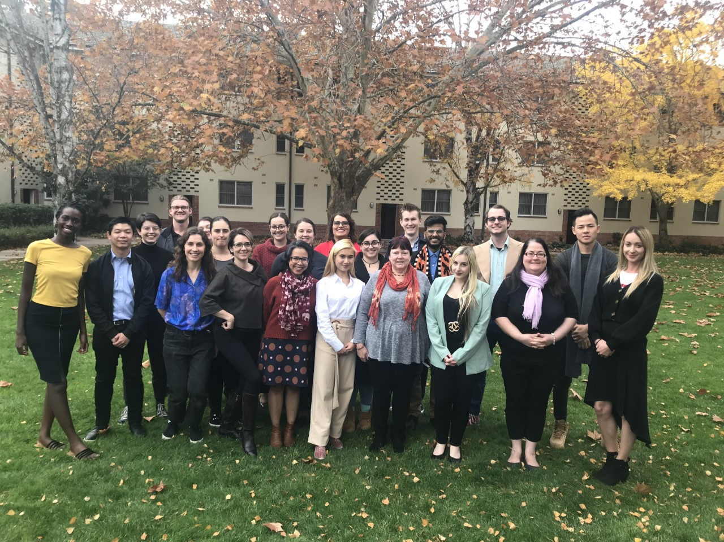
Figure 2. Fellow Postgrad delegates and me at CAPA SCM

- Parramatta Clubs Meeting, May 27th
Here the Music Club and I finalised the details of their ‘Battle of the Bands’ style contest to be held at the SRC’s #WesternWednesday Party at Collector Hotel on September 4th. I spoke to club leaders about the former SRC’s meeting with the university’s Communications team, where we learnt more about the means of accessing the university’s communications assets, which starts from the request submission portal here. I encouraged club leaders to make use of this portal and to provide me with feedback on their experience of this.

- Campus Visits, various dates
So far in my presidency term, I have spent at least a full day at Sydney City, Bankstown, Kingswood, Liverpool & Parra City & South, making time to speak with students at each campus and give out SRC merchandise. Full details of my visiting dates can be seen here, which I will continue with in spring semester.

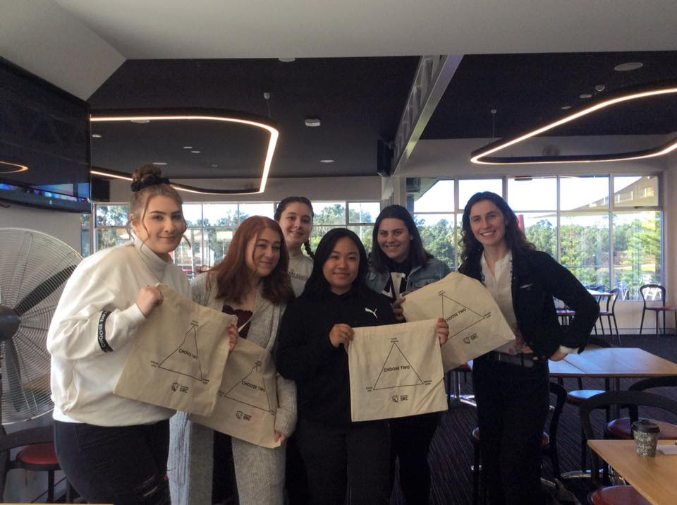
Figure 3. With Students at Kingswood campus.

- University’s Iftar Dinner, May 27th
Organised by the University’s executive, in celebration of the daily breaking of fast during Ramadan, it was a pleasure attending this dinner, at which various members of local Islamic and interfaith networks were in attendance, along with key university staff. Here the University’s Chancellor Professor Peter Shergold ‘unveiled’ the new WSU branded hijab, which would be made available to all nursing students, as part of their uniform package.

- Board of Trustees (BOT) Induction, May 28th
I attended this in my recent election as the BOT postgraduate student representative. Here, I was given information from key university staff and board members about the functions of the BOT and the university’s strategic goals and annual budget. With my term on the BOT starting in July, I will be attending the BOT June 12th meeting as an observer and Strategy and Planning Day on June 13th.

- Clubs’ Board Meeting, May 30th
In contrast to our previous Clubs’ Board meeting in early May, at this meeting we were given notice that Clubs have access to a larger pool of special purpose funding (SPF) than initially understood. This changed the approach of the Board, with us thereon assessing all SPF requests (including the ones presented at the previous meeting) purely based on their merit. However, the Board remained firm on its decision not to allocate SPF for travel expenses.

- Western Sydney Leadership Dialogue (WSLD) Future Forum, May 30th
This forum was a free event of the WSLD on the topic of ‘Exploring the Reputation & Perception of Greater Western Sydney’, with slides accessible here. I would like encourage more students to engage with WSLD, as they are an important advocacy group for the region. From my involvement, I have received a free ticket to the WSLD ‘Out There’ Summit on July 2nd.

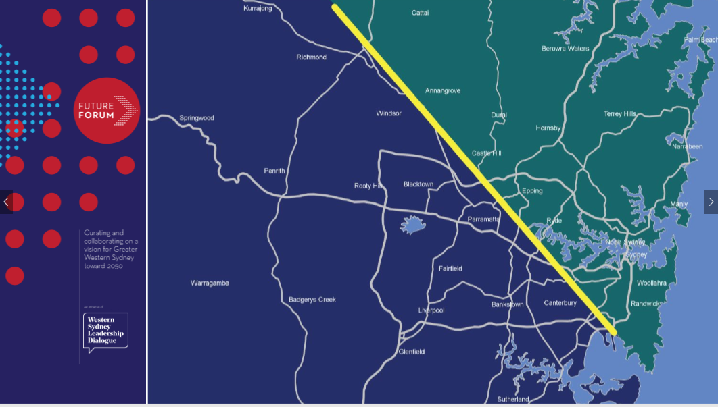
Figure 4. This line marks the two contrasting areas Greater Sydney. Courtesy of WSLD
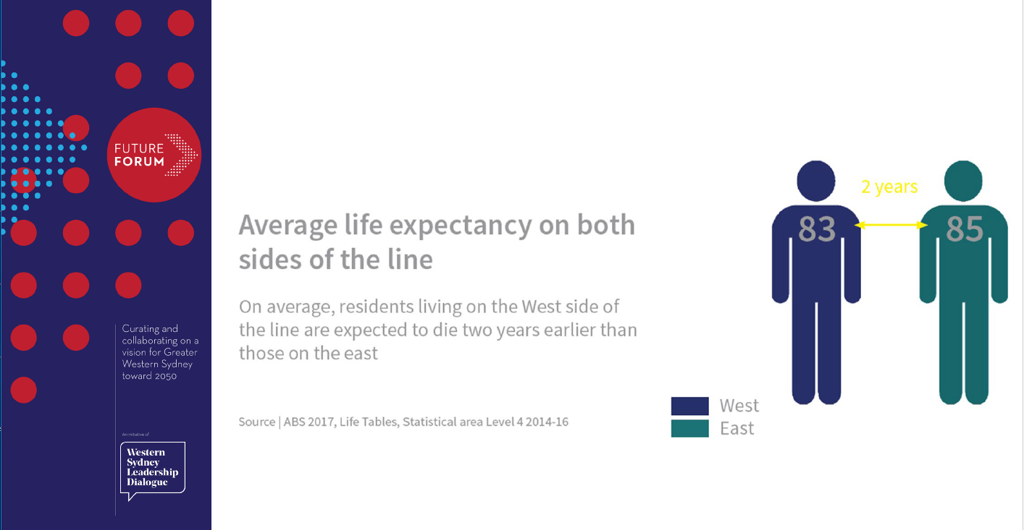
Figure 5. Just one of the significant points of disparity occurring between the area on either side of the line in figure 2. Courtesy of WSLD

- All Provosts’ Meeting, June 3rd
Here Matthew Bojanic and I were able to better understand the strategies and initiatives of various campus provosts. We spoke about the importance of student involvement in provost decision making and flagged that provosts may wish to provide students with additional support during the upcoming exam periods.

- Respect. Now. Always (RNA) Taskforce Meeting, June 5th
Chaired by the Vice Chancellor, this was my first RNA Taskforce meeting, of which I will continue to participate in throughout my term, continuing the excellent work of former SRC President Cheryl Jendrachowski in this space. Key discussion points at this meeting were: compulsory respectful relationships learning modules for CLV residents and HDR students and supervisors, updates on the Our Watch project management of complaints related to sexual offences.

Renier-Clark, Vicky-Rae - Disabilities Rep

This report for the month of June, details the events and initiatives I have been actively involved in since the last report submitted for the May meeting:
1. Bankstown City Campus Consultation Alongside other SRC representatives, I attended this consultation via Zoom. It was most discouraging to hear that most if not all of the recommendations put forward by myself, BSCC, and the Disability Collective previously submitted to the Office of Estate and Commercial as well as the Non-Learning Spaces and Change Committee have been disregarded in the initial fitout of the campus given we have been working on a Sustainable Campus Strategy for an excess now of 18 months. I was asked by one of the architects, Stuart, to re-send these recommendations to his team of architects for consideration. I have not heard anything further to date and will be following up in this shortly.
2. Diversity Fest Dinners @ Bankstown – Multifaith Iftar & Vesak 2019 I, alongside the Bankstown student Civic Community (BSCC) helped cohost a Multifaith Iftar dinner in collabotation with ABSoc and Chaplaincy. This was deemed to be quite successful by all in attendance which also included the Ethnocultural Representative, Allan Feng. The following week, I assisted in facilitating the Vesak Dinner in collaboration with the Buddhist Chaplain and the BSCC. Whilst this was somewhat of a more quitter event, I believe that it gave the students and staff in attendance a deeper understanding of Buddhist traditions.
3. Academic Planning & Course Approvals (APACA) Meeting – 10th May & 6th June I attended both meetings as the Undergraduate Representative on this Academic Committee, where it was noted that the inclusion, training and support of students on this committee is vital for its transparency and function. I have also forwarded the minutes from the 10th May meeting to VP Education, Matthew Bojanic for his consideration and will do so again when the 6th June meeting’s minutes become available.
4. Opening of BBQ Area and Men’s Mental Health Week Celebration (Bankstown) I, in collaboration with Bankstown Provost, Campus Life and the BSCC helped facilitate a Men’s Mental Health Week Celebration Event which was coupled with the opening of the new BBQ Area located outside Building 1. This event engaged students through conversation involving mental health for men; a vital conversation to have especially with students of the Bankstown Campus following the sudden demise of 2 male students on campus last year.
5. Little Free Pantries & Subsidization of First Aid Certificates for PWD – Meeting with Katherine Bland (Student Welfare) and Jo Holland ( Disability Services) BSCC Secretary, Elaine Hamley and myself have been in conversations with Katherine Bland and Jo Holland to discuss two initiatives that the Disability Collective are working in collaboration with this year with Student Welfare. The first of which, being the Little Free Pantries at Bankstown Campus, Bankstown Residence as well as Liverpool Campus. These pantries provide students subjected to food insecurity options for meals and snacks whilst on campus and have been considered an importance resource for students through our conversations with Student Welfare and Counselling on campus. We are also looking to expand this out to also include hygiene items as time goes forward. In addition there has also been conversations with Jo Holland, regarding the Disability Collective subsidising the costs associated for registered students with disability for the first aid courses associated with health sciences degree programs. I have also spoke briefly to Richard Martino in relation to this at last week’s Vesak event and he too has thought of it as a good idea. Conversations are ongoing.
6. Men’s Mental Health Forum collaboration with Bankstown & Liverpool Campus Representives, Disability Collective, BSCC and ABSoc Conversations and planning is underway to host a Men’s Mental Health Forum in late July on the Bankstown Campus. All parties involved with the planning and facilitation of this event believe that an event of this stature is prudent to the culture of the Bankstown Campus especially considering the traumatic departure of two young Pacific Islander men on our campus last year. We have reached out to our community partners from the NSW Council for Pacific Communities at their recent community meeting where PATHE is also a sitting community member and an expression of interest to speak at this event was raised by former chairman of Suicide Prevention Australia, Matthew Tukaki. In addition to this, the BSCC has also been in talks with the PR & Media Management Co-ordinator from Batyr, Andy Tsanadis. I have reached out to Campus Life today in the hopes of finding a suitable venue for this event in-house prior to looking for external options. Conversations and planning to follow.
Dunn, Kezia - Women’s Representative
I am still in the planning and discussion phase for running three women’s networking and professional development events at Parramatta Campus, Kingswood Campus and Liverpool Campus, as after discussions with different student groups I got a lot of excited feedback.
I visited Kingswood Campus to meet with then Women’s Collective Officer for Kingswood Hollie Hammond (Now Kingswood Rep) to discuss the role, duties and scope. Discussed upcoming events and timing for women’s networking nights, venue, speakers and layout. Settled on suggested keynote speakers for Kingswood Campus, and excited to start the planning process for three events next semester when I return from my upcoming study tour overseas.
Plans for the chalk wall in the Parramatta women’s room have been solidified and I will be taking the time next week to draw that up on the wall. The plan is to encourage more use of the room but encouraging women to come and add to the mural, which I plan to change regularly. Once the new collective officers are elected, I will be in touch to organise similar small events and changes to encourage use of the room as they currently see very little use.
I am in discussion with a few people about updating the WoCo branding to be more inclusive, but will await collective reps to be elected before making any changes.
I spoke with Tooba regarding the upcoming collective craftivism day and created a design to be used for screenprinting I will be attending on the day to assist with screen printing and offer any help I can with arts, crafts and design.
I will be unable to attend the next meeting due to travelling overseas where I will have extremely limited access to internet, but upon my return will be immediately engaging staff and students for the networking events.
Kathik, Anirudh - Parramatta City Campus Representative
This past week I have walking through the city campus to the post graduates, under graduates and all the school students talking to them and asking how they find their time at city campus I have been receiving feedback from all the students and I was able to find out that some would like to have a table tennis or pool table at level 1 as not people are able to play they all have to wait and some want a new game.
After talking to some students, it has come to my knowledge that students at times get bullied by the university students by removing them from study booth under the pretext that they have booked the study booths when they have not. On the other hand, I have noticed that sometimes there are some school students that on levels above level 3 without having any access to those levels.
Sengupta, Aditi - Campbelltown Campus Representative
My name is Aditi Sengupta, I am a first year Bachelor of Physiotherapy student. My Student Representative Council role is Campbelltown campus representative. My role is to identify, advance promote and advocate the interests of all students on my campus, keep the student kitchen well stocked at all times and collaborate with the Student Campus Council. My role also includes liaising with the student representatives of University committees and bodies, organising and running events for students, encouraging students to actively participate at the university and voice their opinion in matters concerning their interests, regularly attending all meetings with fellow Student Representative Council and Student Campus Council members. My role allows me to talk to students about Food outlets and prices at the university, Parking and transport, Student services, Clubs and societies, Social action and campaigns, Campus ideas and activities and Campus safety. Having been inducted into this role a few weeks ago, I have attended every meeting up until today via Zoom, have met the people who are my first point of contact for whatever issues I face, restocked the student kitchen, emailed Hussam Jabran and Larissa Baker (SCC office) to organise for cleaning of the fridge and acquiring stock for the kitchen. I am in contact with fellow SRC members and am organising a time to meet and organise for more kitchen stock.
Carr, Mandii – Vice president Activities
As many of you know we launched the first fundraiser event “Drag Trivia” raising money for the annual “Queer Prom”. This event was trialed on a Friday night to test student engagement with evening/weekend events with hopes it would attract Res students. Ticket prices raised approx. $950.00 and the raffle gained roughly $250.00 raising approximately $1200.00. While this seems positive and I relished in the opportunity to do a new type of event before I found that fundraising in this way problematic. Larissa, Campus Life Coordinator covered the cost of security for the venue as well as the table and chair party hire which was upwards of $1200.00.
The ALLY network paid for $200.00 worth of food and the QC donated $200.00. Penrith SCC/SRC had allocated this event $1000.00 for a total of $1400.00 to spend.
The expenses were: drag performer and MC - $600.00, build your own taco bar - $1064.00 not including the decorations that were purchased as a gift from Campus Life. This sets the expenditure at $1600.00 out of the $1400.00 I was allocated. As you can see, we spent more on the event than we made. As VPA, it is my opinion that the SRC avoid doing fundraiser events such as this particularly without greater budgets. Another influencing factor was that I did request several reps to share this content on their respective campuses and on the various social media pages we have circulating. I stand by my statement that this event was only successful as it was due to the staff members involved wanted to see this event flourish and I commend them for their assistance.

Queer Prom
The Hub at Parramatta has been booked for Queer Prom 2019. This year’s theme is 90s, I have sought quotes for arcade games, photobooths and food trucks to be purchased for the evening. Marketing has been contacted to do the promotional flyers and internal comms screen artworks.
Community Garden
After much discussion, I have elected to give the community garden to Danielle Wolf who is the environmental representative on the SRC. This project falls under her portfolio and I look forward to seeing what she creates at Penrith with the garden. I’d like to extend my thank you to Brendan Cauchi who was great in doing a site visit with me and discussing the longevity of the garden. I am flagging this with the SRC for have vested interest in the garden and I hope the SRC will continue to support garden projects across all campuses. #GreenerWestern

Clean up date
I’ve been in discussion with the environmental representative to engage with a “clean up” day/activity which would involve the student body in going to a community space and doing before photos, spending the day cleaning up and creating a before and after photo to promote the SRC’s clean and sustainability message. I project this event being a cheap one, perhaps only providing light refreshments and drinks for those who are participating. Pending the success of the event this could be a campaign the SRC support and encourage to be an on-going event.

NAIDOC
As VPA, I’ve been working on NAIDOC celebrations at Nirimba campus to deliver a Western experience to the college students. The expected delivery of this event is 17th July 2019 with a free BBQ and performance from an Indigenous dance group. I have contacted the Badanami Centre to collaborate with them further to establish a Welcome to Country and perhaps a smoking ceremony. I have also been approached by Campbelltown students who wish to run a NAIDOC workshop over which was set to be in July but after consultation we elected to move it August to increase engagement. I am seeking the cover their extended cost and so that NAIDOC has a presence on various campuses.

Clubs meeting/s
I have been in attendance to several clubs meetings as a requirement as my role as VPA. I intend to work closely with clubs and Matthew Stansfield to develop an ongoing relationship with the SRC and club groups. It is my opinion that the University should be supporting the clubs in helping them with funding, only declining excessive requests. This is the way in which I respond to club requests.
WBW trophies
I have spoken with Richard and we have decided the Who Bleeds Wins trophies will remain at Penrith campus to be displayed – every year. I have sent a request to OCE to have them hung in building N. This decision came as the blood challenge was started at Penrith before becoming cross campus. In relation to the Red Cross, I’ve spoken to Grant Murray, Student Voice Officer who has offered the suggestion that the next WBW challenge winners are announced at awards night at the end of the year.

Online student engagement
I’ve been in discussion with the online rep, I’d like to look at engaging at the online cohort by sending them a package. This would involve online students signing up for this package, targeting those online students who are active and engaged also capping at approximately 50 people for cost reasons. This package would include: an events calendar, who are your SRC, a karma cup or Western shirt (something that is branded) I think this would engage the online the student who may be feeling disenfranchised from the Western experience that may be more available to physical students.

Yigiter, Erdem - Queer Representative
As stated in the last report, the Queer Collective held a discussion forum called “Western Sydney’s Unheard Voices” where we had 5 people of quite diverse backgrounds speak about their experiences in front of an audience. The questions and topics revolved around family, what its like to be queer in the west, improving inclusion and hopes for the future. The panel had a great mix of people, and specifically, some people who usually never get to share their stories. The panel included a Gay identifying refugee from the middle east, A Bisexual identifying asylee from india, and a Trans DJ who works on oxford street.
As the Queer Rep, I would like to start facilitating Queer Picnics that would be held by the Queer Collective. We would like to have a relaxed and casual monthly meeting where LGBTIQ+ Students, Allies and Friends are able to come and share some food in a relaxed and safe setting. The budget will come from the queer collective and will hover around $100 per picnic. We are unsure at the moment where the picnic will be held.
The Queer Collective and I are also planning on a possible end of semester or start of next semester event, which will hopefully involve students in a talent show, where there will be prizes awarded to the winners.
Queer Prom is also coming up later in the year so myself and the queer collective will be heavily involved in its organisation and running.
I completed the Global Leader Experience about a month ago which I feel has given me better understanding of how to lead amongst groups of diverse people. I have also been invited by the academy to join the western Sydney leadership dialogue as a guest, which I hope will improve my ability event more.

Bekker, Frederick W. – General Secretary
Within my role I have been hard at work, I have been responding to a large number of enquiries from the student body, as well as providing administrative and procedural advice to members when they have questions. I on average received 5 emails per day regarding the various faculties within my responsibilities. I met with interest’s groups and represented the SRC’s needs and role within the University.
I collated and welcomed the new incoming SRC members elected in via EOI process, and informed the date and time of the upcoming meetings.
I shall be putting up posters and pamphlets of the upcoming St. Vincent De Paul community Sleep-out’, Where I shall be organizing a group of students to participate St. Vincent De Pauls community sleep out on Western Sydney University grounds. Link to event: https://tinyurl.com/y2wqehex.
General business items I hope to raise at the following SRC Meeting depending on time availability, include;
- Student Concerns of being unable/discriminated against joining a student club.
- Movie Nights to be run by the university for the provision of students
I shall furthermore be recording the minutes of the proceeding of the upcoming SRC meeting as per the functions within my role, and shall aim to release this for public dissemination in the future.

I called for agenda items from all members, and collated and formatted the new Agenda item list and members Report list into documents. I collated all of this and released the following documents;
- SRC meeting #6 Agenda items
- SRC meeting #5 Minutes’ draft
- SRC members reports – June
This in total spans more than 20 Pages, and took a significant amount of time to compile. After the conclusion of the 6th SRC meeting where the minutes shall be confirmed I shall be discussing the uploading all this information to be accessible to the public on to the SRC Website.
Please feel free to contact me on secretary@westernsrc.org if you have any question or concerns; I will always be here to fight for your interests on campus.
Craig, Phil - Liverpool Campus Representative
Since the May meeting (which I attended via zoom) I have continued to work with the Student Satisfaction team on the High School Students interventions at 1PSQ, this project was also in the works to be extended to the Liverpool campus however after consultations it was decided that this is not necessary at Liverpool. I have also collaborated with the Banksown Student Collective club which is made up of former members of the BSCC to plan a Destress with Doughnuts day for during exam time in June. This is planned to occur at the Liverpool campus on Friday the 21st of June, there will also be a similar event held at the Bankstown campus in the week before this. I hope to continue the strong relationship between the Liverpool and Bankstown campuses and collaborate for events wherever possible.
I have also decided from the Spring session to set a weekly drop in time for Students at Liverpool to pop in to have a chat about any issues they have with the campus or WSU as a whole. I will not be able to set this time in stone until timetables are released on Allocate on Friday the 5th of July.
I will do my best to represent the SRC by attending the Liverpool campus first birthday celebration which is scheduled for Thursday 13th of June from 3pm – 6pm however this does currently clash with existing commitments for my compulsory work placement so this may not be possible.
List of members who failed to provided Member Reports:
- Cupitt, Sarah - Online Students Representative
- Wolf, Danielle - Environment Representative
- Feng, Allan - Ethno-Cultural Representative
- Jha, Vageesh - Residential Students Representative
- Chheda, Rohan - International Student Representative
- DaSilva, Clare - Parramatta Campus Representative

