Student Representative Council
Student Representative members reports - May
The following reports are to be provided by all SRC members

Bekker, Frederick W. – General Secretary
Since being elected within my role on the Student Representative Council, I have worked with great fervour in my role for the betterment of our university. Since attaining my role I have;
Registered myself for the St. Vincent De Paul ‘Sleep-out’, where I shall be I shall be sleeping out on the university grounds on the 30th of August with nothing over my head to help raise money and awareness for the 116,000 currently homeless Australians. I did this challenge last year, and our total amount of money we raised amounted to $67,000. This is a great cause to get behind and I shall be moving in the next Council meeting for official endorsement, as well as to match donations dollar for dollar for students hoping to join the WSU team to encourage more to participate. Link to event/to donate: https://tinyurl.com/y2wqehex.
Following this, I registered for the ‘Sydney Tower Stair Challenge’, where on August 25th, I shall be running over 1504 Steps & 309 meters of vertical Height to the top of the Sydney Tower eye. The money raised shall be going directly to Giant steps Australia; not only a revolutionary piece of Jazz music; Giant steps is a great facilitator of education for children with Autism within Sydney, and is a great social cause to get behind. Link to event/to donate: https://tinyurl.com/y3q8ujpq.
Then I booked and finalised everything required for the first inaugural WSU Soiree that I have organizing over the course of the semester. On the 1st of June 6-9pm an event has been planned and organized to be run for WSU staff, faculty, and students, and its purpose is to foster vital networks, allow socialization amongst students, allow staff, students, and faculty to mingle with each other, talk policy, as well as to celebrate the incoming 2019 SRC team. The location is to be at 5 Purchase Street located 10 minutes from Parramatta City campus. Near the end of the night the stage will be open for all incoming SRC members to give remarks on what edicts and policy they hope to achieve throughout the year. The Facebook event has more than 100 individuals saying that they are interested/going so far and thus is deemed to be a highly anticipated event. Link to event: https://tinyurl.com/yxrcqw8w.
Throughout 2018 I have run free movie events for the student community which have been proven extremely popular with Students, garnering an average of 52 attendees per event. I hope to continue to run these events for the student community monthly, on the last Friday of every month. These events have always included plenty finger food, pizza, and non-alcoholic drinks at each event. Feedback I have received included the expansion to more campuses; and as such I plan to expand the event from Parramatta. I shall submit an agenda item to continue these highly anticipated events throughout 2019 in the next Council meeting.
After receiving numerous requests to update the SRC website, I took the initiative to completely update and revamp it to be up to date with current proceeding and members, and move it out of its early 2018 phase. I took measures to update the information on every single page to be up to date, following up Students for their headshots and researching thoroughly relevant information to include. I shall be following up with this by updating it in the future to make the student community aware of future events, as well as uploading all Council meeting Agenda item lists and minutes to increase Council transparency and accountability. By doing this I shall increase student outreach and make SRC news more available for the student community. Website is available from: http://westernsrc.org/.
I systematically read through and reviews the Standing Orders and procedures that run the Student Representative Council. Within it I have found numerous errors, mistakes, as well as major issues within the procedures themselves. These include current standing orders detailing unlimited legal funding for any purpose requested by the Student Publications committee for example, which legally can cause the university to be liable to large amounts of money if used unscrupulously. Another example of a faulty standing item is that there is no incentive for students to provide their monthly performance report, so I hope to address this in order to increase accountability and transparency of members. I have thus written in a two page amendments list to the standing procedures to add transparency and accountability of Student representatives which I shall upload to the Website.
I organized the date and time of our first Student Representative Council meetings, liaising with all members, and finally settling on the 30th of May. I made my call for Agenda Items and reports, and compiled everything received by me into the;
- SRC meeting #5 Agenda items
- SRC meeting #5 Minutes’ draft
- SRC members reports – May
This in total spans more than 20 Pages, and took a significant amount of time to compile. After the conclusion of the 5th SRC meeting I shall be uploading all this information to be accessible to the public on to the Website I have designed.
Please feel free to contact me on secretary@westernsrc.org if you have any question or concerns; I will always be here to fight for your interests on campus.

Bonatti, Daniel - Vice president education (Postgraduate)
Role – Part of the executive, to advocate voices, needs, desires of students of WSU, with focus on education. 1. 1-4-2019, Nominations for elections posted. 2. 4-4-2019, Elected to position Vice president uncontested. 3. 4-4-2019, Elected NUS delegate. 4. 5-4-2019, Out and about Campus Day Meet Vice Chancellor Barney Glover at Parramatta South Campus, with other students including Naomi Hastings, 10 to 11am. 5. 14-4-2019, Elected Parramatta Campus representative gave position to second as preference Vice President position. 6. 14-4-2019, NUS delegate only provisional checking eligibility. 7. 6-5-2019, SRC Meeting Giving Day, I set aside date 4 th September will be available, interest in scholarships as the Education Vice President. 8. Joined Fred General Secretary Facebook page and Joined SRC webpage. 9. 8-5-2019, SRC Meeting informal Executive Team, missed wrote apology had mix up with day Friday instead of Thursday had asked previously, Mandi knows I was about 4 hours late on Thursday the last to know meeting was finished. 10.13-5-2019, SRC Meeting Teleconference Zoom link attended 11.20-5-2019, Bankstown Fit-out Milperra Room Teleconference 3 to 4pm going. 12.21-5-2019 UTS Student Voice Summit – Student Leaders Conference 9.45am to 4pm Registered going. 13.TBA, SRC Meeting Executive Team 14.30-5-2019 Official SRC Meeting going. Summary need to find access to SRC portal and contact Vickey Rae about plans. More information what is expected of me, possibility of a room?

Renier-Clark, Vicky-Rae - Disabilities Rep
This is what Robert Reed, and myself have planned so far for this coming year for students with disability.
- Ensure Inherit Requirements (the basic requirements that students with disability should be able to achieve in order to pas their unit/course program) are achievable and current on all course approvals and variations put forward to the APACA Committee
- Continue conversations with Health Sciences re: the integration of Mandatory Reporting and Disability units within the Health Sciences degree program
- Further considerations made into assisting Health Science students with disability with subsidisation of their first aid course as this forms part of their degree program.
- Continue conversations with Student Welfare, Disability Services as well as Equity& Diversity in relation to the needs of students with disability
- Formulate community partnerships with external organisations such as Australian Tertiary Education Network for Disability (ATEND), Autism Spectrum Australia (ASPECT) and Ability Links
- Continue partnerships with Sydney Queer and Disabled (SQuAD) and further promote the work of this group through collaborations with Queer Collective
- Facilitate conversations with Prof. Sev re: the formulation of the 2020 Disability Access Plan & review promises from previous 2016-2019 plan
- Continue to work with Office of Estate and Commercial (OoEC) and Jacob Pala to ensure accessible spaces and learning environments for current campuses and the proposed Bankstown City Campus

Feng, Allan - Ethno-Cultural Representative
As the Ethno-cultural representative, I am responsible for representing the ethnically, culturally and linguistically diverse student population of WSU. In addition to supporting the other SRC members, committees and projects, my focus will be to engage with students to discuss the ethnic and cultural issues that they are experiencing. I will raise these issues with the SRC and work to resolve them to the best of our team’s ability whilst providing input to uphold respect for the cultural experience of students. I will also represent the SRC at various university functions such as Western Fair, Diversity Fest and Engage Expo where engagement with students and promotion are pejoratives of the council.
As of 2019 so far, I have had a presence from the Ethnocultural-cultural collective at Western Fair and hosted Harmony Day celebrations. I have also supported chaplaincy with their soup kitchen dinners at Campbelltown campus and engaged with students on social media with promoting various cultural events. I will have a presence at the upcoming Diversity Fest in May at the events held at Parra South campus as well as the Iftar dinners held at Campbelltown and Bankstown campuses. I will be hosting storytelling activities at Parra Sth as well as working with chaplaincy to host a screening of the movie ‘Blue’ in line with the themes of Diversity Fest. 4 other projects I have planned for the rest of this year are: a foreign film screening, a mini-library with book from various ethnically diverse backgrounds, the advocacy of building an Ethno-cutural space on WSU campuses and a dinner for international students in collaboration with chaplaincy.
Sengupta, Aditi - Campbelltown Campus Representative
My name is Aditi Sengupta, I am a first year Bachelor of Physiotherapy student. My Student Representative Council role is Campbelltown campus representative. My role is to identify, advance promote and advocate the interests of all students on my campus, keep the student kitchen well stocked at all times and collaborate with the Student Campus Council. My role also includes liaising with the student representatives of University committees and bodies, organising and running events for students, encouraging students to actively participate at the university and voice their opinion in matters concerning their interests, regularly attending all meetings with fellow Student Representative Council and Student Campus Council members. My role allows me to talk to students about Food outlets and prices at the university, Parking and transport, Student services, Clubs and societies, Social action and campaigns, Campus ideas and activities and Campus safety. Having been inducted into this role a few weeks ago, I have attended every meeting up until today via Zoom, have met the people who are my first point of contact for whatever issues I face, arranged for my access to the Student Representative council room and keys to the supplies for re-stocking the kitchen with tea, coffee etc."

Espinas, Jonathan “JC” – Hawksbury Campus Representative
After finding out the results of being elected as Hawkesbury Representative, I decided to gather all necessary training material before any action/decisions can be made. Founded most of the training material in ‘OrgSync’ under ‘Training Materials’ folder. Also re-evaluated updated SRC procedures, roles and responsibilities of representatives and other documents that was required.
During the last few days of April I decided to go to the Hawkesbury campus to see how everything is going. So far so good except for the morning shuttlebus transport. As of which between Monday – Friday from 8:30 a.m. and onwards students have been complaining about transport not being adequate. I decided to investigate further with tis complaint. From my perspective I can see where the problem starts. It has been noted and seen that the same students picked up from the first round starting from 8:30 a.m are still on the shuttlebus with very few seats left. The students that were still waiting are both upset and disappointed and feel like they are gonna be late for a 9am lecture. As of which an investigation to this matter is still under way and will be addressed in the next Hawkesbury Provost Committee Meeting in terms of a solution for both the shuttlebus drivers and the students most importantly.
Finally on Monday 13th of May 2019, an informal training session/meeting was held. I felt that it would be great that a short training session was needed as some representatives like me are new to the SRC team. I found that the meeting was well structured and gave the necessary information needed to carry out and fulfil the roles and responsibilities of an SRC representative. Not only was the training session necessary but also getting to know other members of the team, that way I know who to contact and for what reason.
I look forward into pursuing my role further as Hawkesbury Representative, and will still keep in touch with the investigation as mentioned above.

Hastings, Naomi – President
I am very excited and humbled to have been elected as the new president of the Student Representative Council (SRC). The SRC is the peak representative body for students at Western Sydney University and it is the role of the president to ensure that the needs of all students are adequately met, whether that be by the university itself or by the local, state or federal government.
A little bit about me
I am a sixth year student, having completed a Bachelor of Arts and now undertaking a Master of Research. I am the former SRC Vice-President and Chair of Parramatta Student Campus Council. In 2018, I received the Vice-Chancellor’s Award for Sustainability & Engagement. I have founded and continue to lead the Skateboarders Club and WSU Students for Sensible Drug Policy chapter and have served as an Academy Community Advisor. Throughout my time as president, I will seek out the voices of students most vulnerable and ensure that they are heard and responded to by our university.
Some of the things I’ve been up to
- Only a few days after being elected, I attended the Anzac Day Dawn Service at Parramatta and laid a wreath down at the Prince Alfred Square Cenotaph on behalf of all WSU students, alongside WSU Chaplain Rev. Dr Amelia Koh-Butler.
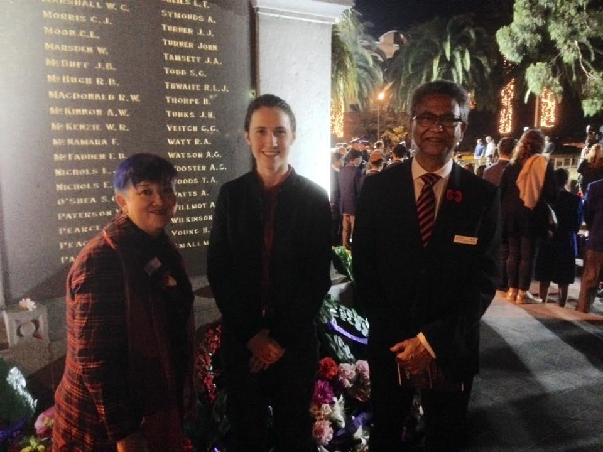
Figure 1. Rev. Dr Amelia Koh-Butler, Rev. Dr. Manas Ghosh and myself at the Parramatta Dawn Service.
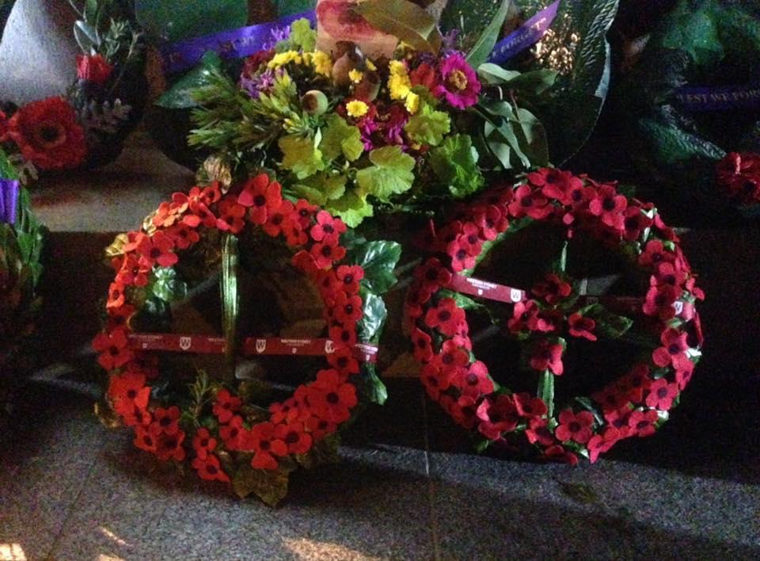
Figure 2. WSU wreaths laid at the Cenotaph
- I have arranged a series of campus visits, where I will be actively reaching out to students from all campuses to better understand their needs and experiences. I am making myself present at high-traffic activities, such as the free student breakfasts and dinners, so that I can meet with as many students as possible. For the full list of dates the campus visits, please click here.
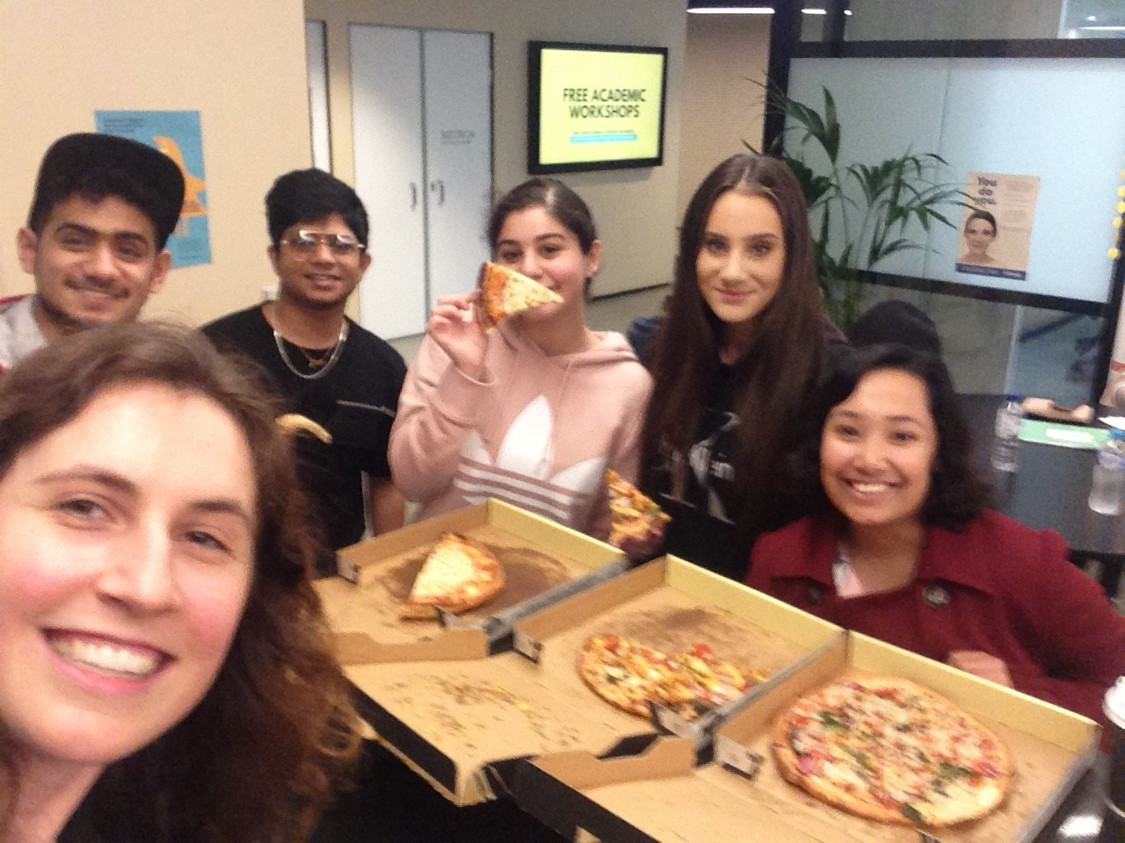
Figure 3. Free pizza lunch with students at my Sydney City Campus visit.
- Starting with the Parramatta campuses, with the help of the Campus Life Assistants, I have begun the process of revamping the free student breakfasts, allowing for more healthy options, less wastage and greater accessibility. I held several ‘Porridge with your President’ events at breakfast time, where I served up over 100 bowls of hot porridge, cooked on the spot and topped with fresh ingredients. I also organised a daily fresh fruit delivery service for Parramatta City students, between Tuesdays-Thursdays, partnering with a local grocer.
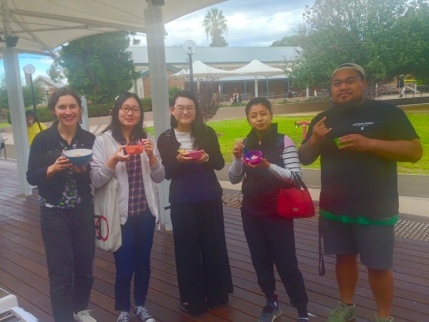
Figure 4. 'Porridge with your President' at Parramatta South
- For WSU international and exchange students, I have created and started giving out a stack of postcards, made using recycled materials and featuring cute/kitsch Australiana artwork on the front and useful information about the SRC on the back.
Figure 5. Postcards for WSU international & exchange students
Making the student voice heard
- For a while now, I have been a regular attendee of the Provost committee meetings at Parramatta South and City campuses. Provost committees are based at every WSU campus and are centred around ensuring that each campus and vibrant and welcoming environment. Each of these committees oversees a budget of $20,000 per campus, which students can have direct input into the allocation of, though this has not always been the case. Barriers to student input have been a lack of clear lines of communication and awareness of these committees, along with an underdeveloped procedural framework regarding these committees and their meetings. In the next few weeks I will be submitting a list of recommendations to all the provosts, outlining ways for increasing student input in this decision making and improving transparency and communication.
- As a member of the Clubs Board, I was recently involved in the process of reviewing the first round of Clubs’ Special Purpose Funding (SPF) bids. A notable decision made within this review was that of disallowing any allocation of SPF to be used towards travel costs. In previous years, travel costs have taken up significant portions of annual SPF allocations. The Clubs Board finds this problematic, as it has meant that large amounts of funding have been distributed amongst a very small numbers of students. So to allow more students to be able to attain the benefits of SPF, club travel costs are now to be covered by means outside of SPF.
- From July, I will officially begin my term as postgraduate student representative on the university’s Board of Trustees. In early June I will begin the induction process and attend the Board’s planning and strategy day, as well as my first Board meeting. I look forward to representing the needs, experiences and opinions of students on this board in both my capacity as a postgraduate student and as the SRC president.

Please feel free to contact me at president@westernsrc.org

Cupitt, Sarah - Online Students Representative
I've attended three meetings and an informal training session so far for SRC. I have recently been in contact with the Penrith SRC rep, and we discussed the possibility of having care packages sent to online students. I've recently contacted Mandii to see if I would able to inquire about getting possible statistics or demographics for WSU online students so I can determine the target audience - and see how many students would be willing to participate in an online student forum etc. I was hoping as the online SRC representative to act as a critical source of communication between the online student body and the University by being a student editor to encourage active participation from off-campus students. I'm currently trying to find a work around this issue since I've now lost my Student Editor position due to SRC protocol. I want to create a long-term space for online students since Orgsync will be no longer be in use at the end of this year. I want to create a digital environment where students can actively contribute to University decision making in promoting a positive student experience regarding emerging issues for online students so that they can provide input into the development of policies and services that support students and advance the quality of learning and research activities. WSU could potentially hold two all-student forums accessible via zoom each year to share information about University strategy and operations with the student community, and this would provide an opportunity for 'all' students to share and discuss matters that are important to them.

DaSilva, Clare - Parramatta Campus Representative
As part of my role as SRC Parramatta South Representative, I have engaged in a few meetings in the past month. I have attended the initial meeting with Grant on the 30/04/2019 where I was introduced to the other members of the SRC and learned more about my role as a student representative; this was furthered in the recent SRC training meeting I attended. I also sat in on the Giving Day meeting where we discussed how the SRC may play a role in helping out on giving day. I voiced my interest in and concerns about how we may be involved. Moreover, I got the chance to be a part of the Provost committee meeting where I heard talk about how funding from Provost was being used on Parramatta South and got introduced to the key members of that committee.
In regards to my portfolio, I am first wanting to attend some of the free breakfasts and other events (particularly diversity Fest) on campus to gauge student’s concerns and wants before concretely deciding on what project/s to run on campus. I have met Daniel - the head of Chaplaincy and in the future will try to arrange going to some of their free events to engage with students. Some initials ideas I have in regards to Parramatta South is trying to get more student engagement and making existing clubs and societies on campus better supported (especially with a lot of the recent changes).

Bojanic, Mathew - Vice president Education (Undergraduate)
The purpose of this report is to outline my activities up until 16 May 2019, and to provide insight into my planned activities into the near future. It is my current intention to provide a further, verbal, update at the SRC Meeting scheduled for 30 May 2019 to notify the council of my activities between the submission of this report, and the meeting.

Preliminary Meetings
I attended the SRC Executive Planning Meeting on Thursday 16th May 2019 and the SRC Training Meeting on Monday 20th May.

Academic
It is my intention to establish an Undergraduate Academic Advisory Committee in order to ensure the SRC remains fully informed on issues from all Academic Schools throughout the year. So far, a number of students have agreed to become a part of such as committee representing the schools of Business, Computing, Engineering and Mathematics, Medicine, Nursing and Midwifery and Social Science. I am still actively search for students from Education, Humanities and Communication Arts, Law, Science and Health, and would greatly appreciate any recommendations for SRC Members.

I have since met with the SCEM representative in a productive meeting on 15th May, which flagged a number of issues that I would like to raise with the relevant members of the Executive, and Academic Senate, after I receive more information. I have an upcoming meeting with the Business representative tomorrow, and the Nursing and Midwifery representative in a fortnight. I also have arranged a meeting with Hollie Hammond, one of our Undergraduate Academic Senators, to help formulate a consistent Undergraduate Academic Strategy for both SRC, and the Senators, to pursue.

International Students
After chatting to Vageesh (Residential Representative) at our training meeting on Monday 20th May, I have begun looking into a number of issues surrounding our International Students, including employability, employment opportunities and mental health and wellbeing. I am meeting with Vageesh and Rohan (International Representative) tomorrow to further discuss issues surrounding international students, and it is my intention to meet with a number of members of the University Executive after gaining more information on these issues.

Employability
I have also followed up with Cheryl Jendrachowski, the former SRC President, regarding the Vocational Training Subsidy Program. I feel this initiative not only presents a great opportunity for our domestic students, but it may also be of strong benefit to International Students who wish to obtain new skills to enhance their employability whilst working part time to support their studies. I hope to be able to provide a further update to the council by the time of the SRC meeting on 30th May.

Yigiter, Erdem - Queer Representative
As the queer rep, I will continue in my efforts to engage and address the needs of LGBTIQ+ students across all campuses. As the queer collective president, I have managed the facebook page and have updated the information on the pages, aswell as updating the logo and being more responsive to queries and messages. The queer collective has also organised an event for IDAHOBIT which is happening on the 15th of May, which serves to engage students from diverse backgrounds who do not normally get a chance to have their voices heard. As the queer rep for all campuses, I think I will be expected to build a LGBTIQ student voice and try my best to increase participation in activities. Within the role of the Queer Collective, I also helped run a Queer Collective stall at the Parramatta pride picnic, which is western Sydney’s biggest LGBTIQ+ event. I also plan to organise regular Queer picnics for students that are catered and allow a chance for the community to meet and grow.

Wolf, Danielle - Environment Representative (Under Required 200 Word Count)
My work campaigning began long before I was elected as the Environment Collective rep. Since being elected however I have continued to work hard to strengthen and develop networks and partnerships with individuals, groups, clubs and offices which are working towards the same or similar objectives. This is to leverage our collective capacities and resources, as well as to avoid duplication of activities and meetings, especially with University staff. The Environment Collective have made this a main goal – to bring together the isolated silos of action and engagement. I am collaborating closely with the student club which I am president of – P.E.A.C.E. Unlimited – which is devoted to achieving the SDGs, with a specific focus on protecting and restoring the wellbeing and biodiversity of Nature. I am also in touch with the Hawkesbury Student Collective, Sustainable Futures, Penrith Provost, Grant Murray, other likeminded reps, and chaplaincy, to name a few. We are currently organising a screening of Blue for DivFest where I will be facilitating the post-movie discussion. At this stage I am also coordinating various waste initiatives and sit on the Hawkesbury Council Environmental Sustainability Committee.

Dunn, Kezia - Women’s Representative
Wednesday May 8.
Parramatta Provosts meeting and catch up with SRC President Naomi Hastings. Attended a three hour discussion regarding division of funding for student pitched events. Was able to gain insights into how Provosts run meetings, what they look for in events and how to seek funds for future events. Brief catch up with Naomi regarding roles and duties as SRC representative. Brief discussion with chaplaincy on how I can help with upcoming events early next semester. Short discussion with Nap from student life about running a women’s fencing event.
Friday May 10.
Meeting with Grant in order to better understand scope of role as Womens Representative, particularly as this is a new role as of 2019. Discussed role, events, expectations and vision as well as SRC governance and policy. Contacted students from Bachelor of Design about running drawing on chalk wall events to generate interest in using the women’s rooms. Contacted WSU Kendo club about getting involved in running “Give a girl a sword” at WSU, an event to encourage women to try martial arts. Followed up with my own fencing club about insurance, running a class and loaner material. Kendo club very interested, setting up a meeting with a senior instructor next week.
Sunday May 12.
During a filming session, discussed running a women’s professional development event with Pallavi Verma, recent high achieving graduate from WSU about providing a keynote speech at a womens professional networking event. Pallavi confirmed her interest and is awaiting a formal date.
Monday May 13.
Informal training with SRC. Attended via zoom due to assignment responsibilities. Went through roles and responsibilities, similar to earlier meeting with Grant. Was able to secure information on WoCo budget for this year in order to begin planning events.
Wednesday May 15.
Focus group at WSU regarding future employability. Ensured I advocated for women and single parents needs in regards to what the university needs to provide. After the meeting, discussed with another attendee Sharon Roy (Diversity Fest) about running womens networking and professional development events and secured her interest in being involved. Brief informal discussion with Nicole Brackenreg (LEAD) and Naomi to refine ideas for running this event, took recommendations on MCs, speeches, possible guest speakers, campuses and dates.

Carr, Mandi – Vice president Activities
I have continued my prep for Drag Trivia Night with constant online updates. I’d like to formally thank those reps who have shared the event though their channels as requested, it is greatly appreciated. Drag Trivia at present has sold 2x student tables and 11 individual tickets (approx. 25 tickets thus far). The fundraiser was the first of it’s kind and I look forward to writing my report on the event for the stakeholders.
I created a timeline of events and I’d like to discuss having all reps turn in their events so the student reps can create an online platform where all students can see what events are happening. This would also assist event management on having events clash – particularly with CLA’s.
I, like most of you attended the informal training day via zoom on May 13th. This was a good opportunity to meet everyone, answer questions and have a “refresher” for those reps who are returning. I would recommend that more zoom locations be booked or that be included in the doodle polls so rooms on campus can be booked.
As an executive I attended the required meeting and we discussed various things including budgets, conferences, meetings as well as bounced ideas off each other. These meetings will assist in the smooth progress of running the SRC meeting.
Although I missed the clubs meeting, I did go to Bankstown campus last Monday to catch up with Matt Stansfield and what I had missed in the meeting.

Craig, Phil - Liverpool Campus Representative (Received past deadline)
Since election to the Western SRC I have networked with a number of students across Parramatta, Penrith & Bankstown & Liverpool. I will endeavour to spend more time at the Liverpool campus after this session as during autumn my time is split across the Bankstown, Parramatta, Liverpool & Penrith campuses. In my previous position as a member of the BSCC we were also responsible for advocating for Liverpool specific issues and I am excited to continue building the student voice and presence at this campus. I am currently in the process of creating posters to advise students that I can be contacted if any issues need to be discussed or raised at a future SRC Meeting. I have represented the university at a number of functions of events including Western Fair, LEAD Conference and I will present at Diversity Fest to represent the SRC and engage with the student body.
I have also been working with WSU’s Mental Health & Wellbeing Team in their partnership with Lifeline Australia to provide training opportunities for our students to become accredited Crisis Supporters. This is a valuable opportunity for students to gain valuable skills and experience whilst supporting Australians experiencing crisis in their lives. I believe that there is far more to the university experience than simply attending classes and submitting assessments and hope to collaborate with the student body, campus life and other representatives to improve the campus atmosphere at Liverpool.

List of members who failed to provided Member Reports:
- Jha, Vageesh - Residential Students Representative
- Chheda, Rohan - International Student Representative
- Craig, Phil - Liverpool Campus Representative (Late)
- Kathik, Anirudh - Parramatta City Campus Representative

