Student Representative Council
Student Representative member’s reports – October
The following reports are to be provided by all SRC members

Bojanic, Matthew - President
Introduction
The period between Meetings #9 and #10 has seen me actively involved across all aspects of my role, including a large amount of strategic planning as the SRC moves towards developing a broader policy program encompassing all areas of student life. I am determined for us to have completed a number of key initiatives by the end of the year so as to facilitate the implementation of an ambitious agenda for 2020, increasing the organisation’s role in the lives of our students.
Administration
Since the last SRC meeting, and my appointment as President, I have been very actively involved in administration of the council. This has included regularly meeting with, and speaking to, members of the SR+P staff, as well as arranging upcoming meetings with senior university executive, including the Vice Chancellor and Chief Student Experience Officer to enable ongoing student advocacy. I have also found myself actively liaising with members of the SRC in order to hear out, and help rectify, grievances that have arisen during the period, working alongside members of the SR+P team.
I have also spent a larger amount of time actively managing a number of projects, helping to coordinate collateral development and promotion on our social media channels, as well as ensuring delegated tasks, such as the planning of Campus Forums, are carried out by the members responsible.
Professional Development and Strategic Planning
Since the last SRC meeting, I attended both days of the Student Leadership Retreat, held on the 18th and 19th of September, which provided a great opportunity for professional development, as well as enabling the council to begin formulating its strategic plan. This included mapping not only the areas to be prioritised by the SRC, but also formulating delivery, something which has greatly influenced my activities since. It also provided me with a good opportunity to explore my ‘Welcome Back Western’ orientation agenda, which will aim to massively transform the First-Year experience at Western by building off my work on improving our club and society offering, and transforming culture, across our campuses.
I was also involved in beginning to review the SRC Procedures and Schedules which govern the organisation, and I am currently working to produce a final draft of new procedures, which I intend to submit to the council for review in time for our November meeting. This is an incredibly important process, and I will strive to continue to consult as many members as possible whilst it is developed.
Academic Integrity
The academic integrity student ambassador program, after a period of stagnation, has once again begun to move forward. The EOI posters have been finalised, with the initial call for applications released on Thursday 26 September, and the training program for our future ambassadors is in the final stages of development. I am also flying to Canberra to meet with other members of the National Working Group on Academic Integrity and Contract Cheating to finalise the development of the Model Statement on Academic Integrity to be adopted by all tertiary institutions. This is a great opportunity to further network with student leaders, and continue to be inspired by developments in this emerging area of policy.
Employability and Internships
All of my projects in the area of employability and internships are continuing to move forward. The Vocational Training Support Program (VTSP) has now been implemented, with all funding approved, and the project being coordinated by the RTO @ the College led by Anne Murray-Bergen. Courses will be offered beginning second week of October, moving into the new year, with 133 subsidised spots available, 100 for RSA, and 33 for RCG. I am also continuing to work with Anthony Mitri and Chris Youness to develop strategies to include vocational qualifications within degrees through course mapping, better enabling our students to find employment, and be upskilled, in areas relevant to their study. I will require a number of SRC members to provide some support in developing collateral and promoting the initiative to the student body, and it is my intention to reach out to W’SUP to more heavily promote the education agenda.
Pitch Day is also continuing to move forward, with it fast approaching on the 10 October. A number of student partners are now working towards the delivery of the event, with most aspects of operations finalised. I have had numerous ongoing meetings with Karin Fehlman and Rebecca Pham, as well as with new partners such as Redbull Basement University, who are supporting the project. I would greatly appreciate all members to actively support the event, not only through their attendance, but by promoting it to their peers.
Communications Strategy Working Group
The development of a new communications strategy remains one of my greatest priorities, with me finishing the job descriptions for Communications Assistant, and beginning to coordinate the roll out of the EOI process alongside Charbel and Grant. I am looking forward to seeing Vageesh Jha present on social media management platforms, so that we can finalise this aspect of the strategy, before moving on to guideline development.
Clubs and Societies
Finally, I have also been actively involved in fast-tracking the creation of a number of our new school-based clubs and societies, with Arts, Nursing and Midwifery and Health societies currently under development. I am also working on a submission to Michael Burgess advocating for greater school based support for clubs and societies (including better support from school-based student engagement officers), as well as more independent finances, to enable better student support, advocacy and events.
I have also been involved in troubleshooting a number of club events that have hit roadblocks over the last couple of weeks, as well as coordinating the funding and promotion of the SRC Black Tie Ball held on Friday 13 September. This was a massive event that not only supported the Business and Sports Business societies, but also provided a great opportunity for us to engage with students, with me delivering a speech about the council’s priorities. It also enabled a large amount of networking to take place that will support our ability to deliver future events.
Bekker, Frederick W. – General Secretary

As my primary role as the General Secretary I collated and formatted the;
- Agenda item list,
- October member reports,
- Minutes from the previous council meeting
Which are made available public online via tinyurl.com/wsusrc2019, and following discussion of coordinating the media effort have sent the Cupitt, Sarah who uploaded all relevant documents onto the SRC website http://westernsrc.org/ for public dissemination and transparency and accountability.

I followed through all actions assigned to me in the previous meeting. At the September meeting we helped fund the WBSOC X WSSBS X SRC Black Tie Ball, and following with that we helped organised the online and real life competitive give away of tickets for attending the event.

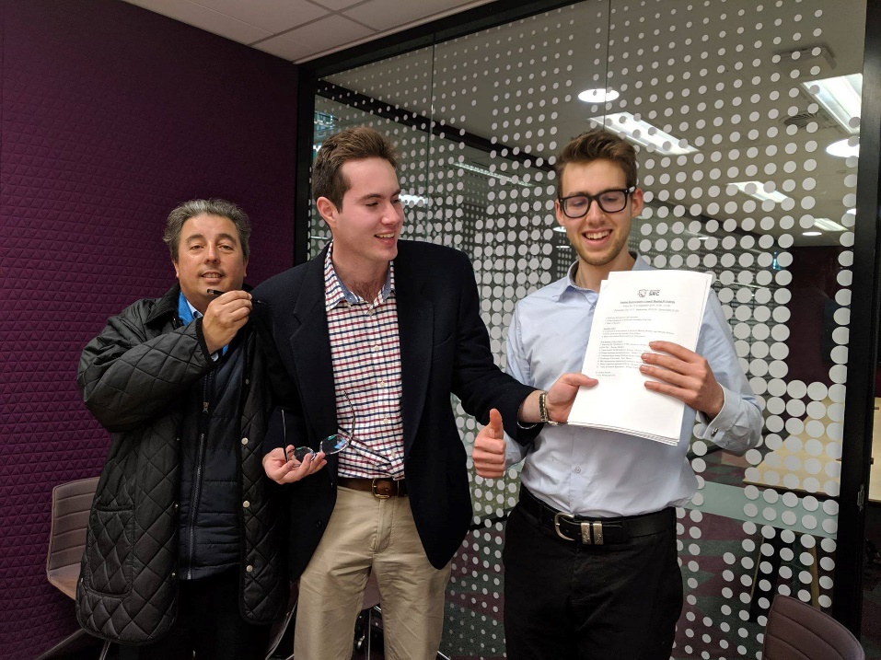

Helped facilitate the Western Wednesday event at the Collector hotel along with other members, and have since then taken on the responsibility of organizing the next and final Western Wednesday creating promotional material at meeting with the Hotel owners to get the best deal for WSU along with Chheda, Rohan, and Karthik, Anirudh

Attended and helped facilitate the fantastic First Year meet up event ran by Da Silva, Clare, and together we provided a very lively and enjoyed event for the student body. Fun competitions/activities were run between the students in attendance, and the winners of which won free double pass tickets to the aforementioned ball.
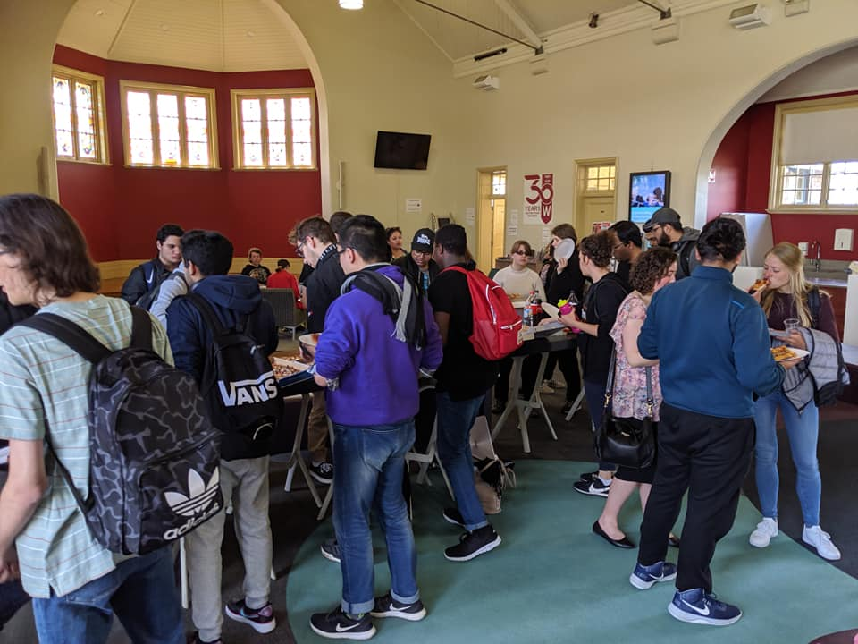
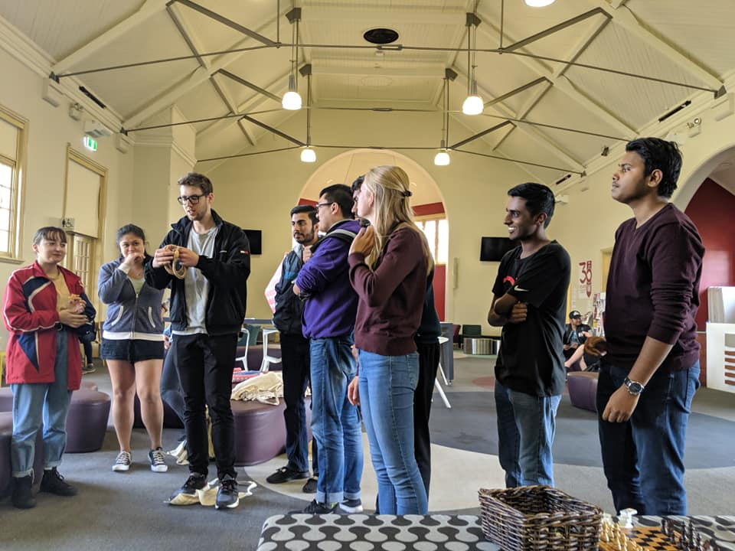

Helped the funding and organising, as well as provided representation and spoke at the Western Business Ball with Bojanic, Matthew, Da Silva, Clare, Vageesh, Jha, and Cupitt, Sarah.

I helped organize, fun, and represented the SRC at the event ran with WISIA the neon fun run which was ran in a group competition format between University Clubs and societies. This event proved to be a great success amongst students and will be investigated for future iterations by the SRC. https://www.facebook.com/pg/WesternSydneyISA/photos/?tab=album&album_id=2297978093787889&__tn__=-UC-R
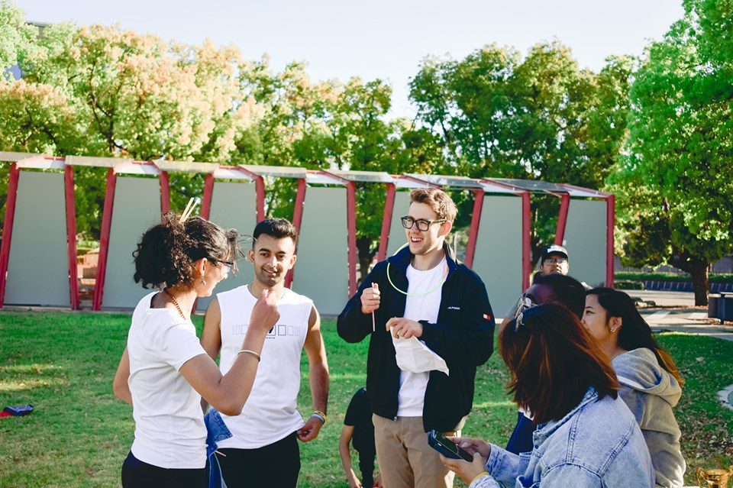
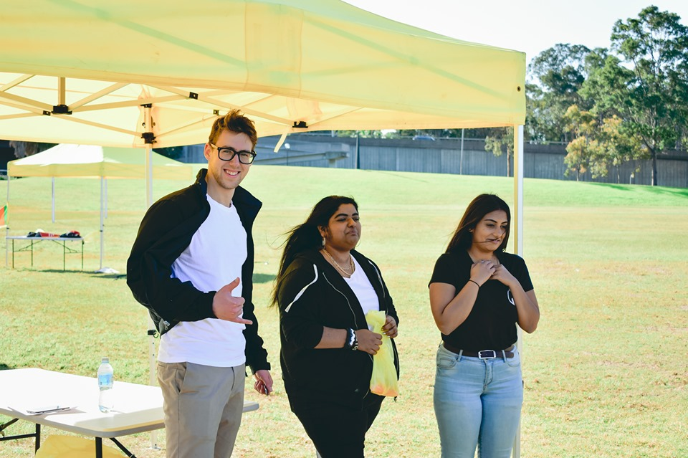

Ran an SRCxCAPS debate/discussion format event which proved extremely popular amongst students that attended, engaging with the student body and garnering important feedback about how to best improve campus life; and shall be an event format looked into for future events.

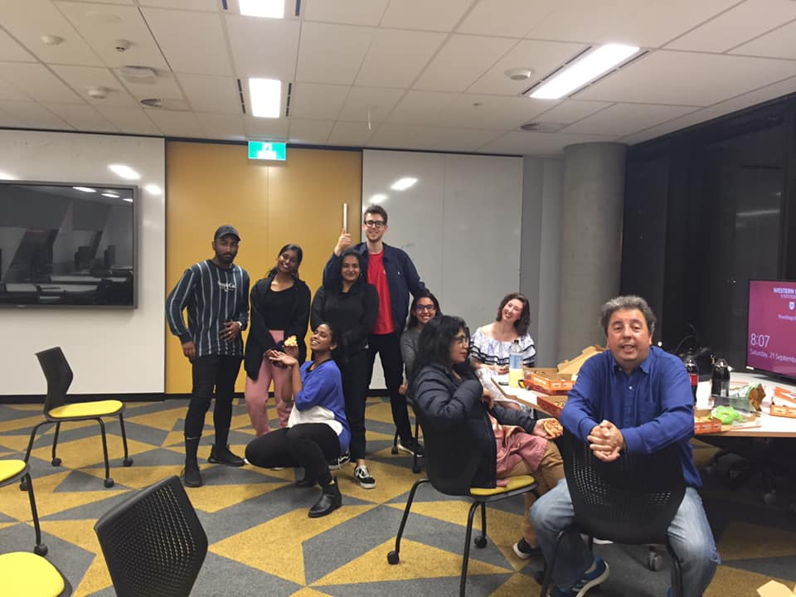

Attended the well-organized and structured students retreat run by Murray, Grant with other members as part of professional development.

Attended a Social Science formal working group with Hammond, Hollie on behalf of the SRC and talked to respective deans and professors about future plans for the school following the restructure.

Attended the SRC Procedural Review meeting and have taken the initiative of drafting the amended procedures document to be accepted by Council taking into consideration the conversations held and following input from members at the following scheduled SRC Council meeting.

Have been busy assisting with Parramatta city’s Thursday night soup kitchens, overseeing activities and providing an SRC presence whilst distributing SRC tote bags and engaging with a high number of students.

Have been busy responding with member enquiries via email, social media, and in real life; answering queries. In addition, I have been in contact with a large amount of students via social media regarding SRC concerns as part of general online SRC outreach.

Have committed to twice weekly walking around campuses meeting with the general student body; talking to and distributing SRC merchandise to learn about any concerns/queries that they may have, as well as getting vital feedback on how the SRC may perform best to suit their needs.

Bonatti, Daniel - Vice President Education (Postgraduate)

Background
I write a report greater than 200 words as I am in the Executive of the SRC. I am the Vice President Education (Postgraduate), & NUS delegate elect, plus CAPA delegate and Budget and Remuneration, Communication, SSAF Committee member. I am in the Faculty Engineering, Mathematics and Computing doing Graduate Diploma in Building Surveying. I am following my role as described in Student Representation Procedures Clause 14 & 15. I easily achieved the required 42 mandatory hours.
My activities have been restricted in September due to my larger course work load for my Graduate Diploma In Building Surveying, next year I may take leave to get more done for the SRC, though at moment accelerating my studies.
Activities – Schedule during September
- Chartered, 27-08-2019, Chartered Engineering Technologist certificate, card and letter prepared and printed by IEAust, for CEngT in Structural Engineering, Building Services Engineering, Leadership & Management, Civil Engineering.
- FELLOW, 27-08-2019, invited to Fellow IEAust, sent criteria.
- EWB 28-08-2019, Special funding Bid by WSUEWB President Caleb Amos, for HEC Humanitarian Engineering Conference.
- SRC training, 29-08-2019, tba, Bullying Recognising and addressing Bullying in the work place, Parramatta City
- AIB 29-08-2019, Call to NSW Chapter president about update on Fellow Application.
- Building Surveying, 29-08-2019, Stakeholder meeting at Dix/gardener to finalise FEB fire engineering report.
- Building Surveying, 30-08-2019, Assignment 2 due FEB Fire Engineering brief, group F team leader must get group to submit parts and select assignment to submit.
- AIB, 30-08-2019, 8 to 9pm, total 1 hour, Kingswood campus went to KW-Y Building with Building Construction Management level 2, spoke to Professor Phil Love and met Professor Alan Todhunter and phd student.
- SSAF, 30-08-2019, 9 to 1.30pm, total 4 hours, SSAF task force, meeting for allocation of funding of SSAF funds, Kingswood Campus, Richard, Jim, Keiza, Daniel, Hollie, Allen, Irene, and Mahein. Only the PAWS $12000 funding was stopped as the SSAF criteria does not allow research, though the program will get money another way. Employability Strategy program $400000, needs Chris to send information to SRC members on SSAF to know what the money is doing? Other small funding programs were dropped to tier 4 funding selection. The funding was almost %.9 million as per allocated funds for SSAF. (see Daniels notes report)
- Werrington South, 30-08-2019, Daniel out and about visit Werrington South campus, Kingswood station got on shuttle bus, walk into the HUB, 8 cows for breakfast, subway for lunch Co-op purchasing a tie and usb stick, visit the library, travel up and down lift found computer books very interesting example Java.
- Parramatta City, 30-08-2019, 3.30pm to 5pm, total 2 hours, Heritage Tourism and planning Expo.
- EWB 1-09-2019, 5 to 7pm, total 2 hours, Inter university coordination meeting at building 11 level 5 Engineering & IT in UTS, present UTS Jasmina, event coordinator, WSU Daniel, UNSW Kelly and on zoom USyd Francis, and
- EWB, 2-09-2019, follow up emails to WSU EWB president and members for action items previous days meeting minutes.
- SRC Meeting, 2-09-2019, Communications strategy meeting, Keiza, Mandi, Daniel, Allen and Mathew, Vageesh not present.
- Charity 2-09-2019, Thankyou letter from the Garvan Research Foundation, became a Partner for Discovery for my monthly donation.
- Charity, 2-09-2019, Letter, Thank you for joining Freds Team, for my monthly donation to Fred Hollows Foundation.
- Charity, 3-09-2019, Letter Congratulations as a Puppy Sponsor for my monthly donation to Assistance Dogs Australia.
- Chartered, 3-09-2019, Chartered Engineering Technologist certificate, card and letter arrived, in the mail for CEngT in Structural Engineering, Building Services Engineering, Leadership & Management, Civil Engineering.
- Project Management, 3-09-2019, follow up RPL application for Diploma in Project Management.
- Giving Day, 4-09-2019, 11 to 3pm, total 4 hours, This year, as part of our 30th anniversary celebrations, Western Sydney University first ever Giving Day on Wednesday 4 September. On Giving Day, in 24 hours we came together to make a genuine difference to the things we're most passionate about. I went to support students through scholarships or donate. This opens in new window towards one of our innovative research initiatives. Whatever it is that you want to get behind, together in just one day, we can make a real difference. See photo below 30 year sign.
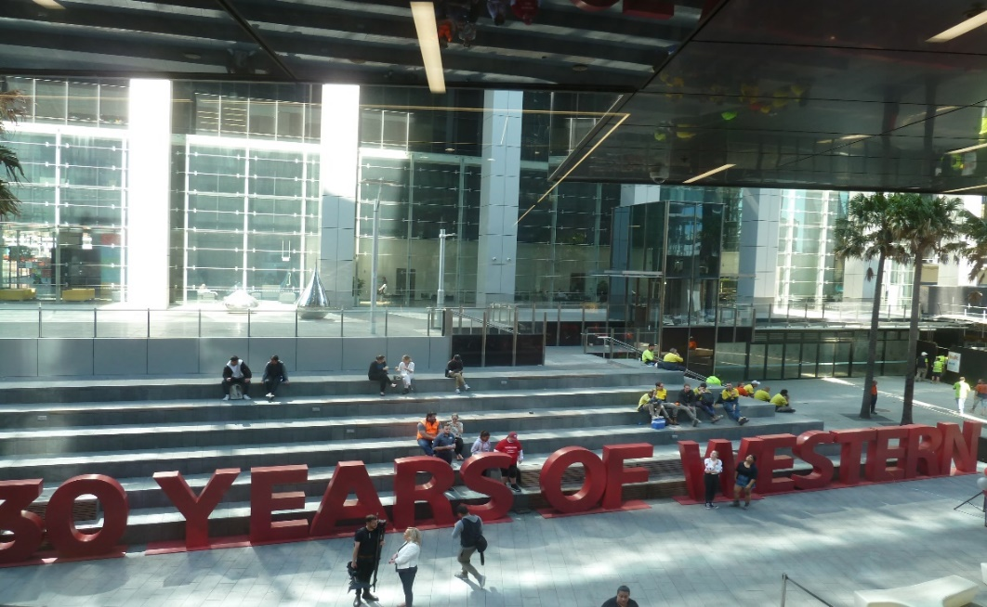
- Chancellor’s Challenge Abseil – 4-09-2019, 11 to 12pm, total 1 hour, Our Chancellor, Professor Peter Shergold AC, invited us to support him in the Chancellor’s Challenge Abseil on Giving Day. Professor Shergold and a brave group of Western Sydney University staff, students, alumni and friends will face their fears and abseil down “The Peter Shergold Building”, in the heart of Parramatta, raising funds to support scholarships and vital research projects at Western. See photo of abseil teams trying to get funds for scholarships.
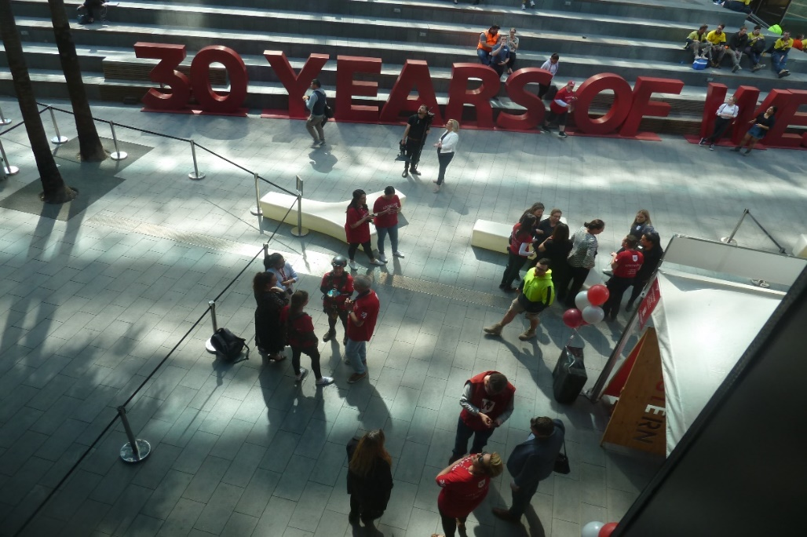
- EWB, 4-09-2019, Paramatta City, Advertising for EWB with posters.
- AIB, 4-09-2019, 12:00 pm to 2:00 pm (AEST), total 2 hours, AIB NSW Chapter: Pizza With The Boss. Meet the Bosses:- Chris Quinn, Project Leader with Laing O'Rourke and - Elliot Howse, Project Director with Laing O'Rourke Presentation from 12.00pm WSU Parramatta South Campus, Building EA, EA.2.13 followed by Free pizza and drinks from 1.15 pm - 2.00pm Parramatta South Camous Building EA, Lobby (ground level).
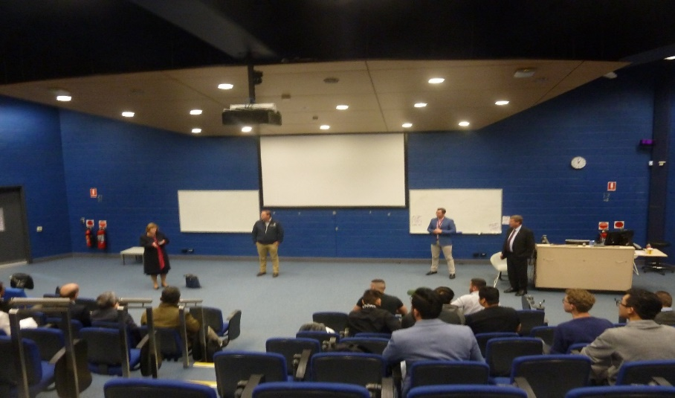
Laing O'Rourke Presentation from 12.00pm WSU Parramatta South Campus, Building EA, EA.2.13
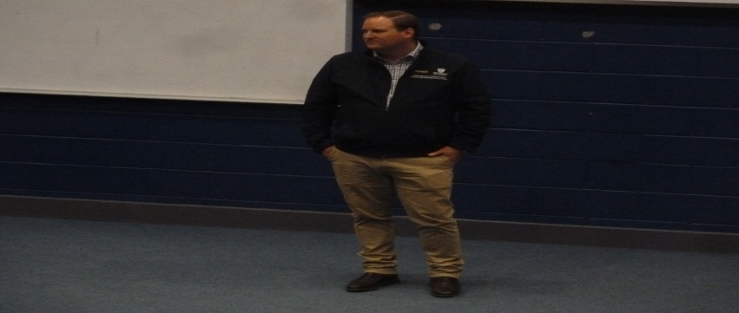
Meet the Bosses:- Chris Quinn, Project Leader with Laing O'Rourke 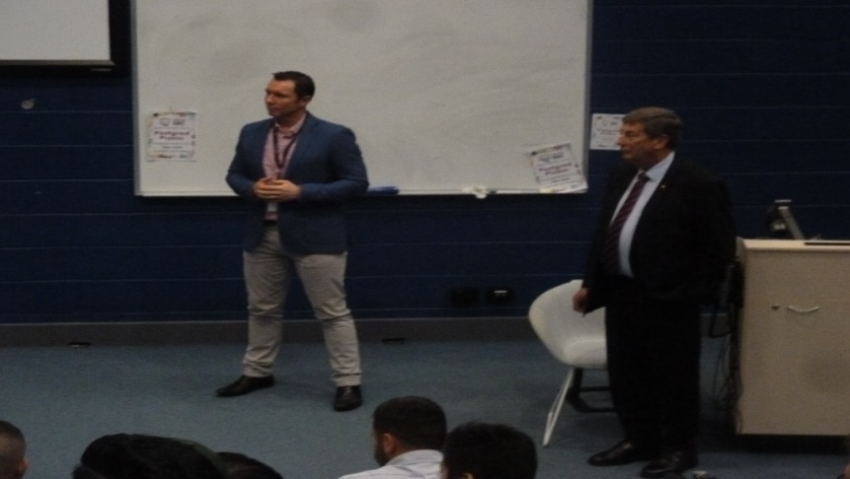
Elliot Howse, Project Director with Laing O'Rourke
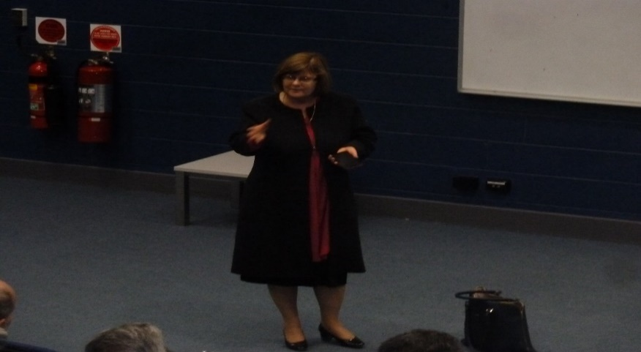
Deputy Dean Kerry London

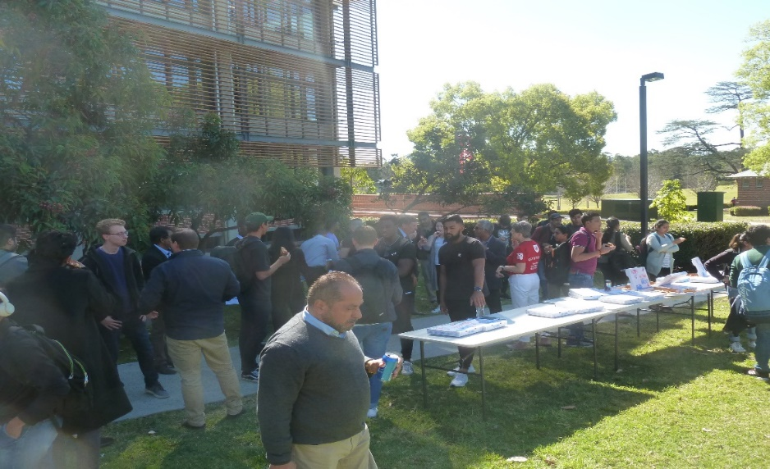
Free pizza and drinks from 1.15 pm - 2.00pm Parramatta South Camous Building EA, Lobby (ground level).
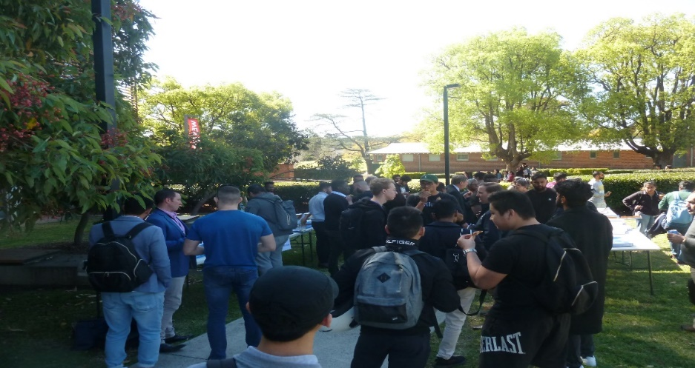
Free pizza and drinks from 1.15 pm - 2.00pm Parramatta South Camous Building EA, Lobby (ground level).
- CAPS, 4-09-2019, total 1 hour, Construction, Architecture, Planning society meeting, I met Matthew Kominski Young Builders Alliance.
- Heritage, 4-09-2019, 11-2pm, total 3 hours, Engineering Heritage Australia National meeting teleconference, Heritage partners with AIB. ·
- EHA Agenda done in EA’s format- please use this copy for reference tomorrow
- The EHA original Agenda – for your records
- Attachment 2.1 – Membership stats and breakdown – we will discuss this
- Two PowerPoints for social media (just a keepsake at this point)
Sarah Jenkins (General Manager, Strategy and Communications, Strategy & Analytics) joined us from 1pm in the Melbourne office for approx. 15minuets discussed the survey results.

- SRC Meeting, 6-09-2019, 12 to 2.30pm, total 2.5 hours, Contact from Vicky and Allan, caught by Bekker, Frederick W. on Procedural Working Group
- SRC Meeting, 6-09-2019, 3 to 5.05pm, total 2 hours, Full SRC Meeting quorum of 12 councillors.
- Budget 6-09-2019, Budget put into Orgsync by Bekker, Frederick W., for SRC Vice president Portfolio Postgraduate total $5000
- CAPS, 6-09-2019, Budget request for Debate Pizza Drinks Treasury CAPS Club application.
- CAMBODIA, 7-08-2019, EOI Expression of Interest to go to Design Summit & study tour.
- 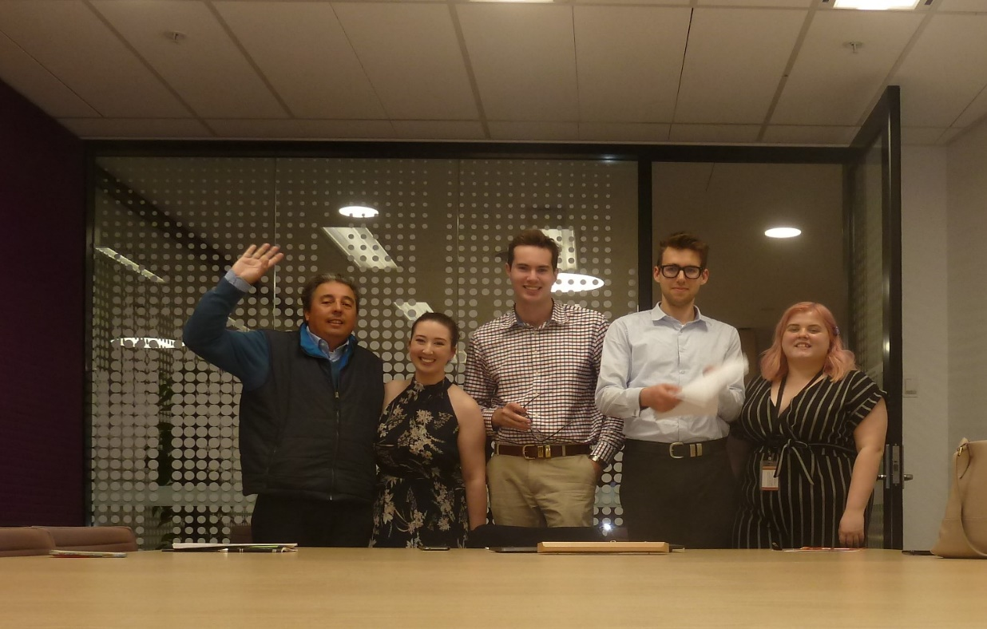
- Budget, 9-09-2019, Budget allocation in Orgsync $5000 allowed Charbel and Grant.
- Bankstown, 9-09-2019, 11 to 3.30pm, total 4.5 hours, Kha Nguyen Testing two new modules for SRC training, Structure & Meeting Practice.
- Request to attend Conferences, 9-09-2019, 8 to 11pm, total 3 hours, Application for TEQSA & HEC EWB, and Payment request July Postgraduate Picnic
- Request to attend Conferences, 10-09-2019, 7 to 9pm, total 2 hours, Application for CAPA
- Building Surveying 11-09-2019, 9am to 5pm, total 8 hours FEDA Fire Engineering Design Assessment,
- Standards Australia, 13-09-2019, Received Certificate, letter & standard AS 4848.1-2019, from Standards Australia for standards on the CH-003 Paints and Related Materials Committee involvement to make contribution to development Standard AS 4848.1-2019 Application Specific for coating systems Part 1: Single coat inorganic (ethyl) zinc silicate- Solvent borne (Passive Fire protection)
- CAMBODIA EWB- Congratulations Letter Engineers Without Borders (EWB) I would like to warmly welcome you to the Humanitarian Design Summit educational study tour, you have been selected to participate in Humanitarian Design Summit - Cambodia February 3rd - 16th 2020, On behalf of Engineers Without Borders (EWB) I would like to warmly welcome you to the Humanitarian Design Summit - Cambodia February 3rd - 16th 2020. To confirm and accept your place on the program a $500.00 deposit will need to be submitted through the Deposit Payment page by 22/09/2019. The deposit will confirm your place on the trip and is non-refundable. The $500.00 deposit will count towards the total trip cost of $3,500.00. Your place on the program is not confirmed until your deposit has been paid.
- EWB 15-09-2019, 5 to 7pm, total 2 hours, teleconference inter-university coordination for Humanitarian Engineering Conference, found qpay system ticketing is down, further prepared conference rewrite of participant information pack change in time for train journey 2.18pm Friday 27th September
- Building Surveying, Assignment 2 open subfloor impact on survivability of buildings, Due 16-09-2019, Course Building in Bush fire Prone Areas, submitted.
- SRC Training 16-09-2019,total 12-3pm, total 3 hours, includes lunch(not involved) Student Representation Procedures Review Workshop, via zoom, at Bankstown Campus.
- Building Surveying 17-09-2019, total 8 hours, Building in Bush fire Prone Areas
- Sydney Tour 18-09-2019,9am to 12pm, total 3 hours, Opera House for Constructing our World Conference.
- Sydney Tour 18-09-2019,2. 30pm to 5pm, total 2.5 hours, Barangaroo Towers for Constructing our World Conference.
- Honorariums 19-09-2019, Due date for Quarterly Refection Report & ABN Form
- Conference, 19-09-2019, 9am to 5pm, total 8 hours, Australian institute of Building Constructing our World Conference.
- Conference, 20-09-2019, 9am to 4.30pm, total 7.5 hours, Australian institute of Building Constructing our World Conference.
- CAMBODIA EWB, 20-09-2019,New Colombo Grant for Design Summit and study tour.
Congratulations Letter! Western Sydney University is pleased to offer you an Australian Government New Colombo Plan Mobility (NCP) Grant.
This grant of $3,000 is being provided by the Australian Government to support your participation in the Cambodia 2018 21979 mobility project to Cambodia.
- HATS, 21-09-2019, Joined Heritage Tourism Student Society
- Engineers Association 21-09-2019, Joined Engineering Society
- CAPS, 21-09--2019, 6 to 9pm, total 3 hours, Construction Architecture Planning Society, third meeting, ISPQ level 2, Pizza Night.
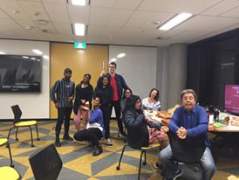
Members and new members of CAPS 21-09-2019
- EWB 22-09-2019. 6 to 8pm, total 2 hours, final face to face meeting for inter-coordination of the HEC Humanitarian Engineering Conference, next meeting zoom on Thursday night. Present WSU Daniel, UNSW Kelly, Deanna, UTS Jasmina, USyd Frances.
- Building surveying 22-09-2019, Assignment 3 FER Fire Engineering Report, due for Course FEDA, Fire Engineering Design Assessment.
- CAMBODIA EWB- 23-09-2019, paid $500 deposit for Design summit and student tour to Cambodia.
- ACA 23-09-2019, confirmation of cross university credit transfer for interest in course at Australian Catholic University towards Western Sydney University
- Bankstown 24-09-2019, 12 to 1pm, total 1 hour, out and about, visit Bankstown had lunch Chicken sub and chips and fanta, found out its been years students do not get a discount as a student. This should be issue for SRC.
- Remuneration Committee 24-09-2019, 2 to 4pm, total 2 hours, Remuneration Committee SRC Vice President Education Postgraduate to check SRC Committee councillors Quarterly Refection Report & ABN Form so as to pay Honorariums
- EWB Conference 27-29-09-2019, Friday 1.45 to 9, total 7 hours, 8am to 9pm, total 13 hours, 8am to 9pm total 13 hours, in total 33 hours, Engineers Without Borders, Humanitarian Engineering Conference, Blue Mountains Hazelwood Flecther Camp

Feng, Allan - Ethno-Cultural Representative

The September period has seen the Ethno-cultural Collective (ECC) plan for our upcoming events, namely the second “International Student’s VISA Information Session” and the “Shared Space Student Forum”.

“International Student’s VISA Information Session”, collaboration between Western Students International Student’s Association (WSISA), Unions NSW and the ECC will be held again on Thursday 17th of October 2019. I have contacted the Ethno-cultural Representatives and SRC/Student Union/Student Associations of most universities in Sydney as this second event will be open to all international students.

We will also be hosting a student forum at 1PSQ campus from 12 PM – 1 PM on Friday 4th October surrounding the issue of the use of shared spaces. This “Shared Space Student Forum” event is collaboration between the ECC and Chaplaincy and will feature free pizza.

I also actioned on the SRC Agenda item by forming the Equity Collective’s working group and holding our first meeting. We discussed several important issues related to our equity collectives and facilitated several cross-collective collaborations. I will brief the SRC during general business at the October SRC meeting, time willing. The minutes are available to other SRC members upon request.

Finally, the ECC held our first collective meeting this year on Wednesday 25th September from 3 PM – 4 PM. During this meeting, we discussed several important items such as creation of collective executive positions and the plan for the collective going in 2020. The minutes for this meeting will be uploaded to the collective Orgsync page and are available upon request.

Planned initiatives

1. International Student’s VISA Information Session, round 2 as above.

2. Student forum in collaboration with Chaplaincy, as above.

3. End of semester celebration dinner, as per previous report.

Education

This month, I have watched the following lecture series from the Affinity Intercultural Foundation: · https://www.youtube.com/watch?v=EEV2lieZLbU · https://www.youtube.com/watch?v=ATE2gRzFsgs · https://www.youtube.com/watch?v=Cw_ymA6apXI&t=335s

I also attended the Student Representative Retreat and the “Diverse Minds” conference delivered by the UNSW Student Minds group at the UNSW Roundhouse.

Ferrer, Natasha - Liverpool Campus representative

Introduction:
As a newly appointed student representative, mixed feelings of joy, passion and uncertainty has been experienced. Though I am new, a feeling of incompetency lingers in my thought, however, through the support of SRC members and WSU staff, negative feelings and perceptions are tamed to an extent. During my time as a new representative, there have been many events that I have experienced as well as many requests and notions for the Liverpool campus.

Attended Events and experiences:
One of the first experiences I had was attending an SRC meeting. During this meeting, I was able to further understand the culture, procedures and framework of my position. A more recent experience was attending the Student Leaders retreat at Olympic Park. During this experience, I was able to become acquainted with many SRC members and WSU staff. An initiative which my team and I had created involved a grooming and handover notion. In regards to the grooming aspect, the purpose of this initiative was to potentially “scout” future SRC members and other leadership opportunities. Once identified, the student who show potential are “groomed” through leadership courses, enhancement of knowledge and given responsibilities. This enables the handover process to be smoother as the future representatives are already exposed to the leadership environment. The handover process all involves initiatives such as access to past reports, past member assistance and documents revealing helpful hints, frameworks and ideas. Another experience I had was gaining access to the Liverpool campus's specified rooms. To further initiate on the grooming and handover notion, I had added a new idea to my weekly schedule. Each week, I will dedicate one hour to physically going around my campus and talking to students about what they like about the Liverpool campus, what they dislike, what they want to see more, etc. This week I had encountered eleven individuals. Only three belonged to Liverpool while the rest were located at different WSU campuses. From this experience, Liverpool Campus was described as a tranquil and quiet place with clean environments and friendly staff and student. The only complaints or worries I received were of air-conditioning fluctuations, lack of social event and club opportunities, poor vending machine choices and a lack of study spaces. I had recorded all positive and negative comments in a logbook I named “Log of praise, complaints, worries and comments”. Not only does this allow my choices to be influenced by the student body, but I can gain a positive relationship with students and raise awareness of the SRC’s nature and values.

Current initiatives and notions in Liverpool Campus:
My only current initiative for Liverpool Campus is the physical weekly rounds and an upcoming campus forum. Leading up to this forum, I have become associated with CBM Liverpool members, Liverpool academy representatives and student soup kitchen members and will invite members to the meeting. I will most likely make posters or send emails to Liverpool students to ensure a decent attendance. This notion further supports the grooming and handover initiative.

Future initiatives and notions in Liverpool Campus:
Being a volunteer at Campbelltown campus for R U OK? Day, I had taken the opportunity to survey and talk to Campbelltown students. One notion which has caught my attention was the students praise towards the “natural” and “calming” aura Campbeltown’s flora had provided. To mimic this, future notions of indoor plants and a possible vertical garden could be implemented into Liverpool Campus. Another initiative suggested by Liverpool Academy representatives to help de-stress students was yoga and de-stress event. Notions to help voice the students' needs involve “pop-up question boards” which allow students to physically interact and write responses to question provided and collaborating with course co-ordinators for information to be put out and received. In regards to clubs, in the future when there is a greater club ratio, I intend on creating a monthly club gathering where clubs can set up stalls and advertise as well as network with other clubs. To further expand Liverpool’s events to students and the public, the creation of social media pages dedicated to the campus may be created. Campbelltown’s TCM Deputy President, Christine Yen has requested to have an exhibition at Liverpool Campus relating to Traditional Chinese medicines and raising awareness and spreading knowledge to the community about these properties. Lastly, through the acquaintance of Mr Dionisopoulos, I have been added to the provost committee and will be addressing some issues, concerns and initiatives for the Liverpool campus.

Updates on initiatives/notions:
N/A

Further notes/comments:
During my weekly one hour rounds of talking to students around Liverpool campus, when I asked what they think the SRC is, they had no understanding and some did not even know the existence of our group. Another concerning observation of mine was that students don’t understand that they have a voice towards their doubts, concerns and even towards the events and initiatives made for them. I am unsure how to tackle this concern and will seek advice from other SRC members and staff.

Personal Reflection:
Being elected to be Liverpool Campuses Student Representative, I must remember my main purpose in daunting times. As challenging and difficult as my role may seem, I am overwhelmingly honoured and privileged to have this role and will continue to deliver quality performance to the best of my ability.

Aditi Sengupta - Campbelltown Campus Representative

I have worked towards identifying and promoting the interests of all students on my campus, and collaborated with the Student Campus Council and other SRC members. I have spoken to fellow students about Food outlets and prices at the university, Parking and transport, Student services, Clubs and societies, Campus ideas and activities and have encouraged them to engage with the university. I had a meeting with Tooba Anwar on future events. I also emailed Hussam Jabran, Campus Life coordinator regarding holding an educational action group meeting. I have submitted an event request for a climate change placard making activity (these placards will be used at the climate strike that some WSU students are participating in (informed by Tooba)) on Campbelltown Campus which has been approved. I have communicated with the Western Sydney Medical Society who have expressed an interest to participate in climate related events and invited them to collaborate with this event. I also represented the SRC on 12/08/2019 at the Bluestocking Week Lunch which was a great opportunity to celebrate women’s achievements. I also restocked the kitchenette and emailed Hussam about the lack of tea, almond milk and other amenities. I communicated with Grant on possible ways of creating a student education action group and a student group to discuss university services. I am currently in the process of planning posters and feedback options for students to report any difficulties or concerns regarding university services such as counselling services, shuttle bus service. I have attended all SRC meetings till date via Zoom and submitted my reports.

Hammond, Hollie - Penrith Campus Representative

September has been a quiet month compared to the previous few, as I was in and out of hospital the entire first week, culminating in the birth of my daughter on the 5th. Despite this I’ve still been consistently engaged with my SRC responsibilities, including a significant number of meetings from home.

This month I attended a meeting for SSAP Student Associations in an effort to further cement the relationship between the School and School-based student clubs. I was also invited to attend the upcoming SSAP Learning and Teaching Committee as a student representative. This is important as the SSAP student population makes up a large portion of Kingswood students, with the Student Associations meeting being very relevant to campus life.

I attended a student advocacy meeting alongside Kezia and Grant, with promising results (please see Kezia’s report for further details).

I’ve also been in contact with Matthew to find out more information about how to set up the Services and Facilities Forums for Penrith, as per my position description. I’ve decided the best way to implement this event is to combine it with the “Donut Stress” end of semester event I’ll be running in conjunction with the Psychology Society, in the hope we’ll have a higher number of present and engaged students on campus. I’m also planning to create a qualtrics survey for students to provide feedback and data that I can analyse in more detail later. I’m also investigating the idea of creating an online space, potentially utilising social media, to support this work.

I’ve also continued my involvement with the Climate Caucus, in partnership with other students and staff, particularly Danielle the Environmental Rep; I created a petition for students and staff calling on WSU to endorse the Strike, and Danielle presented it to the Vice Chancellor. We had some success with his executive response to WSU staff and students. I’m hopeful that it’s the first step toward more proactive efforts by WSU around climate issues and look forward to continuing this work.

I attended the SRC Procedural Review meeting, and also had individual meetings with Richard, Matthew and Kezia throughout the month. I also attended the second meeting of the Academic Senate Review working group as a student rep.

I held a stall with fellow exec members of the Psych Society at the Psych Careers Expo, which allowed me to engage with a number of students to promote Donut Stress and discuss both campus and academic issues.

Dunn, Kezia - Women’s Representative

WoCo shared at stall at Western Fair with the Queer Collective, sharing treats with students and encouraging students to follow our social media pages. Feedback from the student body was excellent and students were excited to hear about events in the pipeline.
WoCo released its new inclusive branding. Dzenita Semic (Parramatta Wom*n’s rep) and I created the new imagery, Dzenita creating the amazing new logo and myself drawing a banner using NSW state flower, Parramatta wattle blossoms and Australian blue bees. Students have responded very positively to the new look and particularly to the update in language, ensuring an inclusive space for gender diverse people in WoCo.
The Wom*n’s collective networking nights have been booked for Parramatta South, Cambelltown and Kingswood. The first day alone saw 17 signups to the events. Sharon Roy from Diversity Fest has been secured as the Parramatta guest speaker and Alumni have been invited. The response on social media has been excellent, and the first event will be held on Thursday September 12th.

I helped to review the special meeting minutes and correct spelling and syntax errors to facilitate speedy release of previous minutes.

I attended the first SSAF meeting on August 30th to discuss allocation of funding. This process is ongoing but it is important to ensure student voices are heard at these meetings. I will continue to follow up and advocate for programs with tangible benefits for WSU students.

I met with Lauren Gecuk from Respect and Equality about university policy, vision and future projects for reducing rates of sexual assault on campus. The meeting was extremely productive and I look forward to continuing to work with Lauren on informing policy, procedures and advocacy.

Myself and Hollie Hammond (Kingswood Rep) are currently pursuing advocacy action for a student who has found herself excluded from WSU carer’s policy allowing her to change tutorials as her childcare needs are not covered by legislation. We are in continued discussions with relevant bodies and are preparing to take the case to Academic Senate.

Myself, Hollie Hammond and Frederick W. Bekker (Secretary) met to review all EOI’s for the new SRC president. We developed a fair rating scale to assess applications and narrowed down to six individuals who will subsequently be interviewed.

Clare Da Silva - Parramatta South Representative

Since the last meeting, I have attended several events and have worked on different initiatives to engage and assist students.

Meetings:
SRC Retreat - One major meeting I attended was the SRC retreat where we gained valuable training on how to work through different issues the SRC is currently happening. Something I brought to light was the issue of handovers for new incoming SRC (both in this term and for next year’s elections). I had new members express some concerns about being unsure of what their role included or how to go about certain initiatives. We were able to work out a good plan regarding how to better engage new representatives as well as create a long term plan for next year. Another important concern was advocacy issues and how to engage with students regarding the feedback that they have. Recommendations were made in regards to creating a clear and easy system for the SRC to follow to allow a better feedback loop.

SRC Office and Posters:
I have kept on schedule with cleaning up the shared office space including the kitchenette and the office itself. There has been the issue of the boxes of post-it notes and bags taking up a lot of space and limiting accessibility. I know that campus life also utilises our office space too. In regards to different posters, I have assisted with creating a draft poster for the upcoming Western Wednesday and once finalised will assist putting them up around campus and having a few at my upcoming event “Make your own pot plant”. I also have printed and with some assistance from Frederick, have put up posters for different events such as the Western Wednesday battle of the bands and First years meetup.

Advocacy:
Over the past month, I have had a few students contact me regarding concerns over approving clubs, clubs funding and events and security. One common theme is that there are delays in the process for approving clubs. Students starting clubs have been met constantly with red-tape about starting their club and have even been processed slower than other clubs which has then resulted in that club being denied due to other similar clubs on that campus (these clubs had just moved there and have apparently put in forms later but still processed before new club approval). Moreover, the Bangladeshi society’s president reached out to me regarding their application to host their “Diversity Fest” event. This was denied by security. I told the student what options were available and contacted Matthew Bojanc about the situation. We then forwarded this issue onto campus life who assured us they were on top of it and said that the event should go through. I made the student aware of these communications and told them I would keep on this case. This is an on-going process that hopefully will be resolved.
I also had reached out to the bball club in order to promote different SRC events and was informed that their club no longer existed. This was due to issues with funding requests being put through and not accepted, emails from Matthew Stansfield that kept saying the club was ‘not set up properly’ and yet provided no clarity as to why nor any assistance, the university taking over 6 months to approve a club logo to print on shirts and more. I am following this issue up as the individual directed me to speak to other clubs that have had similar issues.
Events:
Western Wednesday:
I helped facilitate the Western Wednesday event held at the collector hotel. This event ran pretty smoothly with a relatively good turn out. I stayed for the entire event and took some photos of the event, getting people to like the SRC page and asking what they would like to see more of on campus.

Town Hall Meetings:
This is an ongoing project as there are 3 separate town hall meetings needed. I am wanting to get a time that suits all attendees and am reaching out to different departments to get them onboard. I plan running the event like an informal Q&A session in order to get students engaging. This style will vary depending on the event as I also want facilities to be able to interact one on one with students. I have also answered emails from new representatives about different ideas for their own events and helping them with different tips and tricks on how to get students engaged.
First Years Meetup:
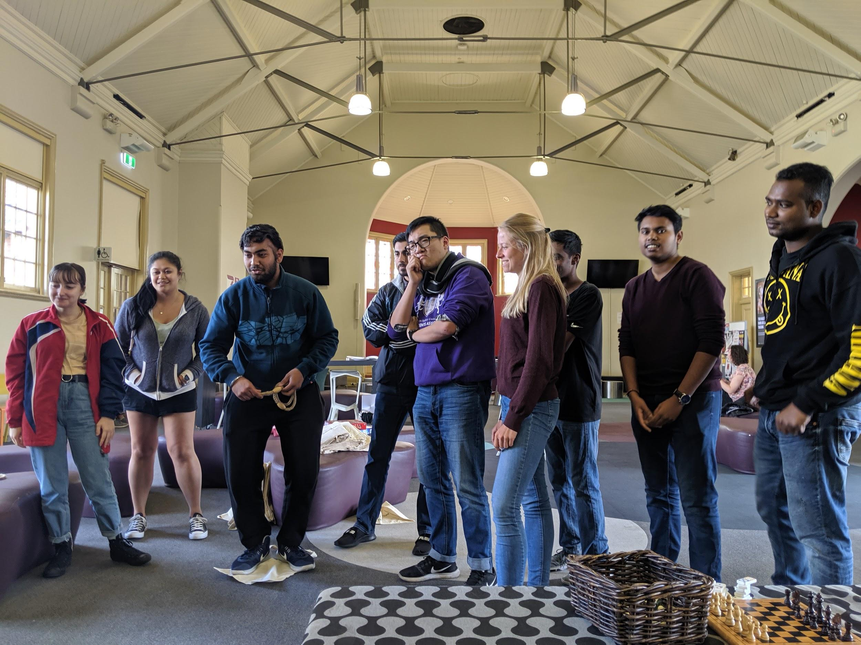
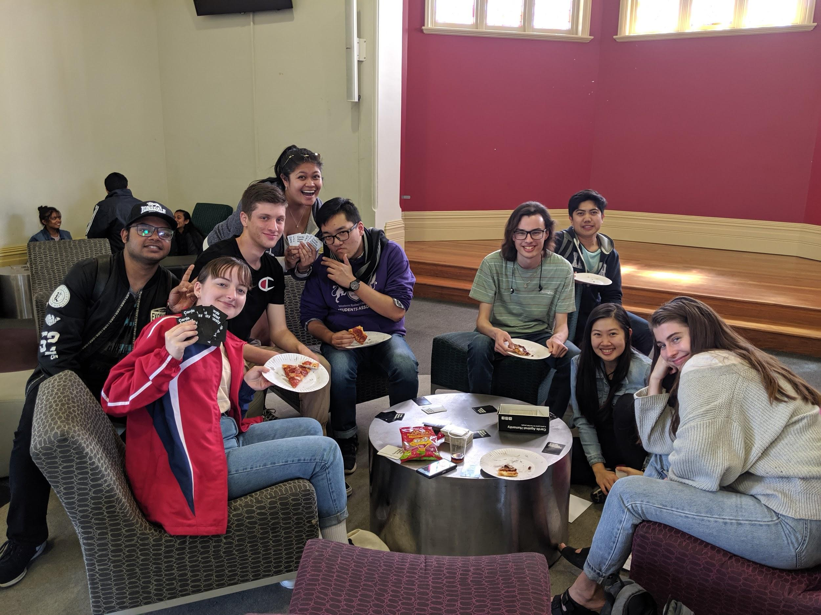
This event was super successful in that we had quite a few students turn up. The cost of said event was about $200 for pizzas, soft drinks, lollies, cutlery and utensils. The pizzas had a deal with WSU by calling them directly saving around $30 and having it delivered. The pizzas did run out quite quickly and in the future event would suggest getting more than 15. Moreover, the different board games such as guess who, cards against humanity and the play station worked really well. We also had the free ball tickets that students competed for in a game of bang and hoops. In future events, I am wanting to overcome the amount of waste that these events create and think that having reusable utensils would be a good idea. This can tie in with such merchandise ideas as reuseable straws and bottles.
Make your own Pot Plant:
This is an upcoming event held on October the 1st. I have worked with Nap to set up the event and would like to thank Mandii for answering all the questions I had regarding how she ran this event herself and what worked. Nap has booked a car to get the materials needed and I have created and am sharing the facebook event.

Kathik, Anirudh - Parramatta City Campus Representative

In the last few weeks we made a comeback for the western Wednesday that was hosted last month with the help of the university band. Frederick, Rohan and I recently talked with the management at the collectors for the nest western Wednesday that is to take place on Wednesday 2nd of October. We also had a chat with the management from the commercial for future events if we need a change of pace for the western Wednesday. Most of the students from the city campus were requesting that a new table tennis table be brought as not many people could pay due to which a table was ordered for $365 and some students were asking for coffee and tea stations in the cuppa areas in city campus will be done soon. Currently Frederick, Rohan and I are planning to host an event in city campus either before or after the semester ends. Some students were also talking about wanting a pool table which will be decided with the help of campus life if we can get space for it. Currently having a chat with some of the reps for hosting the campus Olympic for future events.

Cupitt, Sarah - Online Students Representative

- I have continued to undertake training for my role through workshops, UNSW Roundtable, NOWSA and the SRC Retreat, to name a few.
- I have been continuously following up on actions assigned to me in SRC meetings such as working with Charbel and Kezia for the SRC website, comms strategy, co-ordinating competitions such as free tickets for the Black-tie ball and FOMO 2020 on the SRC social networks etc.
- I have been attending on-campus events and uni events to engage with online students and understand the different types of online students as to better plan future initiatives for the Western Online Students Association and collaboration with campus life.

Other:
- Silly Sock September - Helped previous Bankstown rep Kiara w/event and took over 200 photos throughout the day
- CAPS Catch up event with Bonatti, Daniel & Bekker, Frederick W.
- Da Silva, Clare’s first-year event also with Bekker, Frederick W.
- SRC Procedures Meeting
- Submitted quarter two honorarium documentation
- I will be hosting the Online Students Services and Facilities Forum on the 30th of September from 6 pm - 8 pm. The Online Students Services and Facilities Forum will allow online students to ask questions and make suggestions for the online community at WSU to promote and maintain a pleasant environment.
- I emailed online staff and students to assist in sharing the event. I also spoke with Nicole Bridges regarding useful tactics to engage students - since I can't use food as a bribing tool like for campus events. Permitted me to share the Forum and association in the WSU Communication, Creative Industries and Screen Media Facebook group. Also shared to the SRC Facebook page.
- Finally finished the interactive website platform for WOSA https://westernonlinestudentsassociation.weebly.com/ - FAQ, online student support with contacts, blog, feedback etc. Also promotes the online rants and online love letters Facebook pages.
- Will be liaising with Online Program coordinators (staff) in an attempt to channel student feedback to them.
- I've submitted two poems I recently wrote - unsure what style W'SUP is seeking
- Articles lined up include the WSU competition: who bleeds wins (Mandii - SRC)
- The HCA Engineering conference which also links to the new CAPS society
- Could advertise the Wellness Walk opportunity in the student newspaper? It's a great initiative for students to get involved in and also meet other peers. If not, Andrea Earl is happy for me to write a follow-up piece after the event (lots of photos that way)
- Also working on two challenging 'how-to' articles. One being an advice piece on how to stop procrastinating and get HD's. The other is about taking the first step toward financial freedom with a student budget!
- Website updates: Uploaded all meeting, agenda and member report documents to the SRC website as per Bekker, Frederick W,'s request as per procedures

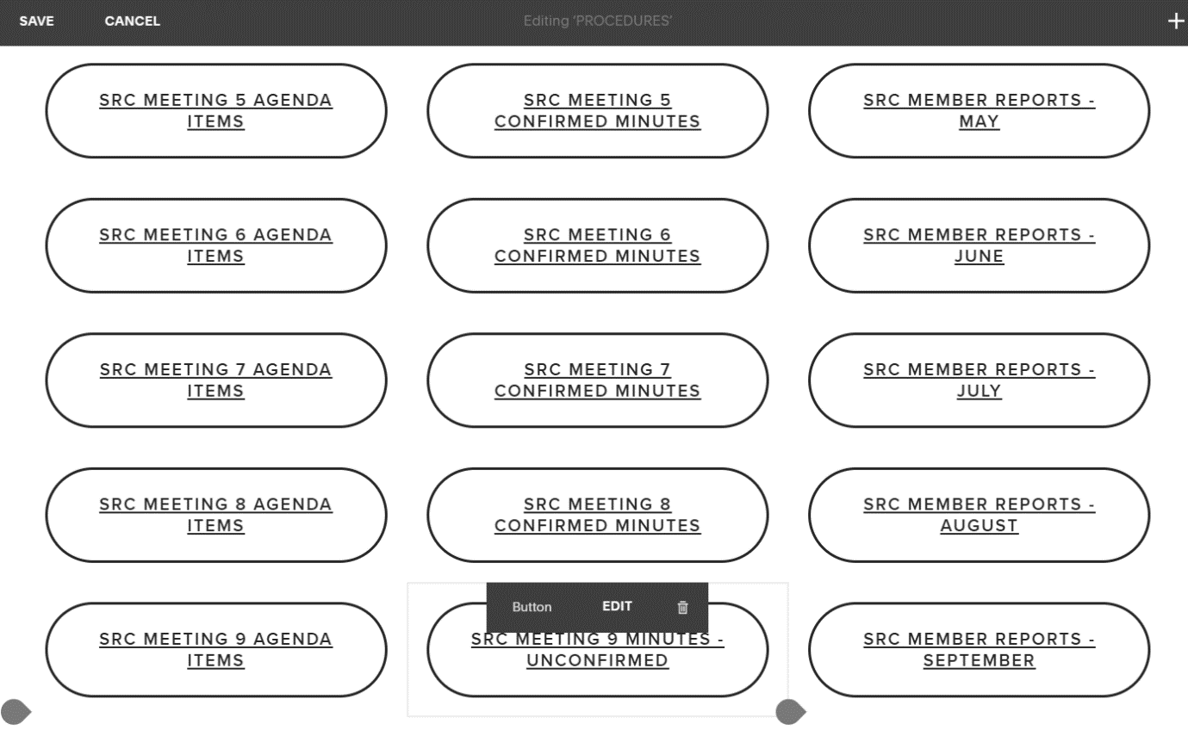

- Also asked Chanelle for an update on who the current student editors are for the SRC website.
- Promoting the start-up of the Arts Society
- Updated the current editors on the members' page and student newspaper page:
Priyansha Kohli
Radia Muhammad
Jostina Basta
Chantelle Al-Khouri
Sinead Simpkins
- Chanelle will let me know who the new member is next week as they have a vacancy at the moment. She'd also be happy to review my articles (they all sounded really great) for publication once I've finished them. W'SUP is also working on their next print edition - might get some included in it depending on the theme. Open to suggestions for success stories on SRC to build the reputation back up with students.

SRC Shenanigans (Just a couple of photos)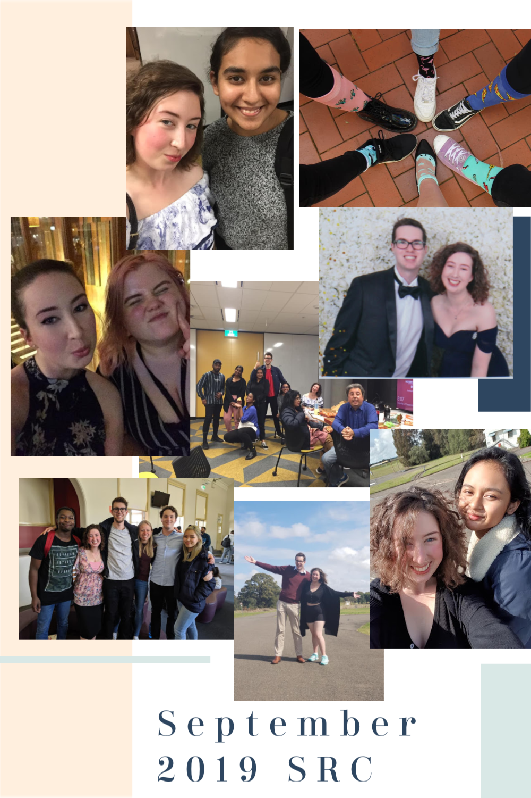

Danielle Wolf - Environment Collective Representative

So, I missed last month hence have tried to make it up a bit here:
- The Collective had a presence at Kingswood and Parra South Fairs this semester. Parra S saw a lot of signups and signatures on the climate strike petition. We now have almost 100 people on our mailing list, and a significant number of people interested in being involved as members.
- We have reps on most campus now (and a few extra), with most having a specific interest which is great, as they can take on project lead roles. I have thrown together a few suggestions for initiatives and I think in Term 4 the Collective will pick up visible momentum. The Collectives as a whole have also begun a working group (thanks Allen!) to brainstorm specific procedures, position descriptions, handbook etc. I think this will have some great results, aside from the opportunity to get to know one another and develop collaborative projects.
- I have also spent the last couple of months networking with staff and academics, particularly Roger Attwater, about current sustainability related things in Western. Roger has begun a series of ‘Resilience Roadshows’, and the Collective presents at these from the student perspective. It has become a great way to bridge the divide somewhat between disciplines and areas, although students are yet to attend. Still, we have made a couple of good contacts so far. Today we had the Hawkesbury officer presenting, which I’m thrilled about as it’s awesome to have someone else stepping up! Prof Simon Barrie (pro-vice chancellor learning futures) has shown some interest in partnering with us and is seeking some corpus funding.
- I have gone through a lengthy application process with the UN SDSN Youth and Western has been accepted into their SDG Student Hub project, which is an unreal opportunity for us (although will also be a ridiculous amount of work). It offers amazing professional development opportunities including the possibility of travel for students who really get involved. I am hoping this will provide incentives for commitment and motivation. The Hub initiative will offer plenty of chances for training and networking, as well as how to engage people (i.e., students, community) more effectively.
- I have spent some time speaking with Eric Brocken about expanding the Kingswood garden project elsewhere on the campus and am also exploring using it as a “classroom” for environmental sustainability workshops in collaboration with himself, and external groups, i.e., Lyttleton Gardens, Farm It Forward (a new initiative). This term I will have the starter garden installed and hopefully at least a couple of workshops. I am planning several events – Busy Bees (meet your environment champion), The Birds & The Bees (short workshop series), Get Your Hands Dirty (cleaning crew for local sites) and hopefully a Fair of some kind (although that may need to wait until next year).
- Tooba Anwar and various staff and students formed the Climate Caucus to prepare for the Sept 20 Climate Strike and that took up a huge amount of time. We had a petition to the Uni about endorsing the Strike, and people’s right to Strike, among other things, as well as a Forum which was livestreamed on FB and also organising a WSU contingent. It is exciting to see how much awareness and interest there is across the Uni on these issues – to go from zilch for the March Strike, to a letter from the VC, sizeable petition, Forum and large group of students at the March itself is fantastic and hopefully a sign that I’m doing something right!
- While I have been in touch with the relevant NUS contact they have unfortunately had to cancel our first appointment and then the Climate Strike just had everyone crazy. I am aiming to connect with them again this term.
- Sourcing merch and advertising materials has taken longer due to exploring as many sustainable and eco-friendly alternatives as possible. I have settled on an advertising supplier however merchandising is proving a little tricker.
- I think I’ve forgotten a lot, but it’s just been so insanely hectic. I have however included some photos for your enjoyment 😉

- 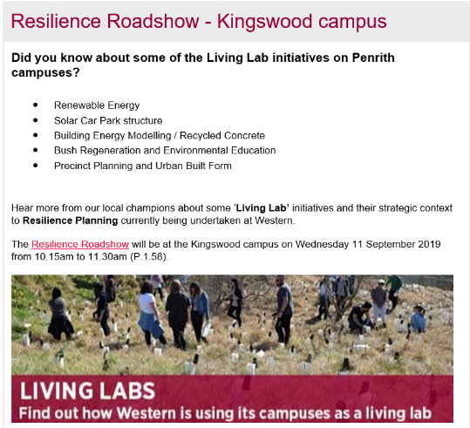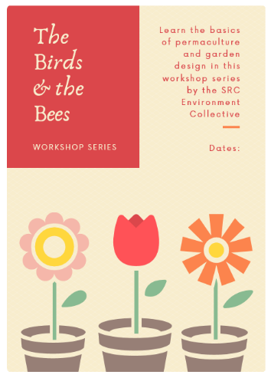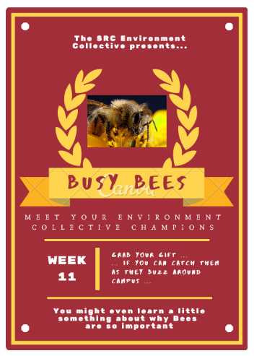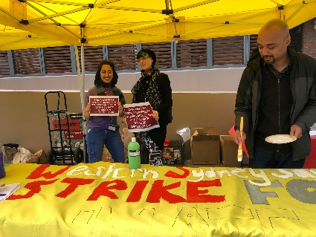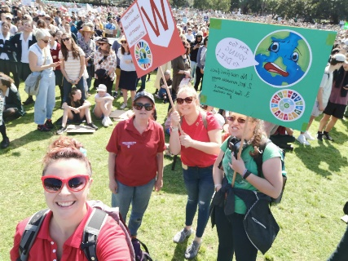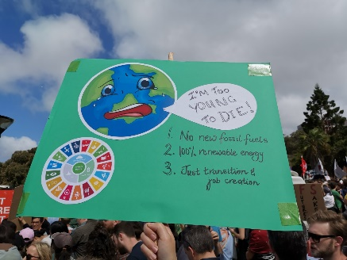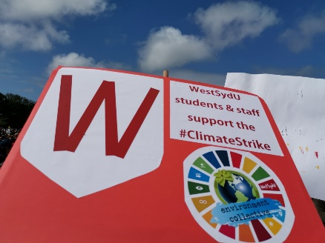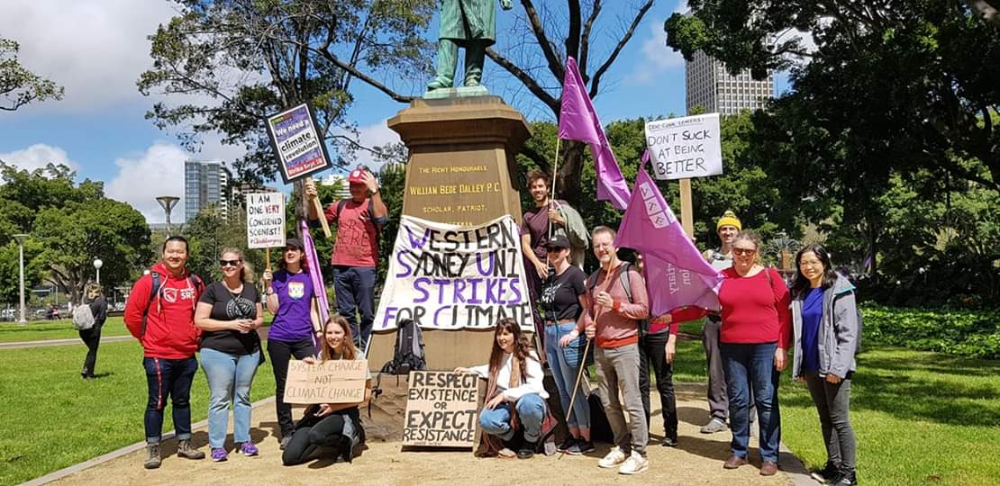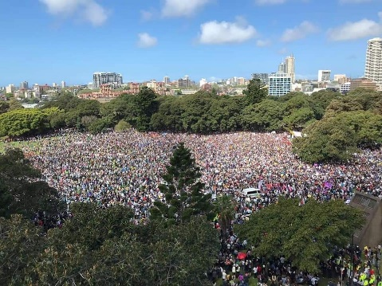
- 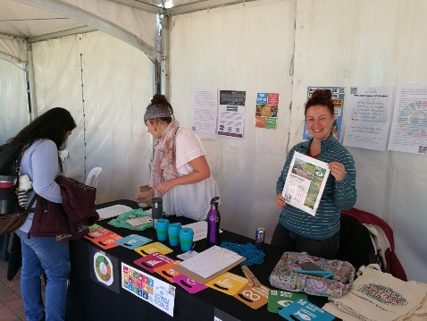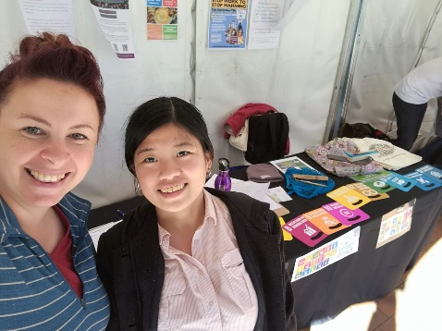

Renier-Clark, Vicky-Rae - Disabilities Rep

I firstly apologise for the length of his report as it covers both the months of August and September as a number of our campaigns and initiatives spanned across this two-month period whilst others are more ongoing. For ease of reading I w ill be listing these events and campaigns rather than writing full paragraphs that will span pages upon pages. If anything does require more information please feel free to email me.
- Liverpool western fair [13th august]
- Campbelltown western fair [14th august]
- disability & accessibility workshop [15th august]
- shuttle bus and student safety initiative [ongoing]
- addressing the complaints of students with disability in relation to the flipped learning model adopted by the university [ongoing]
- pushing for a more inclusive RNA policy for all students not just those whjo are female identifying [ongoing]
- acaemic planning and course approvals meeting - undergraduate representative (3rd september)
- celebrate pacifika evening - Campbelltown campus (21st august)
- orgsync training and consult with parra south disability officer, paulin tan and cso, Nap Andrei samson (27th august)
- wear it purple dinner (Bankstown soup kitchen) [29th august]
- r u ok dinner (Bankstown soup kitchen) {12th september}
- collective meeting catchup with ethnocultural officer, allan feng and disabilities officer Campbelltown, Robert Reed [12th september]
- consultation with chairwoman of the NSW council for pacific communities, mal fruean and former chairman of suicide prevention Australia, Matthew tukaki to discuss better mental health outcomes for pacific students [20th September]
- fair day for the farmers [26th September]
- lgbtiq+advisory committee meeting with choice and connect division of aspect Australia [30th September]

Baker, Leahanne - Nirimba Campus representative

I am identifying the needs of students’ at Nirimba and listening to their concerns of the campus. I have a meeting scheduled, with Dr. Nicolene Murdoch, who is the Chief Executive Officer of The College. The meeting is on Friday 27th of September to discuss more about the campus, budgets, and issues surrounding Nirimba. Since being selected as Nirimba Student Rep I’ve been approach by students about fixing a lecture room by replacing the tables and chairs with new equipment, adding shuttle buses, replacing and adding new and more food/drink options, update of the Nirimba Library and to put a stop of the two high schools coming on campus and using our facilities.

Jha, Vageesh - Residential Students Representative

Over the past month I have been involved in the following activites:

· Made my submissions towards the communications strategy.
· Working on a joint project between CLV and E&Y on the Environmental Sustainability and Governance, to make village a more eco-friendly place to stay in. The secondary focus of the project is on the village life and issues residents face, interms of mental wellbeing and how to improve the current status quo.
· Working alongside Residential Assistants(RA) on building more resident valued events, as events hosted within the villages are in the hand of the RA.
· Over the past month assisted 2 international students in finding suitable accommodation and 4 village residents facing harassment.

Events that I have attended in the past month:

· SRC Black Tie Ball
· International Student Orientation for Q4 intake at SGSM
· 180 Degree Consulting presentation event
· BBQ and Movie nights at the village.

Looking Forward

I plan to organise a sporting event for residents across all campus and seek assistance and strategic support in doing so.
Members who failed to provide reports

Miller, Shayne – First Nations Representative
Yigiter, Erdem - Queer Representative
Carr, Mandii – Vice president Activities
Chheda, Rohan - International Student Representative

