Student Representative Council
Student Representative member’s reports – September
The following reports are to be provided by all SRC members

Bojanic, Matthew - Vice President (Undergraduate) and acting President

Introduction
I have been incredibly busy in the period between Meetings #8 and #9 of 2019, despite it only being a fortnight since the last SRC meeting. It is my hope that this work will enable us to gain momentum with a number of our initiatives, as well as move forward as an organisation after a rather tumultuous four months.

Administration
Over the last fortnight I have continued to fulfil the role of acting president, which has seen me not only coordinate flying minutes, and organise routine meetings with various university executives, but also review the outstanding minutes of the council. Last week I spent a large amount of time (over 6 hours) rewriting the minutes for meetings #5 and #6, with the hope they will be passed by flying minute, or worst-case scenario, at our upcoming SRC meeting. I would also like to take this opportunity to thank the other members who have actively contributed to the minutes, and it is my intention for them to be distributed for review prior to the meeting so that they may be passed as well.

Academic Integrity
The academic integrity student ambassador program continues to move forward. The EOI posters have almost been finalised, and we have begun to construct a training program for our future ambassadors. I had a productive meeting with Associate Professor Tracey Bretag of the University of South Australia, a leader in the area of Academic Integrity, on Tuesday 20 August, who gave my team great insight into some of the areas of our program which require some greater attention.

Employability and Internships
All of my projects in the area of employability and internships are continuing to move forward. The Vocational Training Support Program (VTSP) is fast approaching the implementation phase, with a productive meeting with the management accounting team from the Division of People and Advancement on Tuesday 27 August securing the transfer of $10,000 of SSAF funds to the college to fund the provision of RSA and RCG qualifications to vulnerable student groups. I have a final meeting with Anthony Mitri and Chris Youness on Monday 2 September to finalise our plans, and begin the implementation of the first phase. I will require a number of SRC members to provide some support in developing collateral and promoting the initiative to the student body, and it is my intention to reach out to W’SUP to more heavily promote the education agenda.

The majority of my time however, has been spent on Pitch Day, which is to occur on 10 October 2019 at Parramatta South Campus. This is an exciting collaboration between numerous university and student partners, and aims to provide both professional development and internship opportunities to our Business and SCEM students, who have noted in the past the lack of openings available to them. I met with university stakeholders on Thursday 22 August, with us better understanding the responsibilities of each of the partner organisations, and fleshing out a rough agenda for the day. A full working group meeting was subsequently held on Tuesday 27 August to finalise the division of labour for the planning, promotion and delivery phases of the event. Further meetings were held on the afternoon of Wednesday 28 August with stakeholders unable to attend the initial meeting, as well as to lock in the agenda for the event itself. I would like to take this opportunity to thank Kezia Dunn for assisting with collateral development for the project, as well as Clare Da Silva and Anirudh Karthik for coming on board as student partners.

Communications Strategy Working Group
The development of a new communications strategy remains one of my greatest priorities, with me developing new job descriptions for the roles of Communications Director and Communications Assistant, to be discussed at the upcoming working group meeting to be held on the afternoon of Monday 2 September. It is also my intention for us to undertake some activities in the group setting of the Leadership Retreat to help create new collateral to better engage with students.

Events and Engagement
I was lucky enough to attend Winter Wonderland on the afternoon and evening of Wednesday 28 August, assisting Mandii Carr, Vice President of Activities, with some of the set-up, as well as with the SRC stall. It was an awesome event which engaged many students, and I would like to thank Mandii for all of her efforts in organising and managing the event, as well as Kiara Osborne and Allan Feng for their assistance on the day.

Furthermore, I am adamant that Western Wednesday for September will be going ahead, and I will be meeting with management from the Collector Hotel tomorrow alongside Anirudh Karthik to secure an ongoing partnership with the venue. I am hopeful this will be an exciting event, with both the USyd and WSU Music Societies involved in the evening.

Bekker, Frederick W. – General Secretary

The activities I have engaged with since the previous SRC meeting are as follows;

I have moved all 10,000 tote bags from the Counselling room to the EF SRC office at Parramatta south as well as the Parramatta city SRC office, making many trips to do so. We are really thankful for Student services for assisting us and storing the boxes for that long, and pass on our warmest commendation.

I have been assisting numerous members with administrative and bureaucratic queries, as well as assisting members in the functioning and performing of their role. Including being in collaborating with Clare Da Silva with her highly anticipated First year meet-up, traffic light party, and liaising regarding future event ideas. Furthermore, founded the newly formed built environment school based society (CAPS) with Bonatti, Daniel as VP, Charing the first AGM held at Parramatta City.

I helped out and represented the SRC at both Western Fair and Open day at both Parramatta city and Parramatta South, and we (Vageesh, Jha, Yigiter, Erdem, Da Silva, Sarah, Dunn, Kezia, Feng Allan, Kathik, Anirudh) did a great job representing the SRC and various other organisations.

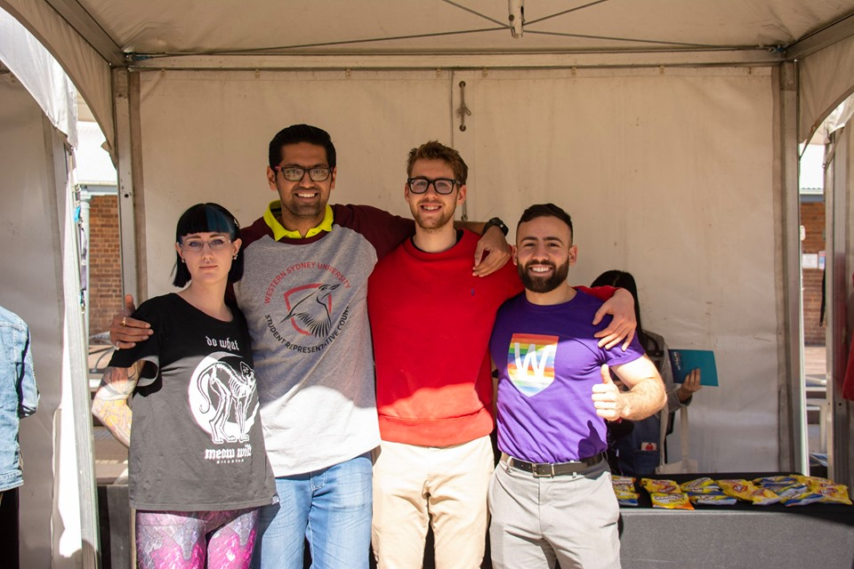

Have been busy assisting with Parramatta city’s Thursday night soup kitchens, and providing an SRC presence whilst distributing tote bags.

Have been busy responding with member enquiries via email and social media, answering queries, and been in contact with many students as part of general SRC outreach.

Was on the SRC President selection panel at Kingswood, with Martino, Richard, Dunn, Kezia and Hammond, Hollie (Zoom) to select the new incoming SRC president, of which I have made the minutes from available online via the one drive shared folder (tinyurl.com/wsusrc2019)

Finally, have collated and formatted the;
- Agenda item list,
- September member reports,
- Minutes from previous council meeting,
- Minutes from Special meeting,
- Minutes from Communications Strategy working group.

Bonatti, Daniel - Vice President Education (Postgraduate)
I write a report greater than 200 words as I am in the Executive of the SRC. I am the Vice President Education (Postgraduate), & NUS delegate elect, plus CAPA delegate and Budget and Honorarium Communication, SSAF Committee member. I am in the Faculty Engineering, Mathematics and Computing doing Graduate Diploma in Building Surveying. I am following my role as described in Student Representation Procedures Clause 14 & 15. I easily achieved the required 42 mandatory hours.

My activities have been restricted in August due to my larger course work load for my Graduate Diploma In Building Surveying, next year I may take leave to get more done for the SRC, though at moment accelerating my studies.

Activities – Schedule during August

- Flying Minutes, 30-07-2019, The flying minute vote collapsed due to lack of response, I personally believe this was the right response as the matter was not clearly detailed. I (Daniel) is on the Remuneration Committee people who did not vote such as myself will have no consequence of there lack of involvement.
- Building Surveying, 31-07-2019, 9am to 5pm, 8 hours, Fire Engineering Design Assessment course commenced DR M.C Hiu, Assignment 1 given FEB.
- Infrastructure, 31-07-2019, 6 to 7pm, total 1 hour, Webinar, 30 years at Sydney Water, Engineers Australia.
- SRC Meeting, 1-08-2019, Vice presidents meeting, Daniel, Matthew, Mandi, Agreement for interim president Daniel let Matthew be interim, Budget and use of orgsync.
- SRC President, 1-08-2019, Email from returning officer President position by EOI, Vice Presidents to do interviews or check applications.
- Communication, 1-08-2019, total 1 hour, Webinar Quantity take off from PDF files using Revu – Vic Engineers Australia.
- SRC Meeting, 2-08-2019, Catch up with Tooba and Grant. Seven people attended, Allen, Keiza, Daniel, Grant, Tooba, Charbel and Mandi.
- EWB, 4-08-2019, Engineers Without borders Meeting UTS for coordination of Humanitarian Engineering Conference 2019, to be held 27 to 29th September. Got minutes filled in as first meeting for WSU.

- IoT, 6-8-2019, 12 to 1pm, total 1 hour, Webinar Video Content Analysis, Engineers Australia.
- WSU Kingswood visit, 6-08-2019, 11.30 to 1.30pm, total 2 hours, Shuttle bus through Werrington South, TAFE, and to Werrington North Campus, visit administration, various buildings.
- SRC Training, 6-08-2019, 1.30 to 3.30pm, total 2 hours, Frogmore house, Werrington North, Background briefing on Sexuality and Gender Diversity update, led by Ally and Jack, LGBTIQ workplace inclusion, Given 49 slides paper version in class for workshop, later emailed full set of slides. Updated with current terminology so as to be inclusive, example no unisex toilets, partner not husband, LGBTIQ changing to diversity of sexuality and gender DGSS and intersex (see notes and slides comments)
- Communication, 7-08-2019, Communication Strategy Workshop
- Innovation, 7-08-2019, 8 to 9.30pm, total 1.5 hours, New Challenges for Electronic Warfare, Engineers Australia.
- Advocacy 08-08-2019, 5 to 6pm, met student phd law 4th year, gave me problem in writing Head MRes ultimatum finish in three months or get only M Res no phd, had waited 4 months for thesis assessment, now need to finish or has to pay for extra semester, with valuable time lost waiting for his right to get a reason his submitted thesis was not accepted.
- EXPO, 08-08-2019, 6 to 8pm, total 2 hours, Property & Construction Expo, Frederick helped Daniel had SRC tote bags distributed. The expo had many employers, I spoke to John Holland, AWJ group, SMLXL, McDonalds Restaurants, Altus Group, City Plan, One Fne One property, There was over 200 students from WSU, the event was opened by Professor Robyn Harding. The morning at 9am Hon. Brian Preston head of the land and environment spoke at Paramatta South Campus previously supposed to have presented at 6pm level 9 1PSQ, changed at last moment.
- SRC Meeting, 09-08-2019, 9 to 11am, total 2 hours, Paramatta south campus Chancellery Building EB level 2, Meeting Executive SRC with Vice Chancellor Barney Glover, Jane Hutchinson, Cheryl, Frederick, Matthew, Hollie, Tegan, Naomi, Mandii, had snacks. Regular meeting, agenda driven, Dialogue to continue approach relationship, student voice, Performance based funding, international students, postgraduate student satisfaction, QUILT, Out and about, Western You, Human Rights Commission, WSU integration children ambassador, Academic integrity, model, employability, Community gardens, YAMA, budgets (Daniel wrote minutes are available)
- SRC, 09-08-2019, Student Welfare support Office to pick up tote bags to give to my classes from the many boxes as seen below in the photo.

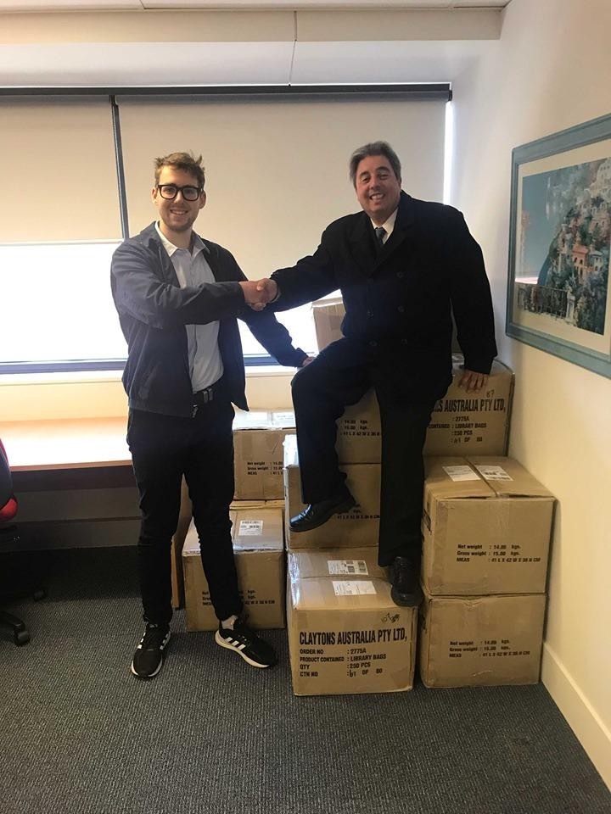
- Chancellery 09-08-2019, I Daniel picked up Best of the West Book, and western growth to read on WSU most recent happenings.
- Advocacy 09-08-2019, I went to Student Welfare Support Parramatta South Campus Chancellery level three, to speak on behalf of student the officer involved changed job to student central Daniel went to speak to this person to be on the same page as student concerned. I organised new Student welfare Support officer for the student sent various emails on behalf of student to get advocacy.
- NUS 09-08-2019, 2.30pm to 4pm, 1.5 hours, NUS meeting best deal for WSU, Sarah, Frederick, Matthew and Daniel level 8 1PSQ.
- Building Surveying, 10-08-2019, Building in Bush Prone Areas Assignment 1 submitted, Bush Fires for Black Saturday & Wyee River & Separation Creek.
- EWB, 11-08-2019, 5 to 7pm, total 2 hours, Engineers without Borders Meeting WSU inter university coordinator met up at meeting with UTS, UNSW, USyd, to organise Humanitarian Engineering Conference 2019, Hazelwood Blue Mountains 27th to 29th September. I got given four projects to do;
- Poster with qpay link amd access to sales
- Participant information literature
- Get Funding $2000
- Make activity and get speaker
- SRC Meeting, 13-08-2019, 3.30 to 4.30pm, total 1 hour, Catch up with Naomi, Grant, Richard, Matthew, Daniel and Frederick. Official Daniel on SSAF Committee meeting 30th August Werrington South (Daniel wrote minutes)
- IoT, 13-08-2019, 6 to 7pm, total 1 hour, Webinar Drought Resilience; An Inter-regional Approach
- Advocacy 14-08-2019, emails phone calls on behalf of student.
- NEM, 14-08-2019, 6 to 7.30pm, total 1.5 hours, Webinar Operational forecasting in the NEM, Engineers Australia.

- Project Management, 15-08-2019, 11am to 12pm, total 1 hours, fourth interview for RPL Recognition of Prior Learning.
- Academic Senate, 16-08-2019, 9.30am to 11.30am, Liverpool Campus, SRC Matthew, Daniel and Tegan Academic Postgraduate Representative and law student, plus academic senate (see report)
- SRC Meeting, 16-08-2019, 1.30 to 2.30pm, total 1 hour, special public relations meeting.
- SRC Meeting, 16-08-2019, 2.30 to 3.30pm, total 1 hour, Budget meeting Frederick followed up with report expenses blow out. (see Frederick’s report)
- SRC Meeting, 16-08-2019, 3.30 to 4.30 pm, total 1 hour, full corium, new member Indigenous Rep Shane, Daniel at commencement meeting had $5000 added to May Minutes this was repeated for Grant to hear later in the meeting.
- EWB, 8 to 11pm, total 3 hours, Engineers without Borders Meeting WSU inter university coordinator wrote up Participant Information for 2019 for inter university, used previous years pdf opened it updated details especiallt time changes this was for WSU UTS, UNSW, USyd, to organise Humanitarian Engineering Conference 2019, Hazelwood Blue Mountains 27th to 29th September
- Building Surveying, 19-08-2019, Building in Bush Prone Areas Assignment official due, Bush Fires for Black Saturday & Wyee River & Separation Creek submitted 10 August(see assignment)

- Building Surveying, 20-08-2019, Building in Bush Prone Areas Workshop 1, assignment 2 given out, presentation power point 20 slides for assignment 4 issued and assignment 3 journal assignment known. I gave out Tote bags to class 20 in total 4 students left the bag.
- CAPS, 20-08-2019, 6 to 7pm, Annual General Meeting, first meeting constitution, budget and officer bearers elected, minutes written by General secretary CAPS Construction Architecture Planning Society Meeting #1 Tuesday 20th August 2019 Running time from 6 to 8 pm, Parramatta City Campus level 1, Meeting Attendance: Frederick W. Bekker (President)
Daniel Bonatti (Vice President / Treasure), Yasser Hemeida (Secretary), Robert Holdom, Allen Isader, Mathew, Mathew Right, Lane Carrol, Alan Izadfar, Mateusz Kaminski (See minutes ).

- Budgets, 20-08-2019, 6 to 7pm, total 1 hour, Security of Payments, Engineers Australia
- Chartered, 21-08-2019, 6 to 7pm, total 1 hour, Webinar Benefits of the chartered Credential, Engineers Australia.

- CHARTERED, 22-08-2019, 9am to 10am, 1 hour Interview by invitation due to over 20 years of postgraduate training, prepared 40 slide power point for interview. I was accepted as Chartered Engineering Technologist CEngT, in areas of practice, Civil Engineering, Structural Engineering, Building Services Engineering, Leadership and Management.
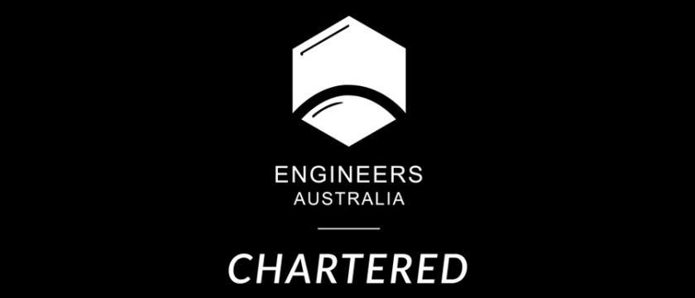
- Project Management, 22-08-2019, 11am to 1pm, total 2 hours, fifth interview for RPL Recognition of Prior Learning, had to write response to episode elements and performance criteria
- Chartered, 22-08-2019, 6 to 7pm, total 1 hour, Webinar Workshop How to become Chartered, Engineers Australia
- EWB, 24-08-2019, various times, total 2 hours, Meeting via emails and face-book next meeting next week, Engineers without Borders Meeting WSU inter university coordinator met up at meeting with UTS, UNSW, USyd, to organise Humanitarian Engineering Conference 2019, Hazelwood Blue Mountains 27th to 29th September.
- SRC training, 29-08-2019, tba, Bullying Recognising and addressing Bullying in the work place, Parramatta City
- Building Surveying, 30-08-2019, Assignment 2 due FEB Fire Engineering brief, group F team leader must get group to submit parts and select assignment to submit.

- SSAF, 30-08-2019, tba, SSAF task force, meeting for allocation of funding of SSAF funds, Werrington South Campus.

Feng, Allan - Ethno-Cultural Representative
The late August/early September period has seen the Ethno-cultural Collective (ECC) execute our plans for the recent events, namely Western Fair involvement and the “International Student’s VISA Information Session”.

The collective had a presence at Western Fair on the Campbelltown, Penrith, Bankstown, Parramatta City and Parramatta South campuses. At the event we distributed merchandise, networked with other associations and clubs and invited students to join the collective. I also promoted the SRC and handed out some of the merchandise (i.e. tote bags). Over the 5 campuses we attended, 149 students filled out the sign-up sheet to join the collective.
“International Student’s VISA Information Session” is an event brought about through collaboration between Western Students International Student’s Association (WSISA), Unions NSW and the ECC. On Thursday 29th August, 59 students gathered on the Parramatta City campus to be informed about their VISA rights through presentations by an immigration lawyer. The event was overall successful as we were at maximum capacity and the feedback was generally positive. Due to this success, we intend to run this event again in the Sydney CBD which will open attendance to all Sydney international students; potentially facilitating cross-institutional collaboration.

In addition, I have reached out to the NUS Ethno-cultural Representative regarding their current initiatives and events. I am awaiting a reply via email. I also helped out by vending and providing manual labour to the SRC team at Winter Wonderland.
Planned initiatives
1. International Student’s VISA Information Session, round 2 as above.
2. WSU Ethno-cultural Collective general meeting, as per previous report.
3. Student forum in collaboration with Chaplaincy, as per previous report.
4. I met a community engagement officer from South West Sydney Local Health District during Western Fair. He introduced me to an initiative they are running which is aimed at addressing health inequity in gay CALD populations. I have forwarded this information to the Queer Representative to discuss possible collaboration on this.
5. Cross-collective working party as per SRC August meeting. – To be actioned.
6. End of semester celebration dinner, as per previous report.
Education
This month, I have read the following articles relevant to the Ethno-cultural sphere: https://journals.sagepub.com/doi/abs/10.1177/0022022113478657 https://scholarworks.iu.edu/journals/index.php/aeer/article/download/314/390

Aditi Sengupta - Campbelltown Campus Representative

I have worked towards identifying and promoting the interests of all students on my campus, and collaborated with the Student Campus Council and other SRC members. I have spoken to fellow students about Food outlets and prices at the university, Parking and transport, Student services, Clubs and societies, Campus ideas and activities and have encouraged them to engage with the university. I had a meeting with Tooba Anwar on future events. I also emailed Hussam Jabran, Campus Life coordinator regarding holding an educational action group meeting. I have submitted an event request for a climate change placard making activity (these placards will be used at the climate strike that some WSU students are participating in (informed by Tooba)) on Campbelltown Campus which has been approved. I have communicated with the Western Sydney Medical Society who have expressed an interest to participate in climate related events and invited them to collaborate with this event. I also represented the SRC on 12/08/2019 at the Bluestocking Week Lunch which was a great opportunity to celebrate women’s achievements. I also restocked the kitchenette and emailed Hussam about the lack of tea, almond milk and other amenities. I communicated with Grant on possible ways of creating a student education action group and a student group to discuss university services. I am currently in the process of planning posters and feedback options for students to report any difficulties or concerns regarding university services such as counselling services, shuttle bus service. I have attended all SRC meetings till date via Zoom and submitted my reports.

Hammond, Hollie - Penrith Campus Representative

This report will likely be shorter than usual due to the previous report covering my activities in the first week of August; additionally, I’ve been sick with the flu twice this month and have started to face difficulties engaging on campus face-to-face due to illness (as well as being at the tail-end of pregnancy).

This month I’ve spent quite a bit of time gathering research on evidence-based ways to improve student wellbeing on campus. This is an ongoing project of mine, however I hope that several initiatives will come from this research towards the end of 2019 and the beginning of 2020.

During the week beginning August 12th I spent at least 5 hours, possibly more, commenting on, amending and refining the minutes from SRC meetings 5, 6 and 7. Though this is outside the scope of my role, I feel it’s crucial that we get accurate minutes of an appropriate standard approved and published as soon as possible. I also attended the regular SRC meeting on August 16th, as well as the budget meeting held directly prior to this. I intend to be present for future budget meetings as part of the SRC budget committee. As per my action item from the regular SRC meeting on the 16th, I created a Qualtrics survey to capture information relevant to our ongoing social media and communications strategies and provided it to other reps for comment.

On August 21st I attended a lunch for scholarship recipients with Katie Page, Gerry Harvey and Barney Glover at Parramatta South; though this was not due to my position on the SRC, it was a useful networking opportunity and I was very fortunate to make connections with staff and students and discuss issues relating to SRC.

On August 22nd I attended a meeting of the WSU Penrith Psychology Club (in which I am an active member) to discuss opportunities for a collaborative event to be held later this semester. We will be holding a ‘Donut Stress!’ event, primarily facilitated by myself as Penrith Rep and with the Psychology Club to provide evidence-based ways to help students study for exams (including how to manage exam anxiety, how to aid memory and how to study effectively). My planning for this event is underway and will also include provision of food to all students on campus, as well as the presence of PAWS Pet Therapy dogs. It’s currently scheduled for October 30th.

I’ve also been involved in on-going work around student advocacy, particularly in the space of flexible tutorial policy for parents (and with great support from Kezia and Grant). This has been difficult as many University departments were reluctant to claim responsibility for these issues, though there has been some progress just this week and I look forward to getting a positive result with this.

I’m also currently being caught up with issues around shuttle bus services, both specifically for Penrith and for WSU campuses more broadly. This is in the hope that if we approach this as a group in a coordinated manner we may see more positive results than if it continues to be
approached by individual campuses. I hope that we’ll be able to get a good resolution around these issues.

I’ve also been in contact with Grant to find out more information about how to set up the Services and Facilities Forums for Penrith, as per my position description. It’s my understanding that facilitating these Forums is a part of my role, but that there is no current mechanism through which to begin them, so I’m hopeful to receive some guidance with this as they seem to be an effective way to learn more about campus-based issues and find solutions to them as effectively as possible.

I’ve also continued my involvement with the Climate Caucus, in partnership with other students and staff, particularly Danielle the Environmental Rep; we will be holding a Climate Forum event at Parramatta next week prior to the September 20 Climate Strike.
And finally on August 30th I attended a SSAF working group in the morning and the SRC President selection panel in the afternoon.

Dunn, Kezia - Women’s Representative

WoCo shared at stall at Western Fair with the Queer Collective, sharing treats with students and encouraging students to follow our social media pages. Feedback from the student body was excellent and students were excited to hear about events in the pipeline.
WoCo released its new inclusive branding. Dzenita Semic (Parramatta Wom*n’s rep) and I created the new imagery, Dzenita creating the amazing new logo and myself drawing a banner using NSW state flower, Parramatta wattle blossoms and Australian blue bees. Students have responded very positively to the new look and particularly to the update in language, ensuring an inclusive space for gender diverse people in WoCo.
The Wom*n’s collective networking nights have been booked for Parramatta South, Cambelltown and Kingswood. The first day alone saw 17 signups to the events. Sharon Roy from Diversity Fest has been secured as the Parramatta guest speaker and Alumni have been invited. The response on social media has been excellent, and the first event will be held on Thursday September 12th.

I helped to review the special meeting minutes and correct spelling and syntax errors to facilitate speedy release of previous minutes.

I attended the first SSAF meeting on August 30th to discuss allocation of funding. This process is ongoing but it is important to ensure student voices are heard at these meetings. I will continue to follow up and advocate for programs with tangible benefits for WSU students.

I met with Lauren Gecuk from Respect and Equality about university policy, vision and future projects for reducing rates of sexual assault on campus. The meeting was extremely productive and I look forward to continuing to work with Lauren on informing policy, procedures and advocacy.

Myself and Hollie Hammond (Kingswood Rep) are currently pursuing advocacy action for a student who has found herself excluded from WSU carer’s policy allowing her to change tutorials as her childcare needs are not covered by legislation. We are in continued discussions with relevant bodies and are preparing to take the case to Academic Senate.

Myself, Hollie Hammond and Frederick W. Bekker (Secretary) met to review all EOI’s for the new SRC president. We developed a fair rating scale to assess applications and narrowed down to six individuals who will subsequently be interviewed.

Clare Da Silva - Parramatta South Representative

Since the last meeting, I have attended several events and have worked on different initiatives to engage and assist students.

Meetings:
I attended the Budget meeting before the last SRC meeting to be updated on what our current spending looks like. This was informative as it gave me an indication to spend max $50 per student for each event, which I think is fair and reasonable.
I attended via zoom the Pitch Day meeting with fellow SRC members. There we discussed this upcoming initiative and allocated different roles for the parties involved. I assisted with information about running events on Parramatta South including potential security costs and how SRC can assist with pre-event advertising and on the day. This event will benefit students as it enables them to pitch ideas in front of potential employers as well as network.
I have been liaising via email correspondence with Nap (Parramatta South CLO) about events on campus that I am running and have started to implement them.
SRC Office and Posters:
I have been keeping up with the roster for the SRC office building kitchen as well as seeing what is needed for the SRC room (we had to get some paper in for the printers and etc). I also printed and posted around campus flyers for the upcoming Western Wednesday! I also have made a variety of posters for my upcoming events on campus (this is discussed further below).

Events:
I attended both the Western Fair stalls at Parramatta South and Parramatta City Campuses all day. I handed out tote bags and asked students what issues they were facing on campus and what they would like to see more of. For Parramatta City campus students wanted to remove high school students especially as all of the rooms are taken and that leaves minimal study spots. Students also wanted to have more study spaces available as well as wanting to have the bathrooms cleaned more regularly as there was rubbish in the toilets (especially on levels 1-3). I also went around and introduced myself to different clubs present to see if they had any questions about funding, Orgsync or feedback on Western Fair.
For Parramatta South campus, I had typed up a document that I handed out to all club/associations present at the event that gave information and links to Provost (a funding pool for engaging the community, students and staff), the communications link for advertising, information about upcoming clubs forums and special purpose funding bids as well as my contact details and a few events that campus life was running so that clubs can promote there. Many clubs seemed to like the document and said it would be very useful and that they did not know about these opportunities. I also handed out tote bags for a lot of the day asking students about what they wanted to see on campus and talked about the upcoming Western Wednesdays.

After the last meeting, I followed up with Frederick W. to tell him about my upcoming events on campus. Frederick W. was helpful in showing me how to put through budget requests and helped edit my posters for the event. I also put in most of the budget requests for these events and am speaking with Nap (Parramatta South CLO) about them. I also spoke to Mandii about my ideas and she gave me some insight into what to look further into and etc. Mandii also contacted me regarding a student who gave her feedback about wanting a creat your own pot plant event on Parramatta South campus (one like Mandii ran). I am now implementing this and have made plans with Nap to buy different tools and etc to make this event happen.
The upcoming events include a “Make your own pot plant”, “First years meetup”, “Traffic Light Party” and “Speed Friending”. I have been working with Frederick to get discounts with the Albion hotel for the Traffic light party as well as glow sticks as you get a glowstick based on your relationship status i.e. Green if you’re single.
Here are a couple of posters for upcoming events that I hope other SRC members can make it to. Note some of the other event posters are still being drafted so if you have any suggestions for these events please let me know ASAP.

Kathik, Anirudh - Parramatta City Campus Representative

During this past month I have assisting the other members in two major projects which are the western Wednesday and the SCEM club. Regarding the western Wednesday Matthew and I have had a chat with the management for the collectors and have got 100 vouchers for free drinks and have reserved a meeting for Tuesday next week prior to the event to discuss all the details and events of the information and have future plan in the process for the western Wednesday that will take place on the first Wednesday of every month. Regarding the SCEM club the club is still undertaking the selection for its executives prior to pitch day such that the entire club is running before the pitch day so that we can provide a list of activities and events that can be done by the club currently for the SCEM club the president is present and EOI application have been sent out and we have got a decent number of applicants for the positions offered. In city campus there have been no complaints regarding the high school students and Advertisement for the western Wednesday will start it next week as it has been confirmed and ready.

Yigiter, Erdem - Queer Representative

I have secured the date for the Queer Picnic for Wednesday the 28th of August. I had created a Facebook event with information about the day, which I shared on the Parramatta Queer Collective Facebook page. This event was supposed to be hosted by Nick, the Parramatta South Queer Officer, but he has recently told me that he unfortunately wont be able to anymore. I have contacted the other Queer Officers (there are only 2 at the moment – Grant and Maria) but due to work commitments, they are unable to host this event. It looks like I may have to cancel this event as I will be overseas during the time that this event is on.

I will be hosting the Queer Collective stall at this weeks Western Fair at Parramatta south campus. The stall will be co-hosted by the women’s collective. We will be handing out prizes and snacks for people who join the orgsync portal and facebook page.

I attended the SRC catchup with Tooba and Grant. They offered advice on ways to boost student engagement and provide support with the process of making events.

I have followed in Kezia’s footsteps and have decided to start ideating what a Queer Collective vision statement and policy/guidelines will look like. This will address appropriate use of the Queer Rooms, and also rules and guidelines for queer students and allies to follow regarding respectful language, privacy, student interactions, etc.

Osborne, Kiara-Lee - Bankstown Campus Representative

I am aware that this report will be shorter than usual as most of my activity was covered in my previous ‘July/August’ report.
August 15, 2019 – Responded to an email by Lisa Tyson, library staff member, in regard to the recent vandalism issue they have been experiencing. After apologising on behalf of the student cohort, it was agreed that the SRC would make an effort to raise awareness for this issue. I have created material to be distributed around campus – please see below.
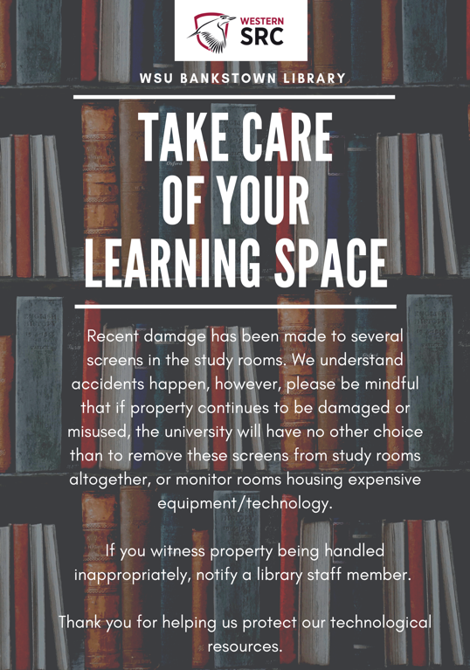
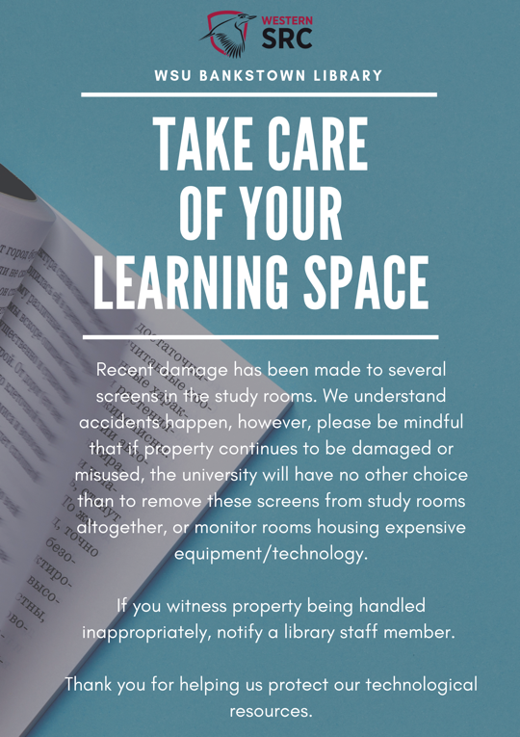

August 22, 2019 – Ordered three suggestion ‘thought’ boxes to be placed around the campus in order to reach a larger scope of students. I hope to place these boxes in building 2 (Collective office spaces), Common area (Cafeteria), the College and potentially the Library.
August 28, 2019 – Assisted in the delivery of the Winter Wonderland event with fellow SRC members: Mandii Carr, Matthew Bojanic and Allan Feng. During this event I had the opportunity to distribute a large amount of old SCC merchandise and connect with students on a personal level. Unfortunately, many students on the Hawksbury campus had made comments about the lack of engagement on campus – which I hope after a collective discussion will be resolved.
August 29, 2019 – Hosted a collaborative event with The Humanities Project Club called ‘Good Thymes in the Garden’. The main reason for the event was to promote sustainability by encouraging students to grow their own food and engage with nature.
- During this event I supplied every student with tote bags
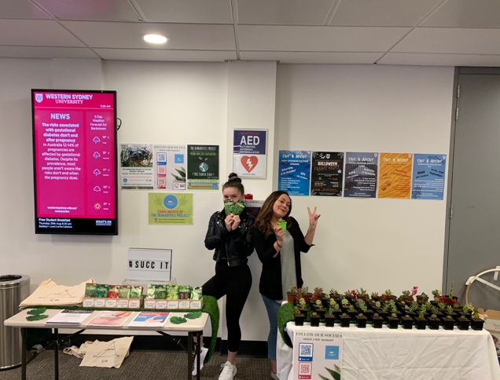
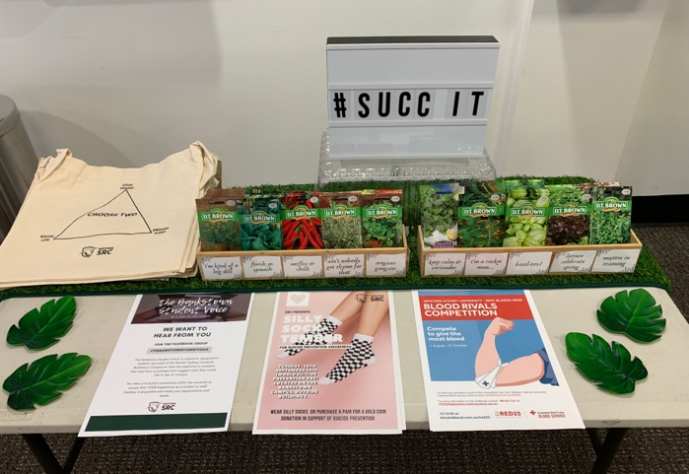
- In exchange for a ‘like’ on the SRC Facebook page, students also received a free seed starter pack and succulent. This event generated 20+new likes for the social media platform.

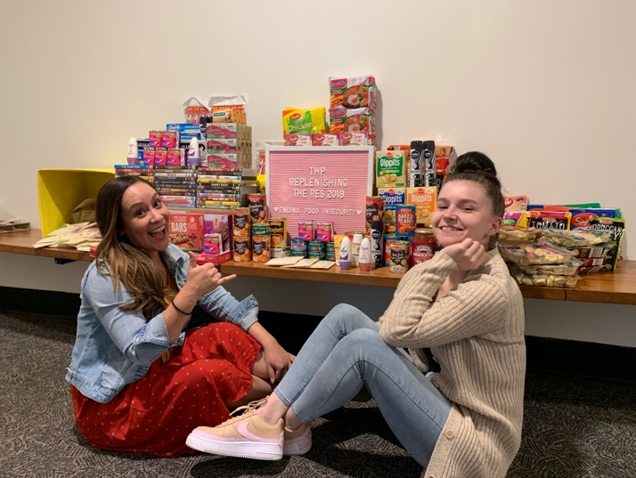
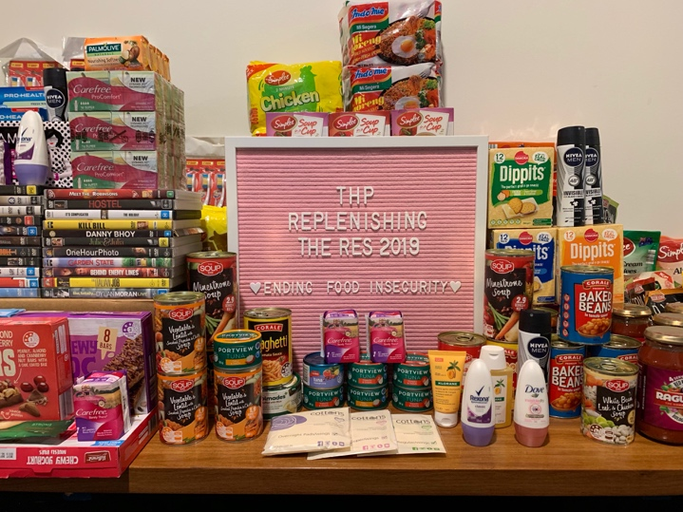
August 31 – 1 September 2019 – ‘Replenish the Res’ is an initiative initially created by The Humanities Project Club to help Bankstown residential students that experience financial hardship/food insecurity. On the 31st August, myself and the Secretary of The Humanities Project gathered donations from both the club and I to deliver to res. Due to time sensitivity, I hadn’t managed to purchase supplies using the SRC budget, so I had donated items that I didn’t need such as DVDs (entertainment purposes) and canned food. I will be making the purchase of $50 worth of items on Sunday 1st September to ensure that the residents are provided with their monthly intake of donations. I do wish to continue this $50 contribution on a monthly basis to help end food insecurity on campus.

Events/Initiatives (Confirmed and upcoming)
- Replenish for Res: Ongoing.
- September 10: Silly Sock-tember for Suicide Prevention
- September 11: Make Your Campus Clean for Ice Cream

Supitt, Sarah - Online Students Representative

- Attended NOWSA 2019 on behalf of SRC/WoCo
- Roundtable UNSW
- Students have expressed interest in the soon to be online student club (WOSA) and have asked for events for students to meet up (we've also discussed speed networking via zoom)
- Volunteering at Parramatta city soup kitchen
- Update on online student packages: Nothing has been ordered until the confirmed minutes go up and through, Mandii has the quotes though, and so they can all be actioned asap. We need to start letters soon.
- Update on Western Online Student Association: survey monkey results on logo have been returned and will now work on creating exclusive branding for the student club
- Panellist Judge for the Tournament of Minds - Regional Finals (Western Sydney)
- Giving Day 2019 – Parramatta south
- For the talent quest coming up is there a way that we can directly message the online cohort to see how many send entries for the competition?

Members who failed to provide reports

Nikibin, Amir - Small & regional Campuses
Espinas, Jonathan “JC” – Hawksbury Campus Representative
Chheda, Rohan - International Student Representative
Miller, Shayne – First Nations Representative
Jha, Vageesh - Residential Students Representative
Danielle Wolf - Environment Collective Representative
Carr, Mandii – Vice president Activities
Renier-Clark, Vicky-Rae - Disabilities Rep

New Members

Baker, Leahanne - Nirimba Campus representative
Ferrer, Natasha - Liverpool Campus representative

