STUDENT REPRESENTATIVE COUNCIL
MONTHLY MEMBER REPORTS

October 2021

TABLE OF CONTENTS

PRESIDENT: ALANNAH HADER 3

VICE-PRESIDENT EDUCATION (UNDER-GRADUTE) NATASHA FERRER 4

VICE-PRESIDENT EDUCATION (POST-GRADUATE): ANUSHKA KAPOOR 5

VICE-PRESIDENT ACTIVITIES: CAMERON CHESTERS 6

GENERAL SECRETARY: SARAH CUPITT 7

RESIDENTIAL STUDENTS REPRESENTATIVE: CURRENTLY VACANT 9

INTERNATIONAL STUDENTS REPRESENTATIVE: LOORE MURAVU 10

WOMEN’S REPRESENTATIVE: ROSINA ARMSTRONG-MENSAH 11

QUEER REPRESENTATIVE: RANNIE SINGH 12

FIRST NATIONS REPRESENTATIVE: TIFFANY SHARPE 13

DISABILITY REPRESENTATIVE: ROBERT REED 15

ETHNO-CULTURAL REPRESENTATIVE: CRYSTAL RAM 18

ENVIRONMENT REPRESENTATIVE: DANIELLE ALBERTINE 19

ONLINE STUDENT REPRESENTATIVE: CURRENTLY VACANT 21

PARRAMATTA CITY CAMPUS REPRESENTATIVE: MUHAMMAD ABBAS 22

PARAMMATTA SOUTH REPRESENTATIVE: RAZIN POLARA 23

NIRIMBA CAMPUS REPRESENTATIVE: SARA MIKHA 24

KINGSWOOD CAMPUS REPRESENTATIVE: SIMON PREUSS-KEARNEY 25

BANKSTOWN REPRESENTATIVE: JASMINE RICCIARELLI 26

CAMPBELLTOWN REPRESENTATIVE: DHARSHINI SATHYANARAYANAN 29

HAWKESBURY CAMPUS REPRESENTATIVE: JONATHAN ESPINAS 30

LIVERPOOL CAMPUS REPRESENTATIVE: MARIA MANOS 31

WELFARE AND WELLBEING REPRESENTATIVE: VICKY-RAE REED 32

SMALL AND REGIONAL CAMPUS REPRESENTATIVE: CURRENTLY VACANT 34

PRESIDENT: ALANNAH HADER
Extension Provided
16/9/21- Diversity Fest 2021 Planning Meeting
16/9/21- I attended the Western Sydney University SRC strategy planning Session with Michael Connolly. This was such a fantastic opportunity for the members who attended to get to connect and get to know each other further. Michael provided us with points for self-reflection on who we are as individual representatives and as a collective representative body.
17/9/21- Brainstorm of externalising the SRC Meeting. As a group, we met to discuss what a model of our SRC would look like if it was to become external. The conversations had opened us up to a lot of possibilities and ideas that we will be moving forward with in the following weeks and months.
20/9/21- Coordinator catch up (Student Retention and Success)
23/9/21- SRC September Meeting. This meeting saw our highest attendance yet and provided us with the opportunity to all meet and discuss key points and issues from the previous month.
24/9/21- I attended workshop 1/2 of the Mental Health First Aid Course. Along with 11 other people, we met with our instructor Fleur who ran a three hour workshop. We learnt how to approach situations where someone may be in a crisis. I feel that this will benefit me in my leadership as I have learnt many skills and strategies that can be applied to such a wide variety of circumstances.
29/9/21- Mental Health First Aid Course, workshop 2/2.
30/9/21- SRC Executive Meeting. This meeting allowed the executive to meet with Grant and Richard to discuss relevant matters and to formulate an agenda for our upcoming meeting with the Vice Chancellor of the University in late October. Additionally, we discussed the barriers to engagement within the internal structure of the SRC for further planning.
1/10/21- Mental Health Wellbeing and Safety Strategy Meeting. SRC members met with staff members of the MHWB sector of the university as stakeholders to discuss relevant issues students and staff were facing, regarding their mental health. We formulated key themes, groups of concern and strategies the University can implement to aid the wellbeing of the University community.

VICE-PRESIDENT EDUCATION (UNDERGRADUATE): NATASHA FERRER
Experiences and Events: | Justification to VPU role:
- Submitted a member report for September.  - Attended executive meeting.  - Maintaining NaMSS (Nursing and Midwifery Students Society) social media platforms by monitoring academic enquiries and needs of the nursing and midwifery cohort. Academic reminders are also done in these platforms for upcoming assignments and tests.  - Working on the data packs initiative. I have accumulated data pack options for the SRC to help decide on which one I will go through with. I will be making posters and interacting with the student cohort via social media platforms to help the progress of this initiative. | - Clause h - providing a report to the Student Representative Council and the relevant sub-committees on their activities  - Clause c - organising and attending regular meetings with the President, Vice-President Postgraduate and General Secretary of the SRC to ensure the proper functioning of the SRC, in accordance with these procedures;  - Clause e - Engaging students and student leaders in discussion around issues with education at the university;  - Clause e - Engaging students and student leaders in discussion around issues with education at the university;

Reflection:
- I have completed my 6 week block of placements and will start to actively perform my duties.

VICE-PRESIDENT EDUCATION (POST-GRADUATE): ANUSHKA KAPOOR
Under 200-word requirement

VICE-PRESIDENT ACTIVITIES: CAMERON CHESTERS
Extension Provided
Over the past few weeks, I have been working with Mehwish, Dharshini and Sara to work on initiatives. Sara the Nirimba campus rep approached me with an idea. She feel there aren’t many events for Niemba students and so she is organising a ceramic event for them which is excellent. I have agreed to provide part of my budget as Vice President Activities to her for this event. I have also offered to help in any way if she felt that would help. Dharshini the Campbelltown rep has an event idea for STUVAC which is for students to hop on a zoom and study together for motivation. She was offering Officeworks gifts cards as an incentive for people to try and engage with the event idea. I suggest she increase the scope of the event to provide higher value gift cards to even more students. From that she will receive $1,500 of my budget for her event. I have also offered to help in any way with budget submission or anything else. Mehwish and I have spoken about securing more funding for the VPA at the October meeting to ensure quick allocation of funds to any additional events that other reps think of and also for some Halloween or Melbourne Cup events later in the year for the VPA role. There was a perceived problem with the way the recent casual vacancy for the Welfare Rep role was conducted. It was a First Past The Post voting system; however, the SRC Procedures stated an Optional Preferential Voting system was required. This was sort out as Grant said this was an appointment not an election by all students and so didn’t need an OPV system to be valid. I also hosted the fourth Kahoot since taking the role of VPA. Initiatives that don’t involve Kahoot will hopefully occur this year to freshen things up. The prospect of planning and hosting in-person events next year is very exciting.

GENERAL SECRETARY: SARAH CUPITT

Rest of September:
- Sent tentative calendar invites for SRC meetings for the rest of 2021
- Switched SRC IG to a business account so we can schedule posts to FB and IG at the same time, posted about the September SRC meeting, WOCO panel event, international student survey (made a graphic for Rayaca) and 21C Curiosity Pod - Students as Partners: Co-creating change (posts also promoted on Western Life SRC page)
- Made graphics for and scheduled all SRC meeting posts for Oct, Nov and Dec
- Expressed interest for - Care Collaborate Connect - Psychological First Aid Training
- Followed up proxy forms for NUS delegates through Rameez - also reached out regarding having an NUS rep talk to NUS delegates about their roles, purpose etc.
- Western Life issues for collective reps - emailed student clubs, Tau and Alissa about two issues that arose and need to be resolved ASAP:
- The disability collective can’t access the src or budget page on WL
- Crystal (SRC ethnocultural rep) can’t be added as an officer to the ethnocultural page, and she's been asking since July
- Created an agenda item for the VCISAC Meeting: SRC - International Representation. I proposed an offshore international rep to be added to the next review of the SRC procedures, with capacity in similarity to the SRC Online Rep.
- Distributed agenda and member reports for Sept - via email, attached to calendar invites and additionally uploaded to Teams for ease of accessibility for reps and staff
- Followed up the TEDx Western Sydney University event idea from Anthony Pun and suggested if he would be interested in hosting a TEDx event to match the theme of Divfest. We can always wait till we're back on campus for something like this to be held at the auditorium; however, I think an online event is possible and worth trying.
- Made a graphic to promote the new SRC vacancies on WL, FB and IG
- Uploaded confirmed August SRC minutes to website and teams archives
- Wellbeing Cafe - Video Opportunity (for Kristi - Equity Diversity Safety & Wellbeing)
- Sent the team a reminder email for the due dates for the rest of the year re: agenda items and reports, as well as the dates again for the remaining src meetings for 2021
- Paul Keating Park Play Design Workshop
- Organised VCISAC Meeting: SRC - International Representation
- Sent Jenny SRC Exec Agenda 27/09 for the meeting on 30/09
- Promoted the Student Safety Survey on SRC FB, IG and WL as well as 15 student FB groups and looped in Nathalia Alcantara Do Vale regarding student reach
- Submitted answers for Student Representative Council Casual Vacancy Votes Sept 2021
- Sent reminders for Oct members report and sent out unconfirmed minutes from the SRC September meeting and uploaded to team with zoom recording
- Positive Affirmations with the Equity and Diversity Team - participated in the initiative and also assisted the team with graphics to promote the campaign
- Sent Sept Exec Meeting minutes to reps and also uploaded them to Teams

Meetings
- Stephen Zissermann – meeting for Respect now Always – divfest – 14/09
- MHWB Champions Meeting & Cross-campus forum - 15/09
- The Community Kitchen - Cook and Connect 15/09
- The Community Table #8 - Power balance and climate policy – 16/09
- Western Sydney University | SRC Strategy Session 1 - 16/09
- Brainstorm discussion of externalising the Student Representative Council – 17/09
- Virtual Workshop - Building Teams and Building People 21/09
- Student Leaders COVID Lockdown Discussions – 21/09
- Paul Keating Park Play - Building An Adult Play Space Workshop 21/09
- The Community Kitchen - Cook and Connect - Diversity Fest Special Event 22/09
- Disability Collective and Equity, Diversity & Wellbeing Meeting 23/09
- WAP: Women Are Powerful – 23/09
- Mental Health First Aid Training – Online – 24/09
- CAMPFIRE CHAT #4 - Individuality vs Corporate Identity – 28/09
- Western Sydney University MHFA Workshop #2 – 29/09
- MHWB Champions Meeting - 29/09
- The Community Kitchen - Cook and Connect - Diversity Fest Special Event – 29/09
- Academy Masterclass: Communicating Complexity - 30/09
- SRC Executive Meeting | September 2021 - 20/09
- MHWBS Strategy Stakeholder consultation workshop 1/10
- Mates Corner - Men's mental health - 1/10
Oct Actions (ongoing)
- Promoted the SRC baking class event (Muhammad’s request) and “Indigenous Enough” (Tiffany’s request) on SRC socials, IG, FB and Western Life
- Diversity Fest: Modern Ink x Ethnocultural Collective (over 90 student registrations) https://padlet.com/crystalram19/in6awwob0bk3v0mo Oct 1 7-8 pm
- Need to finalise budget requests for reps that haven’t reached out to collaborate
- In progress - WHMB article about WSU’s mental health campaign, champions, strategy etc. A mix of staff and students have been interviewed.
- Divfest - meeting with a newly formed book club on the 5th of October to discuss book event collab with Modern Ink and Jostina for Oct
- Mates Corner – ongoing planning and brainstorming

RESIDENTIAL STUDENTS REPRESENTATIVE: CURRENTLY VACANT

INTERNATIONAL STUDENTS REPRESENTATIVE: LOORE MURAVU

As the international student representative, I believe leadership is an action not just a position. During the month, I have engaged in social media platforms for students. I have been responding to SRC emails and contributing to the team. Last month I had the opportunity to attend SRC strategy session on the 16/9 where discussed about how we feel about the role, my strength and weakness in relation to my role. I also engaged myself by attending the brainstorming meeting on the 17/9 regarding externalizing our SRC. I have attended a brainstorming meeting with Grant to discuss more ideas about how I can assist international students and engage them within the community. I have had meetings with Crystal regarding CISA (Council of International Students Australia)

Plans in progress

- Organize a working group to initiate Collective officers for international students.
- I have been nominated to present WSU SRC as National undergraduate officer for CISA, with elections on the 1st week of October.
- Organizing an event to discuss the roadmap for the return of international students, awaiting a response from Mehwish to assist with organizing the event.

Lastly, I would like to apologize for any inconveniences that I may have caused to the team, I will try everything within my capabilities to work as part of the Team to be the leaders we chose to be.

WOMEN’S REPRESENTATIVE: ROSINA ARMSTRONG-MENSAH
Extension Provided

Following on from my previous report, I attended SRC 23rd September 2021 meeting.
Attended the equity collectives officer honorariums, ToRs and funding discussion on the 15th September 2021.
I joined the Western Sydney University SRC strategy session 1 on the 16th September 2021.
I attended the brainstorm discussion of externalising the student representative council on 17th September 2021.
We had the cross-campus brainstorming on 20th September 2021
Women’s collective catch up to discuss about our event Women Are Powerful 21st September 2021
Participated in the SRC kahoot on the 22nd September 2021
Hosted the women’s collective diversity fest event on 23rd September 2021.
Participated in the Mental Health First Aid workshop 1 24th September 2021.
Attended the study NSW industry briefing for education provider, agents and partners 28th September 2021.
Took part in the LEAD campfire chat 4 Individuality and corporate identity on the 28th September 2021
Attended my last workshop for the mental health first aid on 29th September 2021
In addition, I participate in the LEAD community table discussions. I have been checking in with Marissa and Daniel for support by emails as well as zoom meetings. There were some other mini chats among me and the panel for our event.
Also been in touch with Jostina about an upcoming event Be Inspired on the 8th October 2021 1pm
After, our WAP panel discussion we received heaps feedback which I am analysing. It was great seeing lot of staff supporting on the day and hoping for a longer session. These feedbacks seconded our thought of making the panel discussion a series or something ongoing we hope everyone can share their ideas.

QUEER REPRESENTATIVE: RANNIE SINGH
Not submitted

FIRST NATIONS REPRESENTATIVE: TIFFANY SHARPE
Extension Provided
Meetings:
- September 17: Brainstorm discussion of externalising the Student Representative Council
- September 22: Meeting with Grant Murray (Student Voice)
  - Discussion of thoughts and ideas that I’ve been brainstorming.
- September 23: SRC September Meeting
- October 1: MHWBS Strategy Stakeholder consultation workshop
  - Discussion of Mental Health and Wellbeing Survey Strategy Stakeholder, which we engaged and worked as a team gathered significant information.
- October 1: Drop-in Q&A with Grant Murray and Mehwish, along with the SRC team
- October 1: Meeting with Mehwish (Student Community Assistant)
  - Discussed about the Eventbrite event “Indigenous Enough” roundtable discussion, which we created an event under the Indigenous Student Council platform and there is a disclaimer noted.
  - There’s a copy of the created event for “Indigenous Enough” Roundtable Discussion.
- October 1: Chatted to Sarah (SRC General Secretary)
  - The promotion of the event “Indigenous Enough” Roundtable Discussion, which she assisted me with promoting the event on the Western Life, Facebook, and Instagram.
Training:
- September 24: WSU Mental Health First Aid Workshop #1
- September 29: WSU Mental Health First Aid Workshop #2

Events:
- September 21: LEAD Virtual Workshop: Building Teams and Building
- September 23: WAP: Women Are Powerful
  - First Nations Representative role fulfilled by reading out the ‘Acknowledgement of Country’.
- September 23: The Community Table #9: Special Event for Diversity
- September 28: Campfire Chat #4 Individuality vs Corporate Identity
- September 30: Dear Stress, Let’s Break Up! (Edition 1 Burnout)

Upcoming Meeting/Training:
- October 5: LEAD Virtual Workshop: Influencing Without Authority
- October 6: Booked a meeting with Grant Murray (Student Voice)
- October 7: Eventbrite “Indigenous Enough” roundtable discussion
- October 7: WSU SRC Strategy Session 2
- October 7: The Community Table #11: Women in the workplace
- October 12: LEAD Virtual Workshop: Authentic and Vulnerable Leadership

"Indigenous Enough" Roundtable Discussion
by Indigenous Student Council
Educational/Awareness Indigenous Representation Diversity fest Online Indigenous Culture Staff Welcome World Mental Health Day
Have you ever felt you weren't "Indigenous enough"?
Vanessa Lesperance from 'Mindful Managers' is hosting a virtual event on Eventbrite discussing the common experience of many indigenous individual. To anyone who has ever felt not quite "Indigenous enough" - this circle is a safe space for you to share your experience, listen to others and work towards creating your sense of belonging.
Disclaimer: This event is not by any mean affiliated with Western Sydney University. The views of the facilitator do not represent the views of Western Sydney University in any way. This is an external event hosted on the Eventbrite platform.
To register please follow this link: https://www.eventbrite.com.au/e/indigenous-enough-tickets-169878066871?aff=ebdssbonlinesearch&keep_tld=1

DISABILITY REPRESENTATIVE: ROBERT REED
Extension Provided

I FEEL THAT I HAVE ADEQUATELY UNDERTAKEN THE ROLES AND RESPONSIBILITIES OF MY ROLE POST 15TH SEPTEMBER 2021 BY:

- Engaging students and student leaders in a discussion around relevant issues in the University
- Presenting Disabled Students Issues at meetings of the SRC and being the voice of the Disabled Student Population at Western Sydney University
- Chairing various sub-committees of the SRC as per Schedule of Student Representative bodies and the actions resolutions of the SRC
- Undertaking tasks assigned to them as per the actions and resolutions of the SRC
Western Sydney SRC Strategy Session 1 with Michael Connelly – September 16th
Brainstorm: Externalising SRC with Richard Martino- September 17th
Brainstorm: Cross Campus Equity Network – September 20th
- Conversations surrounding Equity Collective events and a possible collaborative series of panels during the Summer semester covering many topics of intersectionality between the collectives.
Student Leaders COVID-19 Lockdown Discussion – September 21st
- Recapped progression of Movember and Mates Corner (Men’s Mental Health Initiative)
- Outlined progression planning with MHWB staff – Emma Taylor, Moera Tufunga, Steve Lee & Ingrid Dernee
Disability Collective and Equity and Diversity –September 23rd
- At this meeting, both the Disability Collective Executive and I spoke with Disability Services and Equity and Diversity around increased support for student carers external from the needs of student-parent carers. These conversations are ongoing with Michelle Falconer.
SRC Monthly Meeting – September 23rd
SRC Action Item Response: Rug and Mug Mental Health Event Safety Plan -September 30th
- Bankstown Campus Representative, Jasmine Ricciarelli, wrote to me during the SRC Meeting regarding her proposed Mental Health Safety Plan for the Rug and Mug event; following my concerns, there was no mental health safety plan attached the agenda item, which has a high risk of student disclosures. Her safety plan, which consisted of less than a paragraph of text, did not outlay any of the plans to deal with potential crises, including approaching the issues with cultural sensitivity. I also reminded Jasmine in my response to proposed amendments that although we are representatives and some of us studying various clinical areas, we are far from experts. I have not had any return correspondence from Jasmine concerning any proposed amendments to her plan.
MHWBS strategy Stakeholder Meeting – October 1st
- I was very disappointed during this meeting. There was no objective reasoning or rationale for why student carers are not adequately supported, especially regarding appointments and unscheduled issues with the person they are caring for. I believe this should be an area potentially spearheaded by persons with actual lived experience of caregiving rather than an anecdotal response. This lived experience would significantly help with awareness of all aspects of caregiving, not just WHEN but also HOW we need help.
- It is a common conceptualised thought that carers are not respected by the University, which has a culture of increasing gaps between academics and students rather than responding compassionately to student needs.
- Further conversations with Emma Taylor and Steve Lee to follow
Drop-in Q&A and Virtual Lunch - October 1st
- Disability Collective spoke on their Men’s Mental Health Initiatives - Movember and Mates Corner. Mohammed also mentioned he would like to run an event for World Mental Health Day, and we have discussed possible collaboration in our communications.
- The collaboration between former Disability Collective Secretary/Current Welfare and Wellbeing Rep, Vicky-Rae Reed and Ethnocultural Representative Crystal Ram for the week-long Diwali events was also discussed at length, including current funding complexities.
Mates Corner Men’s Mental Health Consultation with MHWB (Steve Lee, Emma Taylor, Ingrid Dernee & Moera Tufunga) – October 1st
- Sarah Cupitt, Vicky-Rae Reed and I, along with No Student Left Behind Advisory Group members Becki Cox, Bayan Schailee & David Malik, met with the MHWB team for consultation purposes regarding our proposed mental health safety plan and event plan for Mates Corner. – proposed safety plan is attached.
- Steve Lee – questions regarding referral pathways to services and how to structure the sessions
- Moera Tufunga -has access to a list of cultural facilitators mentored by MHWB, six of whom are men. Willing to connect the team to their community partners. Praised the team concerning their proposed safety plan they have collated and recognises the time and effort put in to create the document.
- Emma Taylor - is delighted with the thought and research taken into the team’s project, just constructive criticism that this will be a lot of planning and back of house work before the events can happen in their proposed format.
- Key theme: develop a safety plan for the first session but be mindful that the safety plan will have to be tweaked for ongoing sessions; it is not a one and done deal.
- Forward Planning: Brainstorm session with cultural facilitators and MHWB champions before the first session to further branch out the consultation concerning the program to ensure it encompasses as many voices as possible and everyone knows exactly what the goals and objectives of the project are.
- Return to Campus: Suggested to revise the current idea as time passes to balance the needs of students.
- Cultural adaptations: Bring mentors onboard for appropriate cultural adaptations, including NEC, ATSI, Pasifika, Philipino & Korean.
- Next deadline: November 27th
Student Leader’s COVID-19 Lockdown Discussion- October 1st
- Ethnocultural Representative Crystal Ram and I logged into this Zoom session which seemed to be cancelled with no communications to students.
UPCOMING:
Assistive Technologies & Disability Collective Meeting with Natalie McLaughlin- October 6th
Western Sydney SRC Strategy Session 2 with Michael Connelly – October 7th
Launch of Movember event to coincide with World Mental Health Awareness Day – October 11th
I FEEL THAT I MAY NOT HAVE ADEQUATELY UNDERTAKEN THE ROLES AND RESPONSIBILITIES OF MY ROLE DURING THIS PERIOD BY:
- Undertaking training to fulfil their role
There has been limited time as of late to undertake training with all the planning surrounding Mates Corner, Diwali and Movember, in addition to Virtual Clinic blocks for my degree program.

ETHNO-CULTURAL REPRESENTATIVE: CRYSTAL RAM
Not submitted
ENVIRONMENT REPRESENTATIVE: DANIELLE ALBERTINE
Extension Provided
Photo comp: We’ve had our first of our monthly photo comp where participants submitted their best uses of old glass jars and containers. There were some very innovative ideas, with our favourite being a candle made from water, oil, wax, and oranges which can also easily be replaced with flowers, etc.
Meetings: We have a Collective Exec meeting coming up next week to go over the budget, sourcing update for the workshop material, upcoming and already running events, pending work, future events, and collaboration ideas.
Workshops: We will be starting our fortnightly workshops soon, now purchased supplies. Some of the workshops will include growing mushrooms (with kit provided), pour-and-melt soap, DIY kombucha or yogurt, and making pickles and jams. We’re also thinking about having a competition for best workshop ideas.
After a bit of confusion, our budget requests have been submitted and handled, with supplies, gift cards, etc., purchased.
DivFest: We are hoping to hold a workshop on Native Australian seeds and their uses, i.e, medicinal, food, etc., and linking them to Caring for Country principles, traditions and strategies.
IPCC Report: A further collaboration is still being explored between Sustainable Futures and Daniel Jantos on maintaining mental health and wellbeing in the face of the many concerns raised in the new IPCC report, for which I have an initial brainstorming meeting with Daniel on Tues Oct. 5th.

SDSN Youth – I attended a meeting with the SDSN AusNZPac Youth Coordinator regarding a workshop she is planning – ‘The Climate Crisis and Universities: Capturing the student perspective’. The aim of this workshop is to create a student position statement that captures the perspective of students on the role of universities in the climate crisis. We also chatted about what SDSN Youth 2.0 might look like in our region due to its unfortunate isolation from most of the action in the Americas, Europe, etc.

General SRC: We are currently in the process of working through ToRs for Equity Collective officers, and the addition of the positions and funding to the SRC schedules. Equity Collectives held our first meeting for planning a forum on intersectionality amongst the Collectives, and briefly explored other possible collabs.

An ongoing concern is the lack of consultation by Western on the use of SSAF, which a few of us are trying to put aside time to address.

I’ve been undertaking my own professional development and knowledge acquisition, networking and developing new contacts, helping new SRC reps, and just general SRC chats, planning, etc.

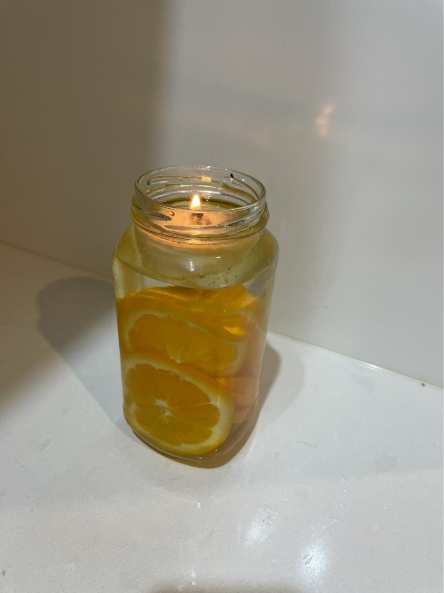
Oil candle idea reusing old jar

ONLINE STUDENT REPRESENTATIVE: CURRENTLY VACANT

PARRAMATTA CITY CAMPUS REPRESENTATIVE: MUHAMMAD ABBAS
Submitted Late

Meetings Attended:

-SRC Meeting (September) - 23rd Sep
- Student Representative Cross Campus Forum -15th Sep
- Student Representative Cross Campus Forum Post Meeting – 17th Sep
- Mental Health Training Workshop 1 – 24th Sep
- Mental Health Training Workshop 2 – 29th Sep
-MHWB Strategy Stakeholder Meeting – 1st Oct
- Drop in Q&A and Virtual Lunch – 1st Oct

Our last collaborative event of Cross Campus Forum in September was a huge success and we had received a massive audience who shared their concerns. We had a post meeting to discuss the results and also choose the winners for the event. Apart from that, I had attended September SRC meeting. I have also worked along with Mehwish to organize a baking class themed on World Mental Health Day on 11th October. We have discussed this with Cameron, and he has allowed us to use his approved budget to fund $1.5k for this event. I am looking forward to hosting this event. The last month has been precious for me in terms of my development trainings. I have involved in several trainings including 6 hours long Mental Health training and MHWB strategy training. I look forward to the second session of MHWB training and contributing actively in this month too.

PARAMMATTA SOUTH REPRESENTATIVE: RAZIN POLARA

Meetings, events or conferences I have attended this month in my capacity as a member of the SRC:

- SRC Meeting
- Consultation Meeting with students

Communication and engagement, I have been involved with this month as a member of the SRC:

- Following my previous report from September regarding sports kahoot I am decided to postpone it for now as I am planning another event.
- Another event I was planning is I thought more important and useful than the sports kahoot. It is related to university questions, like asking questions related to university. That helps new students know something new and gives them new information. ‘Get to know WSU’ is what I call this event.
- I have contacted some other reps to discuss event ideas.
- I will be putting out the Facebook post in the Western Sydney university parramatta south campus page regarding the student meeting (kind of small Forum). As I have got some email regarding some questions. So, I thought it would be best to organise a kind of meeting.
- I will also be following up with the nursing team regarding the accessing of textbook. As I had discussion with the school of nursing executive team in the last meeting. I will update about this once I get more details on it.
- I am also looking at the feedback and suggestions provided in the cross-campus forum by the students. Especially for the Parramatta South campus.
- We had in meeting with the other campus reps. In order to select the winner for the cross-campus forum and discussion regarding other events.

NIRIMBA CAMPUS REPRESENTATIVE: SARA MIKHA
Extension Provided. Under 200-word requirement
KINGSWOOD CAMPUS REPRESENTATIVE: SIMON PREUSS-KEARNEY

Over late September and October, I attended to the following events/activities:

• I have continued my involvement in the SRC related meetings this month, such as the September SRC monthly meeting.
• Secondly, I attended these SRC related meetings and training: I was involved in the first SRC Strategy Session, run by the CPR Group; I attended the Brainstorming discussion, around externalising the student representative council; I was also present in the cross-campus brainstorming meeting; Lastly, with the combined effort of the majority of campus reps, I successfully hosted our cross-campus forum for students (currently above 49 registered – with 24 non-SRC students checking in). Our feedback was largely positive and gives us plenty to build on in the next event.
• Additionally, I have completed the WSU staff offered University training on Equal Opportunity. I believe this will give me a better ability to identify potentially negative, interpersonal situation, and interpret the best course of responding to them, in a supportive and productive way.

Over the month of October, I will attend to the following events/activities:

• Firstly, continuing my involvement in the SRC related meetings which are approaching this month, such as the October SRC monthly meeting.
• Secondly, I will be involved in the following meetings: Multiple SRC Strategy Session – run by the CPR Group; I will be in attendance of the Penrith Provost Committee Meeting; and will engage in the Speak Up-Speak Out! Meeting – on Effective Communication, Mandatory Training.
• Thirdly, the data we received from the campus forum needs a follow up event organised where the campus reps can present the findings to the complete SRC. This will be in the form of a zoom meeting, and will seek to present our captured insight, data, and further develop our response to them, through the discussion of our ideas. We will determine from this, how to best dedicate our time, effort and resources towards better supporting our student groups.
• Fourthly, I will look to follow up on my February agenda items: Creating 3-4 more badges on the WesternLife SRC for members to obtain. I have shelved the idea of any SRC soccer tournaments, until there are any changes in the current lockdown expectations.
• Finally, further develop the Western Sydney University Penrith Facebook group by adding events and acquiring new members. I will look to further develop this with the feedback I get from the data we have collected from the cross-campus forum.

BANKSTOWN REPRESENTATIVE: JASMINE RICCIARELLI
Extension Provided
September 15, 2021- Cross-campus Forum
Attended the cross-campus forum with Kingwood rep (Simon), Parramatta south rep (Razin), Parramatta City rep ( Muhammad), Campbelltown rep (Dash), Hawkesbury rep (Jonathan) and Nirimba rep (Sara) to answer question and see what students would like to see improved on each campus. From this discussion people were asking about having more events on Bankstown campus and if there could be more food outlets on campus. Overall the forum was a success and a lot of conversation was brought up on how to improve the students engagement with uni. The campus reps help a separate meeting to disuses the outcome and options amongst themselves.

September 16, 2021-Western Sydney University | SRC Strategy Session 1
Attended SRC Strategy Session 1 with Michael Connelly where we discussed thing about ourselves and how we became interested in SRC and why we became a part of the university student representative council. During the workshop where we given the time to reflect on different questions and then discuss our responses.

September 17, 2021-Brainstorm discussion of externalising the Student Representative Council
Sat in on the discussion about externalising the SRC and what services would likely to be externalised in the process

September 24, 2021- Mental Health First Aid session 1

September 22, 2021- Zoom meeting for rug and mug
Meeting with Daniel to see what logo and promo material I would like for my event. Here are the options that he decided
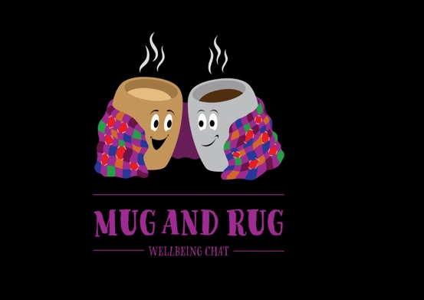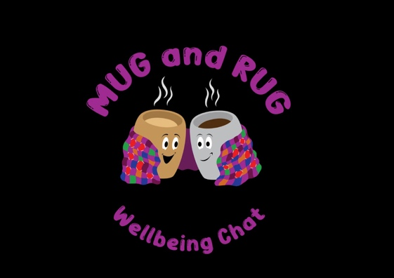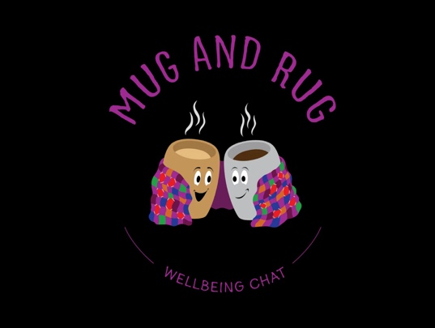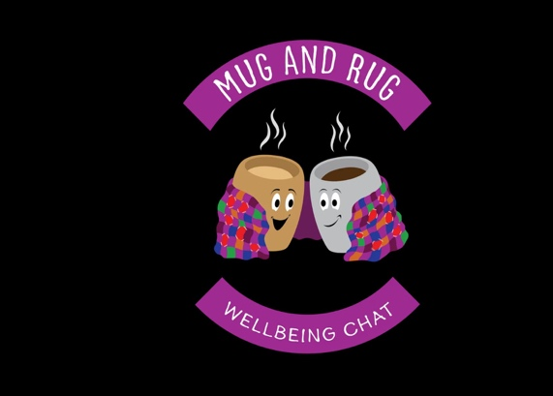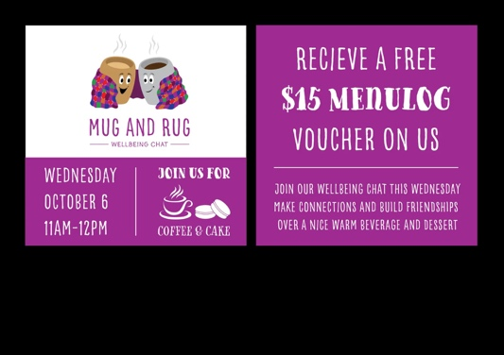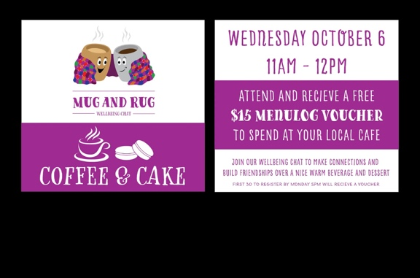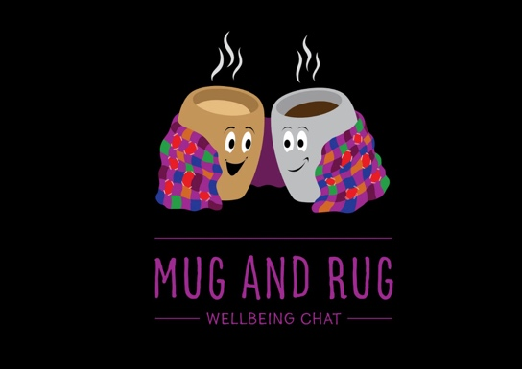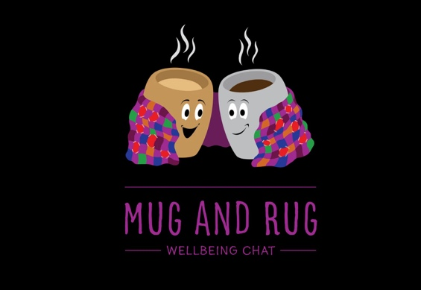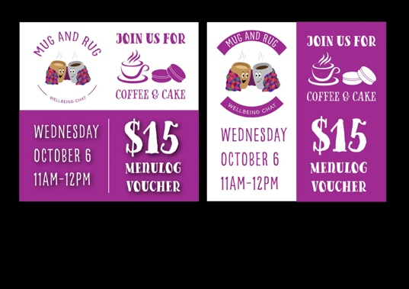

September 27, 2021- Rug and Mug Date and Promo colour choice
Decided on a date to launch the rug and mug event the proposed date is 13th October sent Danial a message and he agreed that it would be a good date as it also fell within the week of mental health day. Choose the promotional colours for the event as well.
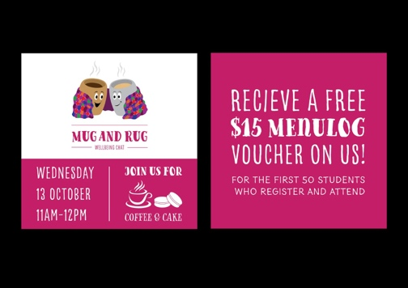

September 29,2021- Mental Health First Aid session 2

October 1, 2021- Rug and Mug
Finalised the event page and submitted it on western life.

CAMPBELLTOWN REPRESENTATIVE: DHARSHINI SATHYANARAYANAN

I attended various meetings conducted by the SRC. I listened and did my best to share my opinions. In my last report, I mentioned that I would like to engage with the student by conducting various fun events, like the study live stream. I am currently planning this event. More research on how to advertise and conduct this event on Zoom is under progress. Hopefully this STUVAC I am able to conduct the event where students could study together and be productive. Due to various personal commitments, I feel like I haven’t met the expectations of a Campus Rep. This October month, I am determined to be committed and be more active in meetings and other events.

Last report, I had also mentioned that I would like to address the concerns that students made as part of the 2020 survey. After discussing with other SRC representatives from home campus, we have taken responsibilities in addressing each of the concerns made by the student on the survey. Responsibilities have been allocated and we are going to make sure we know each other’s progresses. My role is to contact the WHS regarding the sanitating issues and share my concerns regarding the WSU app to the IT department. This is under progress. Hopefully, by next year these issues are resolved.

I look forward to working with the SRC and helping each students feel welcomed and heard.

HAWKESBURY CAMPUS REPRESENTATIVE: JONATHAN ESPINAS

I was able to attend the SRC September Monthly Meeting 2021. At some point in the meeting, member reports were going through. It has not been second as my report has not been handed in. Confusion of member report was cleared with Sarah and I do apologize for the inconvenience.
I also have been privileged to attend the Mental Health Workshop, the very first one on Friday the 24th of September 2021 via Zoom. It was a 3-hour workshop and it was interesting training and was certainly helpful. One of the things I have learnt in the workshop is the ALGEE action plan and how certain words can either be triggering words or very subtle.
I also was able to be formerly invited to attend the Hawkesbury Provost Committee Meeting that was held on Wednesday the 22nd of September 2021 via Zoom. It was a really good meeting. Mostly went through an event proposal plan for next year in 2022. I agreed to help them in assistance with their events in 2022 especially in the Intersport Robin events. The committee has put in Volleyball event for now but would like to change it up. I mentioned on creating an all sports rally event which involves multiple sporting activities. This will be put into consideration in the next meeting which will be sometime in October. What was also mentioned in that meeting was their Staff Awards Night. There is still a concern as to where it should be held, more will be available hopefully in the next meeting.
Finally, I was able to attend the second Mental Health Workshop via Zoom on Wednesday the 29th of September 2021. In this workshop training, went through situations in relation to depression, anxiety and drug and alcohol substance abuse. It was a great discussion on how to formerly sum up the action plan and what to say for those suffering in one of the following areas. As of which looking forward in the next SRC meeting in October and any upcoming trainings throughout this year.

LIVERPOOL CAMPUS REPRESENTATIVE: MARIA MANOS
Not submitted

WELFARE AND WELLBEING REPRESENTATIVE: VICKY-RAE REED

I FEEL THAT I HAVE ADEQUATELY UNDERTAKEN THE ROLES AND RESPONSIBILITIES OF MY ROLE POST MY ELECTION TO THE ROLE ON 1st OCTOBER 2021 BY:

- Engaging students and student leaders in a discussion around relevant issues in the University
- Presenting Student Issues at meetings of the SRC and being the voice of the Student Population at Western Sydney University
- Chairing various sub-committees of the SRC as per Schedule of Student Representative bodies and the actions resolutions of the SRC
- Undertaking tasks assigned to them as per the actions and resolutions of the SRC
Drop-in Q&A and Virtual Lunch - October 1st
- I expanded on the recurrent conversations I have had with Ethnocultural Representative Crystal Ram for the collaborative week-long Diwali events between the Disability Collective SRC and Ethnocultural Collective. The arrangements and planning were discussed at length, including current funding complexities.
Mates Corner Men’s Mental Health Consultation with MHWB (Steve Lee, Emma Taylor, Ingrid Dernee & Moera Tufunga) – October 1st
- Sarah Cupitt, Robert Reed and I, along with No Student Left Behind Advisory Group members Becki Cox, Bayan Schailee & David Malik, met with the MHWB team for consultation purposes regarding our proposed mental health safety plan and event plan for Mates Corner. – proposed safety plan is attached.
- Steve Lee – questions regarding referral pathways to services and how to structure the sessions
- Moera Tufunga -has access to a list of cultural facilitators mentored by MHWB, six of whom are men. Willing to connect the team to their community partners. Praised the team concerning their proposed safety plan they have collated and recognises the time and effort put in to create the document.
- Emma Taylor - is delighted with the thought and research taken into the team’s project, just constructive criticism that this will be a lot of planning and back of house work before the events can happen in their proposed format.
- Key theme: develop a safety plan for the first session but be mindful that the safety plan will have to be tweaked for ongoing sessions; it is not a one and done deal.
- Forward Planning: Brainstorm session with cultural facilitators and MHWB champions before the first session to further branch out the consultation concerning the program to ensure it encompasses as many voices as possible and everyone knows exactly what the goals and objectives of the project are.
- Return to Campus: Suggested to revise the current idea as time passes to balance the needs of students.
- Cultural adaptations: Bring mentors onboard for appropriate cultural adaptations, including NEC, ATSI, Pasifika, Philipino & Korean.
- Next deadline: November 27th

Gender Equity Discussion with Tanya Pilbersek, Prue Car and Nina Funnel hosted by Unions NSW- October 5th
- Let Her Speak Campaign lead by Nina Funnell found that the policies of 39 public universities had a c omplaints mechanism that either contained inaccessible language or was non-trauma informed with some universities limiting the countdown of disclosure to 40 days after a traumatic event. With USyd making notes of “punishments” towards victims if their claims seemed “frivolous”.
- Spoke of need for holistic reform “REVOLUTION” as sexual assault usually begins a vicious cycle of F&DV and gender inequality.
- Tanya Pilbersek spoke of NSW Parliamnts 55 requirements regarding Respect at Work in which the government voted AGAINST fully implementing.
- Prue & Tanya fully support women to go into political and advocacy branches further agreeing that intersectionality is key as decisions more thoroughly reflect their communities when all the voices are in the room.
- Respectful Relationships should start from preschool age with resources given to parents to implement with their children in age appropriate ways such as looking at consent and respectful friendships.This can then be worked on as the child comes of age to teach what reflects respectful sexual practices.
- Emphasis that all this teaching starts in the home.
Promotion of Movember event and set up of the Western Sydney University Movember Fundraising Page through the official Movember website
I have assisted with the promotion of the Movember event and EOI for participants via WesternLife and Facebook in addition to setting up the team page for participants to register on the official Movember website.

UPCOMING:

Western Sydney SRC Strategy Session 2 with Michael Connelly – October 7th
I FEEL THAT I MAY NOT HAVE ADEQUATELY UNDERTAKEN THE ROLES AND RESPONSIBILITIES OF MY ROLE DURING THIS PERIOD BY:

- Undertaking training to fulfil their role
I have undertaken a great deal of training within the Diversity, Inclusion and Belonging framework on LinkedIn Learning the week prior to being elected to my role. As such as it was not completed during my elected period I have not mentioned it here.

SMALL AND REGIONAL CAMPUS REPRESENTATIVE: CURRENTLY VACANT

